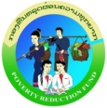

Project Operations Manual
LONG
English version

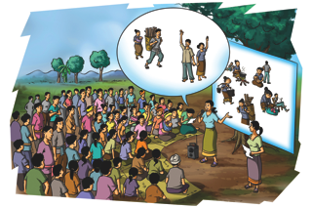

Lao People’s DEmocratic Republic

PEACE INDEPENDENCE DEMOCRACY UNITY PROSPERITY

The Poverty Reduction Fund
Amendment Draft
May 1, 2013

Table of Contents
1 Introduction to Project Operations Manual 9
1.1 What is LONG 9
1.2 What is the Objective of the Project Operations Manual (POM) 9
1.3 Who shall use the POM 10
1.4 How to use the POM 11
2 PRF’s Country Program 12
2.1 Background of PRF in Lao PDR 12
2.2 LONG Key Elements 14
Vision of LONG 15
2.3 LONG Vision Statement 15
2.4 LONG Slogan 15
2.5 LONG’s Actionable Implementation Rules 15
2.5.1 Community Development Rules 15
2.5.2 Additional Livelihood and Nutrition Rules 19
2.5.3 Sanctions 19
2.6 Key Expected LONG Outcomes 20
3 Project Description 21
3.1 Project Objectives 21
3.2 Project Components 21
3.2.1 Component 1: Formation of SHG and Capacity Building of Local Service Providers 22
3.2.2 Component 2: Community Asset Creation for Improved Livelihoods 22
3.2.3 Component 3: Livelihood Linked Nutrition Activities 23
3.3 Approach 24
3.3.1 Social Mobilization 24
3.3.2 Improving Livelihoods 26
3.3.3 Improving Nutrition 27
3.4 Scaling-up in Three Phases 29
3.5 Long beung - Formative Research 29
4 Overview of Field Implementation 31
4.1 Annual LONG Cycle 31
4.2 LONG’s 5 Phases and Key Steps 32
4.3 Training of Trainers 34
5 Detailed description of PRF-LONG Field Implementation 36
5.1 Phase 1: Orientation 38
5.2 Phase 2: Planning 43
5.3 Phase 3: Social mobilization, LONG sub-project design and appraisal 48
5.4 Phase 4: Sub-project Implementation by SHG 56
5.5 Phase 5: Community Monitoring 75
6 Roles and Responsibilities in Field Implementation 79
6.1 Basic Skills for Field Staff 79
6.2 Human Resources Set-Up 81
6.2.1 Central Team 82
6.2.2 Provincial Teams 83
6.2.3 District Teams 84
6.2.4 Village Coordinators 84
6.2.5 Village Livelihood and Nutrition Activists and SHG Facilitators 85
7 Capacity Building 87
8 Safeguards, Feedback and Resolution Mechanism 91
8.1 Social and Environmental Safeguards Policy Framework 91
8.2 Feedback and Resolution Mechanism 92
9 Partnerships and Project Coordination at Local Level 93
9.1 Coordination with Line Ministries and Agencies 93
9.2 Relationships with Other Projects 94
10 Monitoring and Evaluation 95
10.1 Progress Reporting 95
10.2 Project Monitoring Reports 95
10.3 Community Monitoring 95
10.4 Special Studies 96
10.5 Evaluation of Pilot Results 96
11 Results Framework and Monitoring 97

Acronyms and Abbreviations
AusAID | Australian Agency for International Development
CDD | Community Driven Development
CRPF | Compensation and Resettlement Policy Framework
D | District
DRM | Disaster Risk Management
VNC | Village Nutrition Center
FM | Financial Management
GoL | Government of Laos
IEC | Information Education Communication
JSDF | Japan Social Development Fund
KB | Kum ban (lao language for cluster of villages)
LONG | Livelihood Opportunities and Nutritional Gains
LVH | Livelihood
NGPES | National Growth and Poverty Eradication Strategy
NLCRDPE | National Leading Committee for Rural Development and Poverty Eradication
NUT | Nutrition
NTFP | Non Timber Forest Products
POM | Project Operations Manual
P | Province
PMT | Project Management Team
PRA | Participatory Rural Assessment
PRF | Poverty Reduction Fund
PRF I | Poverty Reduction Fund Project I (2003 – 2011)
PRF II | Poverty Reduction Fund Project II (2011 – 2016)
SDC | Swiss Agency for Development and Cooperation
SHG | Self-help group
TIG | Technical Implementation Guidelines
TOT | Training of Trainers
VA  VIG | Village Association  Village Implementation Guidelines
VLNP | Village Livelihood and Nutrition Plan
VSMC  WB | Village SHG Management Committee  The World Bank

List of Figures
Figure 1. Overview of LONG Toolbox 10
Figure 2. Development of Community Operations Manual 11
Figure 3. Overview of PRF’s Country Program 12
Figure 4. The Lao CDD Platform for Improving Livelihoods, Well-being, and Nutrition 13
Figure 5. Key Elements of Community Driven Development Through PRF-LONG 14
Figure 6. The Four Project Components of LONG 21
Figure 7. Overall LONG Approach 24
Figure 8. Social Mobilization for Improving Livelihoods and Nutrition 26
Figure 9: Life Cycle Approach of LONG – Focus on 1,000 Day Window Between Pregnancy and Age of Two Years 28
Figure 10. Phasing of the LONG Pilot 29
Figure 11. Phases and Steps of LONG Field Implementation 31
Figure 12. Overview of Indicative TOT Themes 35
Figure 13. Overview of LONG Field Implementation 36
Figure 14. Example Visual Aid for Nutrition Sensitization 40
Figure 15. Indicative Elements of Family and Food Center 70
Figure 16. Organization Chart of PRF-LONG 82

List of Tables
Table 1. Summary Phase 1: Orientation 42
Table 2. Summary Phase 2: Planning 46
Table 3. Summary Phase 3: Social Mobilization, LONG Sub-Project Design and Appraisal 54
Table 4. Sample Format for a SHG Savings Book 61
Table 5. Targeting and Objectives of VNC 71
Table 6. Summary Phase 4: LVH and NUT LONG Project Implementation by SHG 72
Table 7. Performance Rating Indicators 77
Table 8. Summary Phase 5: Community Monitoring 78
Table 10. PRF-LONG Coordination Arrangements with GOL Line Ministries and Agencies 93

List of Annexes
Annex 1: Results Framework and Monitoring
Annex 2: Gender Action Plan
Annex 3: PRF-LONG Problem Tree
Annex 4: Village Implementation Guidelines (VIG)
VIG1 “LONG Project Introduction”
VIG2 “Village History”
VIG3 “CDD, Livelihood and Nutrition Sensitization”
VIG4 “PRA with Livelihood and Nutrition Focus”
VIG5 “Development of Village Livelihood and Nutrition Plans”
VIG6 “Social Mobilization (including SHG formation, capacity building and strengthening, community monitoring)
VIG7 “Sub-project Proposal and Appraisal (including Negative List)”
VIG8 “Universal Livelihood Linked Nutrition Education”
VIG9 “Livelihood SHG”
VIG10 “Nutrition SHG and Graduation into Village Nutrition Center”
VIG11 “Savings and Loans”
VIG 12 “SHG Exchange Visits”

Annex 5: Technical Guidelines (TG) and Other Guidelines
LONG Glossary for Field Staff
Behaviour Change Strategy Livelihood Linked Nutrition
TG 1 “Social Mobilization” (including SHG formation, capacity building and strengthening, community monitoring))
TG 2 “Nutrition” (various themes)
TG 3 “Livelihood” (various themes)
TG 4 “Savings and Loans”
Manual “Procurement by SHG”
Manual “Financial Management by SHG”
Annex 6: Project Forms and Templates
Form “Village History Profile”
Form “PRA Report”
Template “Village Livelihood and Nutrition Plan”
Template “Agricultural Value Chain”
Form “Appraisal Report”
Compliance Checklist For Appraisal
Form “Sub-project Proposal, Budget and Procurement Plan”
Form “Sub-project Agreement” (and supplementary agreements)
Template “Workplan with Milestones”
Form “SHG Information”
SHG Member Passbook
SHG Fund Request Livelihood and Nutrition Grants
SHG Fund Request Incentive Grants
Attendance and Meeting Minutes Books
Saving Book
Loan Book and Ledger for Recording Small Loans
Performance Checklists for PRF LONG Staff and Village Activists
Annex 7: Profiles of Training of Trainers (TOTs)
Annex 8: M&E Forms
SHG Monitoring Report
Annex 9: Workplan 2012-2015

Introduction to Project Operations Manual

What is LONG
As part of the Lao Government’s vision for the country to graduate from Least Developed Country status by 2020, the Lao Government has requested the World Bank’s support in extending the Poverty Reduction Fund’s (PRF’s) coverage to include livelihood improvement activities. The pilot project on livelihood and well-being improvement, locally known as “Livelihood Opportunities and Nutritional Gains (LONG) Project” - which means “to try” or “test out” (long beung) in Lao language - is the response to this demand.
The objective of LONG is to pilot an innovative community driven development (CDD) program in five poverty reduction priority districts in Huaphan and Savannakhet Province, enabling rural households in project target areas to improve their livelihoods and well-being through group based activities.
LONG will be the entry point for further developing a Lao CDD/livelihoods model as has been successfully established in other countries. Tapping into the underutilized potential of social mobilization is congruent with key messages from the 9th Party Congress. LONG will be built on lessons learned from PRF I and other initiatives in Lao PDR, as well as from other CDD projects. The institutional and political context of the PRF will make it necessary to develop a unique approach without compromising CDD principles and approach.

What is the Objective of the Project Operations Manual (POM)
The overall objective of the Project Operations Manual (POM) is to give a basic overview of the LONG project design, process and steps, which involved staff adhere to. More specifically, the POM will guide LONG, PRF and Government of Laos (GoL) field staff in properly carrying out their roles and responsibilities and to ascertain that they are effective in the organization and administration of their work. This is to ensure that all operational activities have a minimum uniform approach, which is transparent to all participants and are in line with key principles of community driven development. More specifically the POM aims to
Achieve quality facilitation during all steps of operation;
Ensure transition from community participation to community driven development;
Maximize ownership, creativity, and accountability among all stakeholders involved.
The POM is the Principle Guiding Document for LONG with which a larger LONG toolbox will be developed during the course of the operation. The full toolbox will complement this POM with specific tools for capacity building (e.g. LONG curriculum, LONG training slides, LONG glossary), tailored tools for field work (e.g. technical guidelines, village implementation guidelines, IEC materials), guidelines for project administration and financial management, many of which still needs to be developed and field tested (see Figure 1). The LONG operation will use PRF II tools wherever possible (e.g. Manuals for Financial Management and Procurement).

Figure 1. Overview of LONG Toolbox
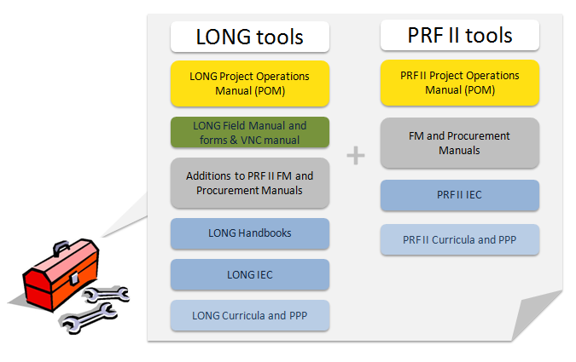
The various documents for fieldwork can be seen as a starter for compiling a full community operation manual, which will be tested in year two and finalized in year three of the pilot (Figure 2).
Despite its binding nature, the POM is a living document. It is anticipated that the LONG POM will be reviewed and updated as it is tested by and with PRF-LONG staff, government, and other project partners over the four year pilot period. The steps and process described in the POM are meant as guidelines and shall unlock the communities and field staff’s own vision, thinking and commitment to strengthen the operation and the results we all want to accomplish.

Who shall use the POM
The primary users of the POM will be LONG Coordinators, LONG District Managers, LONG Operation Officers and LONG Village Coordinators (Young graduates) to guide the operation on the ground.
The POM will also be used by the PRF/ LONG management team, World Bank, consultants, and other service providers to provide remote trouble shooting, to ensure CDD principles and subsequently ensure to reach expected results.
The field staff and communities will be provided with additional guidance with the more detailed field took kit (and later Community Operations Manual) as mentioned above.

Figure 2. Development of Community Operations Manual
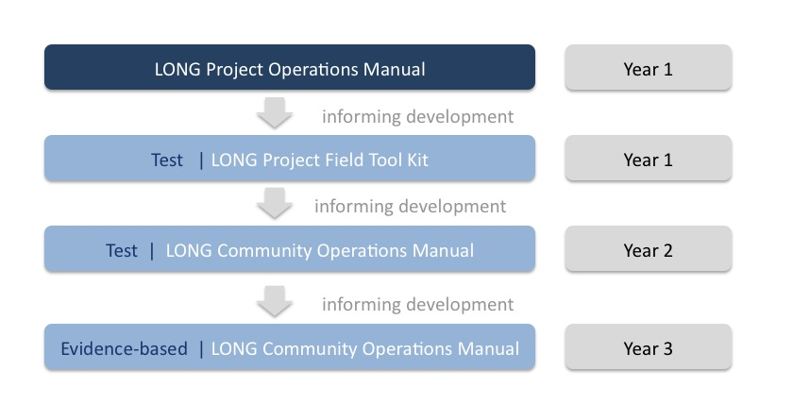

How to use the POM
It shall be mandatory for managing staff at central and district level to be familiar with the content of the POM from the beginning to the end, before beginning to test out activities. In particular, the POM shall be used:
To recruit staff and to train on LONG rules and procedures before staff is taking up their positions;
To identify Technical Assistance (TA) needs (e.g. inputs from experienced resource persons from other successful CDD projects in the Asia region);
To identify training needs, design the capacity building program and inform the curriculum development;
To implement activities in the appropriate sequence and with a clear vision to achieve expected results and in adherence to CDD principles;
To develop village technical and village implementation guidelines;
To supervise and feedback on field activities and provide remote trouble shooting; and
To design the IEC strategy and inform the development of the IEC tools (both public and operation).

PRF’s Country Program

Background of PRF in Lao PDR

Figure 3. Overview of PRF’s Country Program
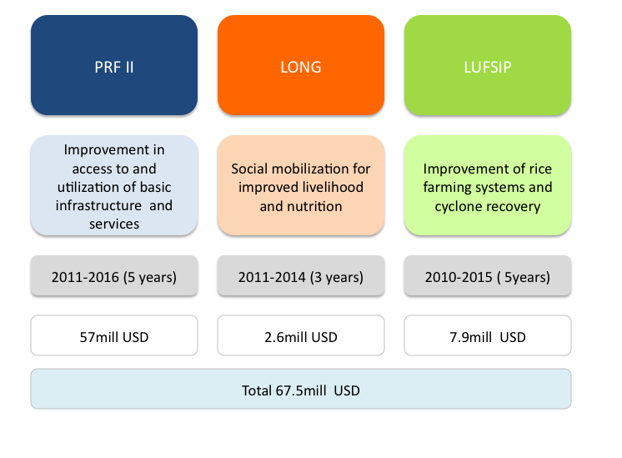

PRF-LONG would be part of PRF’s country program (see Figure 3) and strategically complements the Poverty Reduction Fund Project. As such, PRF-LONG is seeking to work through the same or adopted institutional and implementation arrangements.
PRF II’s objective is to improve the access to and the utilization of basic infrastructure and services for the targeted poor communities in a sustainable manner through inclusive community and local development processes in 10 Provinces. PRF II mainly focuses on providing:
Grants to communities for the financing of small-scale public infrastructure;
Training for communities and local government officials in the identification, planning, implementation, supervision and monitoring of community and local development investments.
PRF-LONG is also aligned with the Lao Upland Food Security Improvement Project (LUFSIP). Component 3 of LUFSIP is implemented by PRF (while the rest of the project is implemented by the Ministry of Agriculture). LUFSIP’s objective is to contribute to improved food security of rural households in selected poor villages in upland areas in the Project Provinces by demonstrating and implementing improved rice-based farming systems, and address recovery needs of cyclone-affected households in the Xekong, Saravane and Attapeu provinces.
Activities with strong synergies to LUFSIP can include:
Support to conservation agriculture stations and seed multiplication centers - improvement of soil fertility through conservation agriculture approaches;
Strengthening the capacity of public sector to produce high quality crop and forage seed;
Support to Improved Farm Systems for Food Security;
Support for investments for small community infrastructure in upland areas.
Through social mobilization, devolving of decision making and SHG formation the LONG project will trial to establish community driven development platforms at village level. Figure 4 shows how the CDD platform is linked across sectors suitable to accommodate small-scale infrastructure development, delivery of basic social services (PRF I and II), as well as social mobilization for improving livelihoods, well-being and nutrition (LONG).

Figure 4. The Lao CDD Platform for Improving Livelihoods, Well-being, and Nutrition
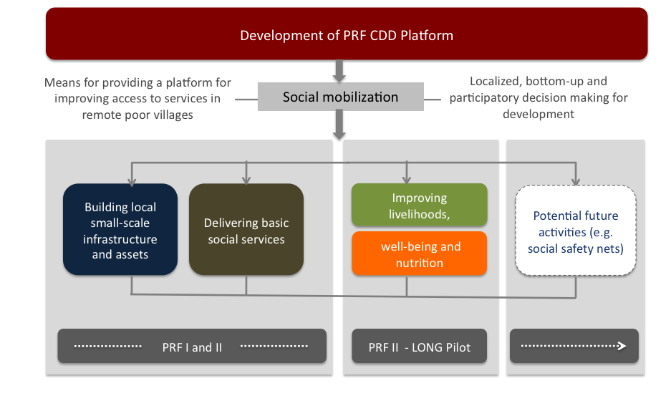

LONG Key Elements
Key elements of PRF-LONG’s Community Driven Development approach will feature:
Strong village institutions: Through social mobilization villagers’ own self-help potential and willingness for change will be identified, enhanced and organized. As a result, a transparent village CDD platform - an organization of committed, pro-active and visionary villagers - will be formed that is closely aligned to GOL authorities. The village CDD platforms will be managed by the villagers and each member of the village will have access to and the opportunity to know what is happening in/around those platforms.
Full community control over financial resources: In order to effectively enhance people’s participation and influence in local decision-making, LONG grants for improved livelihood and nutrition are directly provided to the villagers through Self-Help Group (SHG) bank accounts and not routed through GoL or other agencies.
Community led decision-making: LONG seeks to empower communities to influence local development decision-making and resource use during all steps of operation: planning, implementation and monitoring and evaluation.
Co-management of community natural resources: LONG seek to enhance sustainable co-management of natural resources including the enforcement of GOL regulations and laws as well as the full ownership over management of village natural resources (with focus on including land, water, biodiversity).
Figure 5. Key Elements of Community Driven Development Through PRF-LONG
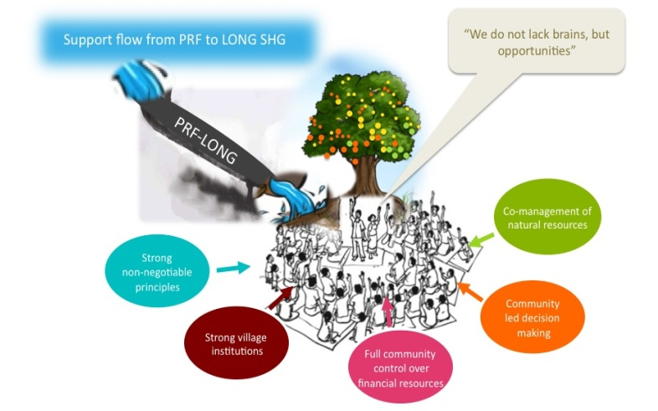
These five key elements are also aligned with PRF’s six core principles that provide the basis for guiding overall program implementation as well as for monitoring and evaluation. The six principles include: Simplicity; Full community-participation and sustainability; Transparency and accountability; Wise investment; Social inclusion and gender equality; Siding with the poor.

Vision of LONG

LONG Vision Statement
The vision of LONG is:
To change people’s lives by coming together in groups to push for ownership and breakthroughs for improved livelihood and nutrition - FOR ALL!
LONG starts from the assumption that the “poor don’t lack brains, but lack opportunities”. This is to build on the idea that villagers are willing to undertake development activities by themselves if they have access to adequate services, finances and technical support.
The overall goal of LONG is to effectively increase opportunities for making villages a better place to live in, mainly through more livelihood opportunities, greater food and nutrition security – especially for mothers and children -, and improved well-being brought about through social mobilization.

LONG Slogan

The LONG slogan is:
Produce well, eat well, and live better – TOGETHER !

LONG’s Actionable Implementation Rules

Community Development Rules
The six PRF operational principles (outlined in chapter 2.2) have been translated into ten actionable community development rules for working with communities on a day-to-day basis. Each village or SHG can expand those rules to their liking.
Any violation of at least one of those rules by any person in the village or PRF, LONG, GOL staff will account for a severe set-back of community development. The LONG sub-project agreement between the project and the SHGs will stipulate that violation of any of those rules can lead to the immediate termination of financial or technical support provided by the project (see also chapter 2.5.3 for sanctions).
The community development and LONG rules will be introduced during step 2 in phase 2 ”Planning” (see chapter 2.5.2) and continuously applied throughout the LONG subproject design and sub-project implementation by the SHG.

Rule 1. Unity (“samakee”)
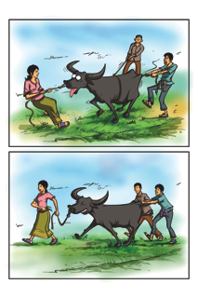

“All of us in the village should work as a team and sacrifice time, money and labor to implement LONG activities”.

Role 2. Equity (“samerphab”)
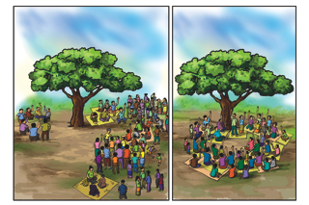
“It is our responsibility to ensure that, all members of the village, especially those who need support the most, like single-headed households and households with low work force, those with low land security or bad land, those with disabled family members, are involved in the community development process and equally share the benefits of development”.

Rule 3. Pro-poor (“hai okat tuk ngak gone”)
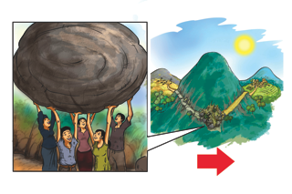
“We must learn to manage our poverty affairs by ourselves in a sustainable manner. We can lift ourselves out of poverty if we get a voice and can better participate in village decision making”.

Rule 4. Women empowerment (“hai xit kae mae ying”)
“LONG provides opportunity to women to come forward and improve their leadership qualities and taking full control over financial and development resources”.

Rule 5. Correct vision (“tong mee vixay that”)
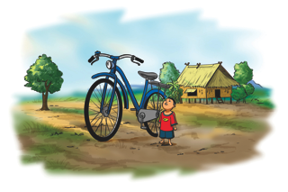
“Development is a gradual step-by-step process and we must plan only what we can afford and successfully manage”.

Rule 6. Bottom-up planning (“vang phaen chak khan ban”)
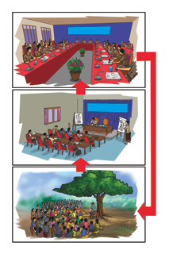

“We prioritize our own development needs and develop our own proposals for our own benefits of us and our future generation”.

Rule 7. Ownership (“kan chao kan”)
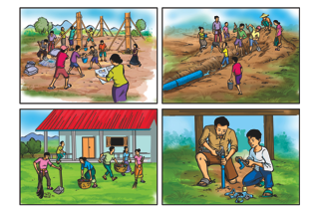
“We have full freedom in our decision-making process and management of financial resources, and hence must be responsible and accountable for all our actions and demonstrate clear ownership”.

Rule 8. Self-confidence/self-esteem (“kuam pen eng”)
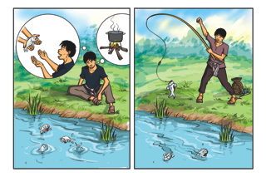
“Let’s be self- reliant to reduce dependence on others and demonstrate leadership to make the village a better place to live in for ourselves”.

Rule 9. Transparency (“kuam pong xay”)
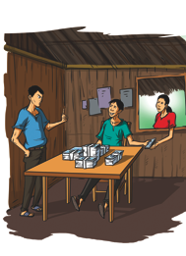
“Everybody should have access to all the information related to LONG development opportunities and activities at any time. Any misuse of LONG grants by anybody in the village shall be immediately reported and punished”.

Rule 10. Wise Investment (“khan long tuen tong kum kha”)
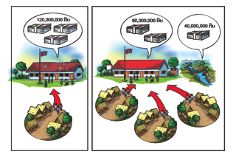
“Treat the grants provided under LONG as our own funds. Realize that, if we can avoid wastage of grant money, we will be able to take up more grants for our SHGs and village”.

Additional Livelihood and Nutrition Rules
In addition to the ten PRF rules, the communities that are part of LONG should also apply two more rules in their sub-project implementation capturing the essence of social mobilization and actionable livelihood and nutrition links.
Rule 11. Community mobilization through self-help groups (“pak dun sum son duay kum ton tua eng”)
“Together we stand stronger. Organized in groups with common interests, we can prove self-help, solidarity and ownership and effectively manage external support”.
Rule 12. Produce for well-being (“parit pua kunaphap siwit”)
“We need to be smart in how we spend our money and resources. We need to think about how the investments and expenditures will help our families’ wellbeing today, tomorrow and in the future”.

Sanctions
During all phases of the project implementation sanctions can be applied. For LONG the same sanctions apply as for PRF (see PRF operation manual, chapter 6.10). This can be the case, if PRF-LONG project objectives are not adhered to or in the event of serious violations of PRF rules or regulations. Sanctions can also be made in cases when members of the SHG have not benefited from participation in LONG as stipulated in the sub-project agreement. Sanctions are aimed at ensuring the accountability of the all stakeholders involved in the management of PRF-LONG activities.
Sanctions can be in the form of:
SHG sanctions: Determined by agreement during SHG meetings with particular reference to the 10 community development and two LONG rules;
Government-imposed legal sanctions: In cases where laws are violated, legal sanctions can be imposed on government officials, PRF staff or consultants, or communities in accordance with prevailing legislation;
LONG sanctions: In cases where PRF guiding principles are violated, funds or authority is misused or there is serious deviation from PRF-LONG procedures districts, kum bans, villages or SHG can be sanctioned in the form of a suspension, temporary or permanent, from further participation in LONG. Any LONG project sanctions must be approved by the Executive Director before they are enforced.
All agreed sanctions must be clearly explained to all stakeholders (including PRF donors), and formally documented in the official minutes from relevant meetings, before they take effect. Notice of any such sanctions must also be publicly displayed on information boards in all kum ban and villages involved in any cases where sanctions are applied.
No consultant or staff hired by the Program is allowed to directly handle any funds provided to a village from the district grant allocation. A staff who does not live in the district, or is often absent from work without prior permission, will be dismissed. Any consultant who is evaluated and considered not to be serving the interests of villagers, especially the village poor, will be dismissed. Village opinions will be considered in making any such decision. Corruption by consultants or facilitators will not be tolerated. This includes lack of action on reported cases of corruption by supervisors or staffs on instances of corruption reported by villagers. Consultants and staffs who do not report suspected cases of corruption are in effect covering up corruption and considered to be in collusion.

Key Expected LONG Outcomes

The expected higher-level outcome from LONG pilot is improved livelihoods and wellbeing of 28,800 households in five poverty reduction priority districts within Huaphanh and Savannakhet provinces. The key expected outcomes of LONG interventions at the end of 4-years implementation are as follows:

60 percent of targeted households adopt improved pro-nutrition livelihood activities;
Decision-making on development of livelihood and nutrition development plans involves at least 50 percent women, and 60 percent poorest community members;
50 percent of the expected 28,800 of direct project beneficiaries are women.

The detailed results framework is discussed in the M&E chapter.

Project Description

Project Objectives
The LONG Project’s objective is to pilot an innovative livelihood focused community driven development (CDD) program in five poverty reduction priority districts within Huaphanh and Savannaketh provinces enabling 28,800 households in rural areas to improve their livelihoods and wellbeing through group-based activities.

Project Components
The project consists of the following four components (see Figure 6):
Formation of community self-help groups and capacity building of local service providers;
Community asset creation for improved livelihoods;
Livelihood-linked nutrition activities;
Monitoring and evaluation of pilot activities.

Figure 6. The Four Project Components of LONG
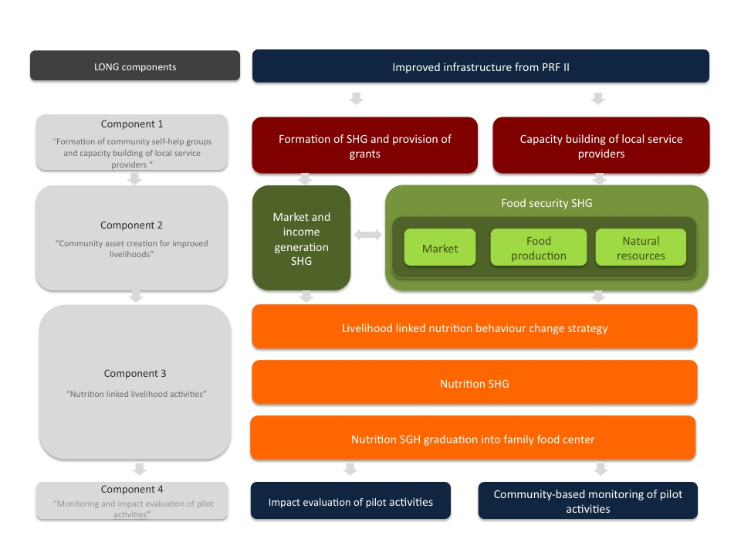

Component 1: Formation of SHG and Capacity Building of Local Service Providers
Component 1’s centerpiece is the formation self-help groups (SHGs), with a specific focus on women’s SHGs in ethnic communities and building the capacity of these groups to articulate their own needs with regard to livelihood and nutrition. SHGs can form as new groups, or can build on already existing groups in the village. Several SHGs can be formed in one village. Through the formation of SHG the institutional and human resources capacities of poor rural communities will be strengthened.
Under this component, recent young graduates will be trained to serve as village coordinators and be deployed to work in the target villages. Finally, the component will build the capacity of local GoL and other service providers. Key themes of the capacity building will include:
Social mobilization;
Financial literacy;
Improving livelihoods;
Improving nutrition and links to livelihoods.

Component 2: Community Asset Creation for Improved Livelihoods
Component 2 will provide grants (maximum of about USD 2,000 each) to eligible village SHGs. Each SHG will receive support in the planning, implementation and sustainability of livelihood activities all of which should be tailored to the specific agro-ecological settings and potentials in the Northern and Southern Zone. This component includes two sub-components:
Provision of input support for production and marketing through grants and community contributions;
Empowering self-help groups through training and technical assistance and sustainability.
Formation of livelihood SHGs: In all villages SHGs will be established around common interests including the following six key themes.
Rice production;
Vegetable, fruit, bean and oil seed production;
Livestock production;
Domestication of NTFPs;
Non-farm income generation;
Marketing of products.
Smallholder farmer organizations will be strengthened through training and technical assistance in:
Increasing household and community food security through adoption of improved agricultural production technologies, including improved varieties of seed and plant material and livestock breeds;
Improving post-harvest handling and value addition at the farm and community levels;
Improving management of community natural resources including conservation of non-timber forest products;
Income-generation activities using resources available locally;
Identifying local and urban markets and fostering market linkages through agribusiness enterprises;
Increasing financial assets and access to finance.

Component 3: Livelihood Linked Nutrition Activities
While increasing income and enhancing food security will be key factors in making nutritional gains, additional direct measures will be required. Component 3 is designed to exploit actionable linkages between livelihood and nutrition improvements through social mobilization and the provision of grants. Activities will aim at improving time economies of households (in particular of women) and to increase the food and nutrient intake through-out the life cycle inclusive of related care and hygiene practices.
This component consists of three sub-components:
Livelihood linked nutrition education (universal activities);
Formation of women SHGs around nutrition and provision of grants (for intensive activities);
Graduation from SHG group into family and food centers and provision of grants (for intensive activities).
Livelihood linked nutrition education: In each target village a universal livelihood nutrition linked behavior change strategy will be implemented – including a fixed event/training schedule. The behavior change strategy aims to increase awareness and capacity around nutrition issues, and their links to livelihood improvement and well-being as well as to seek stimulating demand for intensive activities.
In each target village nutrition center will be established around common interests based upon the following five themes:
Day care (for children under two years of age) and other aspects of time and labor savings;
Food preparation and/or processing;
Own food production (for home consumption or sale);
Wild food collection (for home consumption or sale);
Food purchases (making savings in food expenditures, healthy food choices, shopper groups).

Village Nutrition Center (VNC): In selected villages, where demand in nutrition is high, the VNC will be established. The VNC will be an innovative, self-managed “community hub” (CDD approach as a platform) aiming to initiating positive behavior change through frequent demonstration and practice. Activities at the VNCVNC will build on increased awareness from the universal education measures and the social and financial capital of the nutrition SHG groups, which alone do not suffice to bring about positive behavior change.
The VNC will be a self-managed “community hub” (using the CDD) platform) for:
Discussing nutritional problems and identifying vulnerable households and individuals;
Providing regular meals and child care for pregnant and lactating mothers, children < 2years and vulnerable households;
Demonstration and best practices in food acquisition (own production, wild collection, purchase), preparation and storage;
Income generation activities;
Learning and exchanging information on livelihood, nutrition and well-being;
Quarterly growth monitoring for children younger than 5 years.

Approach
The overall LONG approach towards improved livelihood, nutrition, and well-being features a three-phase development process at the village level (see Figure 7):
Phase 1: Social mobilization;
Phase 2: Improving livelihoods;
Phase 3: Improving nutrition.

Figure 7. Overall LONG Approach
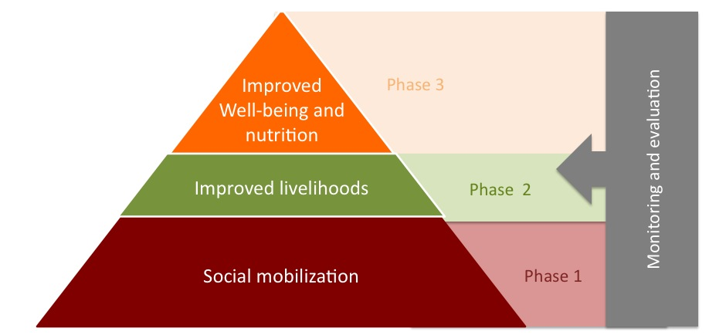

Social Mobilization
The centerpiece of the LONG approach is the mobilization and organization of villagers, in particular of women, in order to enable them to directly participate in the decisions that improve their livelihood, nutrition, and well-being. The social mobilization approach consists of six key elements.
Element 1. Building self-help institutions of the poor
For a true participatory development process LONG aims at building social institutions at village level, in the sense of structures, customs, rules and values that enable villagers to improve their livelihood, nutrition and well-being in ways that are sustainable and just. These social institutions at village level (SHG, VNC and other platforms) will mobilize the resources of the poor (not for the poor). They will build on the platform already in place by PRF.
Element 2. Forming of self-help groups for community organization around common interests
Villagers will form self-help groups consisting of people who are facing similar problems and are committed to helping each other, to solve their problems using a common agenda. Members of SHGs will share their thoughts, experiences, and worries, and elect leaders among themselves for the effective functioning of the group. They will save small amounts of money on a regular basis to build up a group fund and some may start inter-lending. The amount of savings will be decided by the SHG members. The poorest of poor and poor villagers will be given a priority in forming SHGs and receiving grants.
Element 3: Enhancing “voices” and “choices”
Villagers will identify and prioritize what they are willing to undertake themselves. They will be provided with structured opportunities to improve their knowledge and skills and to verbally express and monitor their own development process. This may lead to improved self-reliance, with villagers better able to devise ways to improve their livelihood, nutrition, and well-being.
Element 4. Creating assets for the poor by providing opportunities
Villagers do not lack brains, but opportunities. The giving to villagers of a voice in decision making and support for asset creation will be the first step for helping poor communities help themselves when there are institutional or market limitations in remote rural areas. LONG will facilitate, arrange and secure the flow of required resources and asset support for undertaking identified opportunities.
Element 5. Identifying true and genuine village activists
LONG will identify true and genuine activists and train them as functional specialists in specific fields of livelihood (agriculture, marketing, etc), nutrition, bookkeeping, and other rural development tasks. They can act as guides and role models for other individuals. At a later stage, they can build capacity of newer groups, inside and outside the village. In the long-run, the training and capacity building of village activists on a large scale will help to substitute a large number of paid extension workers.
Element 6. Letting women come forward and to take up leadership roles
LONG will provide opportunities to women to come forward, mobilize poor women into SHGs, improve their leadership qualities, and promote the specific knowledge they have accumulated in their daily routines in fields, forest, marketing and their kitchens. LONG will integrate gender dimensions throughout the project cycle, capacity building activities, IEC materials, organization and structure, and other aspects of program implementation, and reflect these accordingly in the community, too.

Figure 8. Social Mobilization for Improving Livelihoods and Nutrition

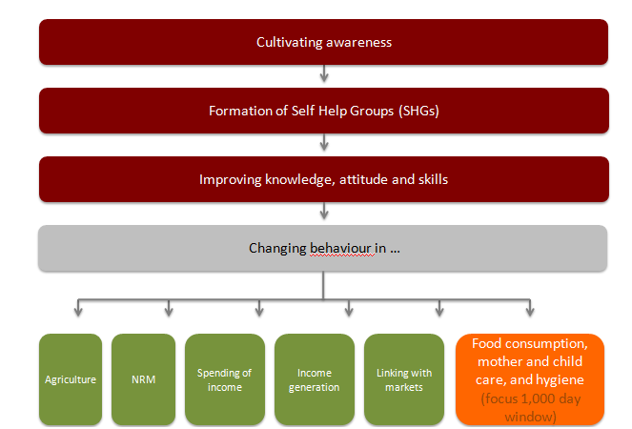

Realizing benefits from social mobilization for positive behavior change will not materialize automatically, but will need to be designed in four sequential steps (Figure 8):

Step1: Cultivating awareness around CDD, livelihood and nutrition and their actionable linkages;
Step 2: Improving knowledge on and attitude towards good practices in livelihood and nutrition and related benefits;
Step 3: Group formation around common livelihood and nutrition interests;
Step 4: Initiating positive behavior change in daily routines (including agricultural production, natural resource management, income generation and expenditures as well as food consumption, related care and hygiene practices).

Improving Livelihoods
The provision of grants to eligible village SHGs will be facilitated through strong, bottom-up support in planning, implementation and sustainability of nutrition linked livelihood activities. The livelihood approach towards improved land- and water-based production for food security and income generation consists of six key elements:
Element 1. From rice security towards food security and balanced diets
In the past, food security has been narrowly defined as rice security. In contrast, PRF-LONG has a broader definition of food security that includes having physical, social and economic access to sufficient, safe, and nutritious food that meets dietary needs and food preferences. LONG will promote the production of a diversity of healthy and safe food products that leads to a more active life, with any surplus being sold for cash.
Element 2. Increasing assets and capital
LONG will support increasing assets as well as human, social, financial, physical, and/or natural capital. Its key instrument is the provision of SHG grants – directly transferred to SHG accounts – and increased access to financial capital through regular savings and inter-lending.
Element 3. Improving agricultural productivity and sustainability
Increasing production (e.g., yield, number of animals, volume of fish, number of trees, etc.) will improve household food security, with any surplus being bartered in the community or sold for cash to traders or in local markets. Enhancing agricultural productivity and sustainability shall be achieved through agricultural diversification in order to minimize risks to livelihoods, improved breeds of domestic animal/improved seeds/stock for plants as well as through the application of post-harvest technologies to retain maximum value-added yields at local level.
Element 4. Income generation
Means for increasing income will include the diversification of both on- and off-farm income linked to marketing opportunities, the production and sale of healthy meals and snacks, the production through SHGs (group selling, quality control) for higher prices of commercial crops and the generation of a critical mass of agri-food products to attract traders.
Element 5: Natural resource management
A focus to sustain a natural resource base for future household and income security will center around improved management of forest, agro-biodiversity and water resources through co-management and the domestication of NTFPs for consumption and sale to avoid overharvest. Arrangements will also be made to manage roads build under PRFII to contain the extraction of illegal timber and wildlife resources.
Element 6: Mitigation of any potential impact from livelihood changes on food and nutrition security
It will be necessary to minimize any potential downsides from new livelihood opportunities to avoid any adverse impacts on food and nutrition security (e.g. avoiding that increasing women’s time to generate income may negatively affect child care or household food security). Livelihood linked nutrition education and the introduction of labor saving measures could prevent such downsides.

Improving Nutrition
Changing daily routines and dietary practices are not easy and time consuming. The overall nutrition approach features five key elements, which are inter-linked:
Element 1: Family profiling around nutrition issues for effective targeting and ownership
Women will jointly analyze nutritional problems in their village (what problems do they have, who is most effected, what impacts, what are causes, what are livelihood and nutrition links) and identify vulnerable families and women who are pregnant, lactating and mothers with children under two years of age.
Figure 9: Life Cycle Approach of LONG – Focus on 1,000 Day Window Between Pregnancy and Age of Two Years
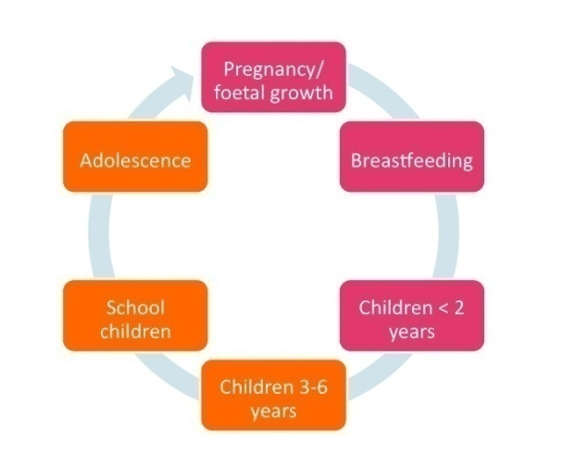
Element 2: Improving time economies of mothers
Key elements for maximizing time economies of households will be centered around women’s daily routine and exploit opportunities for day care for children under two years of age and the utilization of labor saving devices. During pregnancy and breastfeeding women could engage in light income generation activities at the VNC instead of doing hard labor in fields and forest.
Element 3. Improving food and nutrient intake and related care and hygiene throughout the life cycle
For highest returns in nutrition outcomes LONG will aim at improving food and nutrient intake as well as care and hygiene practices during most vulnerable periods of the life cycle: pregnancy, breastfeeding, children under the age of two years (see Figure 9). In addition, special focus will be given on school children (as young and dynamic change agents for influencing parents’ knowledge, attitude and practices) and adolescent girls (who will be future mothers and are in need to cope effectively with livelihood transition due to loss of local knowledge and lacking opportunities to acquire new skills and capacities).
Element 4. Learning to produce, collect and purchase foods in response to dietary gaps
Women will be trained in identifying dietary gaps (what is missing in their diets) and learn about potentials to close these dietary gaps, including the improved access to and availably of foods (what foods do villagers have to eat more and where can they source it from). Where indicated and culturally accepted new food items will be introduced into local diets (e.g. beans in villages in which access to and availability of wild and domestic meats and eggs is low and livestock intensification may take a long time).
Element 5. Regular practice and joint learning
At the VNC, women will come together on a regular basis and benefit from demonstration and practice and discuss and exchange information with peers. Fostering good practices (at VNC) will be the key factor in sustainably increasing and diversifying people’s food and nutrient intake and a precursor for initiating behavior change at home at a later stage. For effective capacity building and remote trouble shooting usage of IT will be trialed.

Scaling-up in Three Phases
Figure 10. Phasing of the LONG Pilot
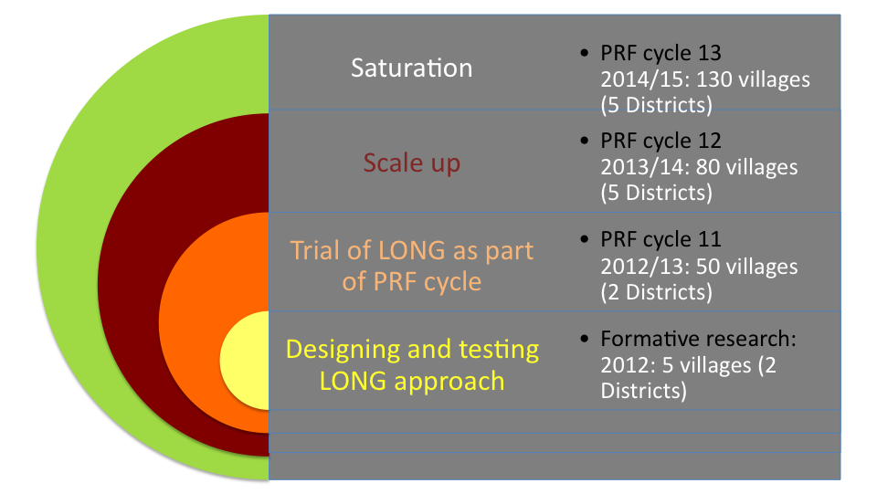

Firstly, through a period of formative research in five villages in two Districts (four villages in Viengthong District in Houapanh Province and two villages Sepone in Savannakhet Province) the LONG approach will be designed (including the field tool kit), field tested and evaluated.
After this the LONG pilot will be scaled up in three phases.
Year 2012/2013: Trialing LONG model as part of PRF cycle in 50 villages (in 8 kum ban and 2 Districts), including formative research in 6 villages;
Year 2013/2014: Scaling up to 80 villages (in 12 kum ban in 5 Districts);
Year 2014/2015: Saturation in 130 villages (30 kum ban 5 Districts).

Long beung - Formative Research
All steps of the LONG project cycle will be field tested through a small formative research programme (long beung phase). The overall objective of this field test is to verify and modify all steps and processes of the cycle in a sequential manner in five villages of key ethnic groups (Khamu and Hmong in Houapanh Province, Makong/Tri in Savannakhet). On a timeline, the formative research villages will be about 3-5 months ahead.
More specifically, the formative research aims at:
Testing all activities, methods and tools (including IEC tools) of all five implementation phases with a specific focus on: performance of staff, utilization of tools, levels of acceptance and understanding by villagers, feasibility, completeness and effectiveness;
Identifying needs for changing and/or updating activities, methods and tools (including IEC tools) before expanding to larger group of villages;
Providing useful guidance for project management and for the development of a system for remote trouble shooting;
Providing first insights into the impact chain and mechanism, which will determine success or failure;
Identifying differences between cultural settings and locations and mainstreaming activities, methods and tools into a best-fit tool-kit (e.g. considering different dietary practices related to different taste preferences);
Enhancing understanding of community needs and perceptions;
Identifying training needs and updating the capacity building plan (in-service trainings);
Reviewing results framework.

Key questions which will drive the formative research program will be:
What works – and why (what are the success factors)?
What does not work – and why (what are the bottlenecks)?
What methods, activities, and tools do we need to change before scaling-up?
Does the team set up and management mechanisms need to be changed?
Will we be able to reach the expected results with current activities, methods and tools?
Involving all key stakeholders, namely villagers, local service providers, PRF/donor in the assessment will be essential to allow for triangulation of information. What may work from a local service providers’ perspective may not be acceptable from a community or donor perspective and vice versa. The methodology for the formative research can also be used to gauge potentials for effective community monitoring and potentially later on for the development of score cards.
The outcome of the formative research will be lesson learned and an adopted approach and toolkit which can be regarded as the draft LONG model brought to scale in more villages (see Figure 10). This will be a “best-fit” methodology for reaching different ethnic groups and ensure that the information and messages imparted are appropriate and help to achieve the anticipated results. Final tools shall be user-friendly, easy to use and meaningful in the local community context.

Overview of Field Implementation

Annual LONG Cycle
LONG features the same five phases as the PRF II cycle (Figure 11). These are:
Phase 1: Orientation;
Phase 2: Planning;
Phase 3: Social mobilization, LONG sub-project design and appraisal;
Phase 4: Livelihood and nutrition LONG sub-project implementation by SHG;
Phase 5: Community monitoring (note: in PRF focus is on total M&E).
Steps and activities in PRF II mainly focus on improving and increasing access to small-scale infrastructure and basic services and can be planned according to a fixed schedule. The steps and activities in LONG will be mainly demand driven and of more flexible nature.
During the course of the LONG pilot it will be important to explore how LONG steps and activities can be effectively incorporated into the PRF II cycle for the long-term. For example, the CDD, livelihood and nutrition sensitization could be incorporated into the PRF II village orientation at a later stage.
As described in chapter 3.4, in PRF cycle 11 a joint PRFII-LONG model will be tested. Steps and activities for which actionable linkages between PRF II and LONG are not possible, sub-steps for LONG can be introduced. This may be the case for time and technical intensive activities (e.g. the setting up of SHG, their formalization and developing by-laws, rules and regulations). The main aim of joint PRF II and LONG implementation arrangements will be to align the five cycle phases and explore synergistic, cost-effective role out where sensible and feasible.
The important and time taking tasks are divided over 12 months period and fixed in a cycle for easy project implementation and organizing trainings and monitoring purpose. The LONG staff at the ground can develop work plan according to this timeline. See annex [X-INSERT LONG 12 months interval graph as annex]
Figure 11. Phases and Steps of LONG Field Implementation
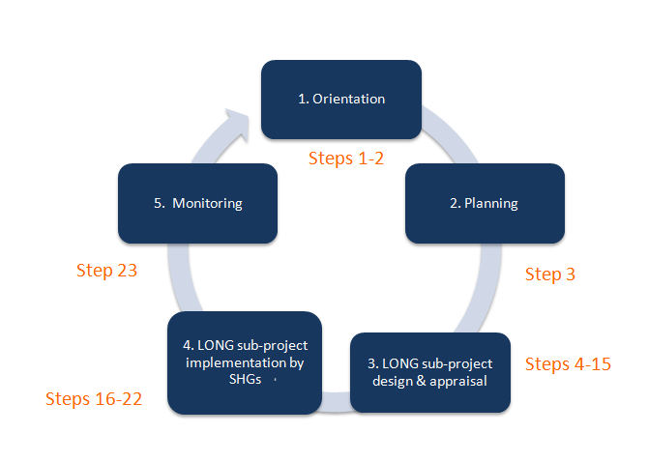

LONG’s 5 Phases and Key Steps

This section describes the five phases in details, including the different steps that are included in each phase which consists of 23 steps and 9 milestones (M) all together.

Phase 1: Orientation
Phase one consists of one key milestone and two steps.
Milestone 1: Setting the scene at the District and Village levels
Step 1: The first step is an inception workshop with all PRF-LONG staff and concerned GOL staff and stakeholders from Provincial, District and kum ban level. The orientation of LONG will take place during this workshop.
Step 2: The workshop will be followed by an inception meeting at the village level that includes an orientation, introduction, and sensitization (on CDD, livelihood and nutrition) of the LONG project.
Poverty ranking and POPs identification will take place during this meeting. In addition, the convergence with PRFII and the creation of a village development history based on a consensus of key stakeholders will be explored.
Phase 2: Planning
Phase 2 consists of one key milestone and one step:
Milestone 2: Conducting participatory rural appraisal
Step 3: Participatory Rural Appraisal (PRA) will be used as a planning tool to identify specific livelihood and nutrition links within the socio-economic and agro-ecological conditions prevailing in the village. The outcomes of this PRA shall include a clear picture of social mapping and poverty ranking of all households, seasonality analysis of livelihoods, food availability, trends on food availability, village project history. Venn diagram shall be used.
Phase 3: LONG sub-project design and appraisal
Phase three consists of five milestones and12 steps, namely:
Milestone 3: Mobilizing the poor into SHGs
Step 4: Firstly, the SHGs will be formed around affinity with a focus on POPs. The SHGs will meet to deepen their vision for SHG formation with support from PRF facilitators (but only as required). The SHGs will receive a first basic orientation in SHG group management necessary for sub-project development.
Step 5: Training to SHGs leader
Step 6: Promotion of savings, facilitation of SHG meetings by village coordinators (VC) and pre-requisites
Step 7: Training to SHG book-keepers
Step 8: Promotion of internal lending among members from savings fund available
Step 9: Poverty ranking of SHG members
Milestone 4: SHG evaluation
Step 10: SHG evaluation (after four months)
Milestone 5: Design of sub-projects
Step 11: Formation of SHG Village Association, precursor is called Village SHG Management Committee (VSMC)
Step 12: Training on family investment plans (FIPs) and revolving fund concept (include prioritization of eligible members of group for first loan)
Step 13: Design of FIPs (part A of sub-project proposal)
Step 14: Design of Community investment plan (part C of sub-project). This step also includes setting up of committee for VNC and preparation of part C on VNC.
Milestone 6 & 7: Appraisal and fund release
Step 15: Presentation of FIPs and VNC in Village SHG Management Committee (VSMC) meeting. Sub-project implementation committee and sub-project finance committee will be formed.VSMCVSMCVSMCVSMCVSMC
Phase 4: LONG sub-project implementation by SHG
Phase four is the core of LONG’s field implementation through a sequence of one milestone and seven steps, including:
Milestone 8: Implementation of sub-projects
Step 16: Sub-project proposal by VSMC-preparation and submission to PRF (District)
Step 17: District coordination meeting-feasibility and viability of FIPs by concerned line ministries.
Step 18: Sub-project approval by PRF, sub-project agreement and transfer money to VSMC (Vientiane->District->VSMC). Initiate transaction based software.
Step 19: Training sub-project implementation committee and sub-project finance committee.
Step 20: Training to beneficiaries on sub-project activities (part B of sub-project proposal) including training to VSMC committee and focal person).
Step 21: Sub-project activities implementation (part A+ C): FIPs and VNC including training (part B)
Step 22: Repayments (part A+C)
Phase 5: Monitoring
The last phase has one milestone and one last step
Milestone 9: Community monitoring
Step 23: The last phase is simply held monthly VSMC meetings for sub-project monitoring and accountability meetings. SHG exchange visits can also be organized during this phase to encourage knowledge exchange and lessons learned.
Figure 12: SHG Structure and Implementation

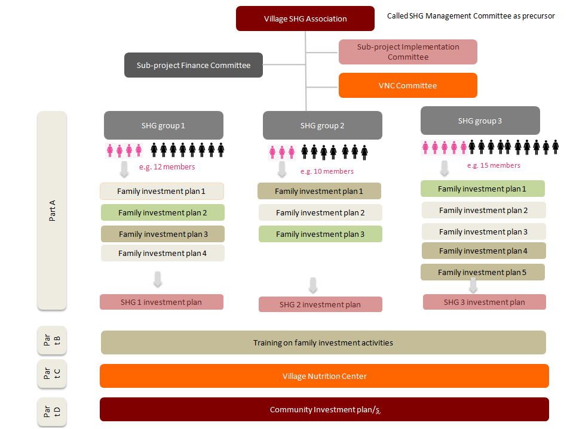

Training of Trainers

Trainers will be trained by subject matter specialists external to the project to assist with the implementation of the different steps.
Figure 13 gives an overview of the key themes of the trainings of trainers (TOTs). Overall, there are five key indicative training blocks. Curriculum, syllabus, training modules, technical guidelines, village implementation guidelines, forms and IEC for each theme will be developed and/or finalized during the formative research period. Changes to the TOT blocks may be considered necessary during field implementation.
Phase 1: Orientation
TOT 1.1: LONG orientation, nutrition and gender trainings (1)
Phase 2: Planning
TOT 1.2: PRA with focus on livelihood and nutrition links of POPs and poor.
Phase 3: LONG sub-project design and appraisal
TOT 2: Mobilizing the poor into SHGs which includes the following training topics:
-Formation of SHG
-Training to SHG leaders
-Savings and conducting meetings
-SHG bookkeeping
-Internal lending methodology
-Poverty ranking of members in SHG
-SHG evaluation
-Nutrition & gender training (2)

TOT 3: Design of sub-project and nutrition & gender training (3) which includes the following training topics:

-Formation of Village SHG Management Committee
-FIPs and revolving fund concept
-Design of FIPs (part A)
-Design of CIP (setting up VNC committee and preparation of part C)
-Presentation of FIPS and VNC in SHG-VSMC
-Nutrition & gender training (3)

Phase 4: LONG sub-project implementation by SHG
TOT4: Training on sub-project implementation activities, monitoring and evaluation. This also includes nutrition and gender training (4).
Phase 5: Monitoring
TOT 5.1: Social mobilization: Community monitoring
TOT5.2: SHG exchange visits
TOT 5.3: Nutrition and gender training (5)

Figure 13: Overview of Indicative TOTs
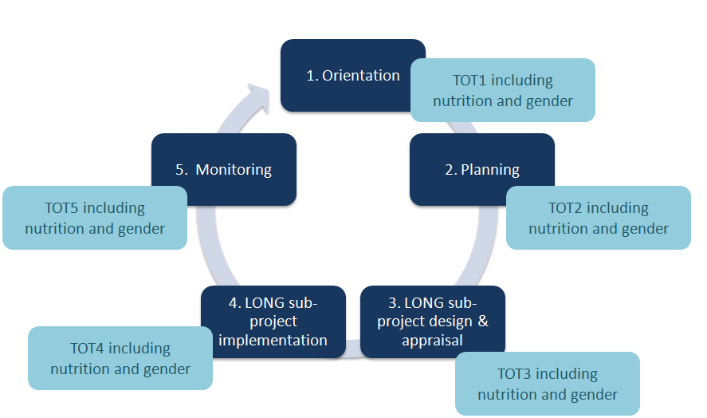

The curriculum and syllabus for each TOT will feature six key topics:
Review of previous steps and activities implemented in the field (indicative review framework and guiding questions can be adopted from the set of questions for the formative research, see chapter 3.5);
Discussing and documenting actionable recommendations for the next cycle;
Providing technical background knowledge for the next field steps and activities;
Training on implementing next field steps and activities (including objectives, expected outcomes and usage of IEC materials);
Field testing next steps and activities in 1 or 2 villages and fine-tuning methods, activities and tools;
Implementation arrangements for roll-out.
During the course of the formative research, training curricula, manuals, village guidelines, forms, protocols for field implementation will be developed and tested. The curricula and syllabi for the trainings will refer to key components listed in TOTs.

Detailed description of PRF-LONG Field Implementation
Building on chapter 4, this chapter provides a detailed description of the different steps and TOTs of implementation of the LONG project at the field level (see Figure 14).
Key features of the five phases are presented in a summary table at the end of each chapter.
Figure 14: Overview LONG Project Implementation Cycle
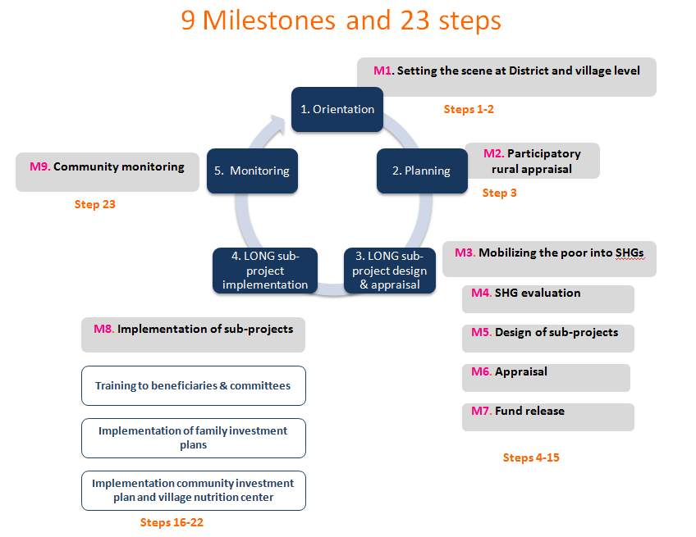

Figure 15: LONG Field Implementation with 23 Steps in Details

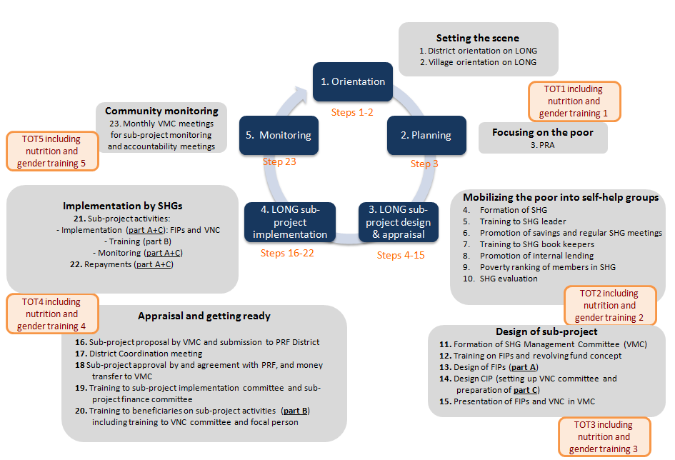

Phase 1: Orientation

Phase one consists of two key steps:
Step 1: LONG inception workshop;  Step 2: LONG orientation, introduction ,village history,CDD, livelihood, and nutrition sensitization. | 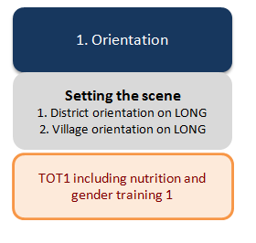

 | Phase 1 “Orientation” |  | Step 1: | LONG inception workshop (or annual update meeting)

LONG will be launched with a two-day inception workshop facilitated by the PRF-LONG team. Participants will include PRF-LONG staff (all levels), GOL staff from provincial, district and kum bans and key stakeholders, including other development partners active in the same districts and kum ban.
The main objectives of this workshop are:
To review local development challenges to sustainable rural livelihood development and improved nutrition and the potential to mobilize local resources using a CDD approach;
To introduce and promote the LONG project including vision, expected outcomes, approach, key steps and activities;
To start effective cross-sectoral coordination among concerned line agencies and in consultation with all relevant stakeholders;
To identify concrete partnerships as well as synergistic delivery channels.

The LONG project will formulate direct responses to the development challenges identified during the workshop, in particular towards:
To reduce persistent high levels of poverty, focusing on remote areas and among non-Lao-Tai ethnic groups despite strong aggregate economic growth (see 7th NSEDP);
To facilitate rapid transitions in upland livelihoods to decrease rising inequalities (see Agricultural Development Strategy 2020);
To decrease persistent and high levels of malnutrition (see Nutrition Policy 2020);
To exploit potential capacity for social mobilization (see the Resolution of the 9th Party Congress).

The LONG project will support implementation of GOL’s policy through:

Applying changes set forth in the 7th National Social and Economic Development Plan (7th NSEDP) and the four Breakthroughs stated in the Resolution of the 9th Party Congress;
Strengthening village and kum ban institutions;
Supporting development of market-oriented products;
Sustainability of economic development along with cultural and social progress, while preserving natural resources and protecting the environment;
Working towards increasing household food and nutrition security.
After the workshop, all participants are expected to have the same level of understanding of the LONG project with its innovative CDD approach for improved livelihood and nutrition. PRF-LONG project staff and GOL officials will fully understand their roles and responsibilities. In districts that have participated in PRF-LONG for at least one year, the inception workshop will be replaced by an annual one-day update meeting for the purpose of reporting on progress during the previous year and of discussing any necessary changes or modifications to the LONG activities, methods, tools and regulations.

 | Phase 1 “Orientation” |  | Step 2: | LONG orientation, introduction ,village history, CDD, livelihood, and nutrition sensitization

LONG Orientation and Introduction
Villagers will be oriented and introduced to the LONG project through a half day village meeting (followed by an overnight stay). The objectives of the LONG orientation and introduction are:
To clarify project objectives, outcomes and key activities through presentation and Q&A sessions;
To familiarize villagers with their rights, roles and responsibilities;
To acquaint villagers with LONG’s innovative approach and household benefits.
Each household is invited to participate in the village meeting to introduce the LONG project to communities (both head and spouse) facilitated by the young graduates and PRF-LONG staff. During the meeting villagers also will be informed about the mechanism to redress grievances during all project stages.
LONG History
After the meeting the villagers will decide on which authorities and group of households shall continue to work together and explore, analyze and document the history of village development (ideally a groups of 6-8 villagers, including both women and men). The village history will be conduced the subsequent day (half-day morning session).
The investigation will focus on previous project activities, methods and outcomes (what worked and why as well as what did not work and why). The identification of existing SHGs will help villagers to understand that they already practice “self-help” and help the staff to identify potentials on which to build.
The main objectives reporting the village development history are:
To understand the development history of the village (including potentials and/or barriers for the LONG project);
To identify and document existing SHGs, their activities, and results;
To identify first potentials on which the LONG project could capitalize;
To avoid making the same mistakes during LONG as previous projects.

CDD, livelihood, and nutrition sensitization
In order to have a focused, effective and sensible PRA, communities need to be sensitized to the potential for CDD, livelihood and nutrition, for which an interactive one-day sensitization session at village (preferably two half days with overnight stay) will be facilitated by the young graduates and PRF-LONG staff.
The main objectives of the CDD, livelihood and nutrition sensitization are:
To raise awareness about nutritional and livelihood problems and their dual linkages (in particular between nutrition-agriculture, nutrition-natural resource management, and nutrition- income growth);
To raise awareness to the lack of community organization and missed opportunities;
To comprehend the potential benefits from CDD and rising interest in participating in LONG.
Graphics: LANN training material
Figure 16: Example Visual Aid for Nutrition Sensitization
TOT 1 for young graduates and PRF-LONG staff will train on the proper facilitation of the LONG village introduction, the village history, and the sensitization sessions on CDD, livelihood and nutrition. This includes the appropriate usage of visual aids (e.g. banners on LONG vision, rules, menu-list), and the facilitation of games and exercises to explain and demonstrate the benefits from self-help group formation (around the theme “united we live, divided we die”). Key steps will be outlined in VIG 1, 2 and 3 (see Table 1).

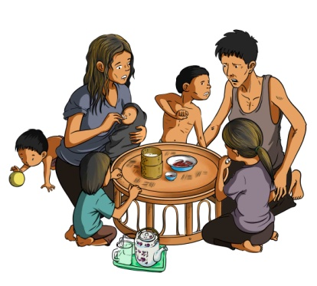 | 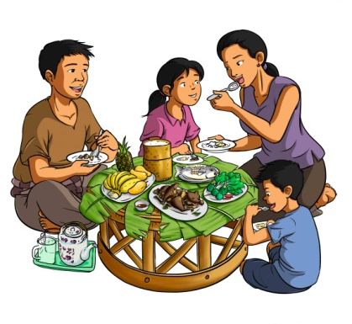

A summary of phase 1 is provided in Table 1.
Table 1. Summary Phase 1: Orientation
2 Steps/activities (A) | TOT/components (C) | IEC materials | Village implementation (VIG) and technical guidelines (TG), forms
Step 1. LONG inception workshop  A1: Inception workshop (or: annual update meeting for previous/on-going districts) | -- | LONG banners (LONG vision, LONG rules, menu-list, etc), PRF banners (e.g. community development rules) film/video, etc. | - LONG project brief (PowerPoint)  - LONG POM (in English and Lao language)  - LONG glossary for field staff
Step 2.1. LONG introduction and village history  A1: TOT for YG/PRF/GoL at D  A2: LONG introduction and village history at V/KB/D | TOT 1 “LONG Orientation”  C1: LONG project introduction  C2: Village history  C3: Nutrition brief  C4: Livelihood brief  C5: CDD brief | Same as above | - VIG 1 “LONG introduction”  - VIG 2 “Village history”  - Village history form  - LONG glossary for field staff
Step 2.2. CDD, livelihood, and nutrition sensitization  A1: TOT 1 for YG/PRF/GoL at D  A2: Sensitization in V |  | Same as above | - VIG 3 “CDD, livelihood and nutrition sensitization”  - LONG glossary for field staff

Phase 2: Planning

Phase two consists of one key step:
Step 3: Implementation of livelihood and nutrition focused PRA. At this stage the PRA tool will focus on assessing and recording poverty ranking of the villagers in order to identify POPs and poor as the target beneficiaries | 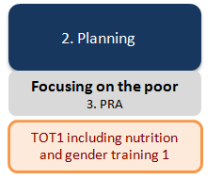

 | Phase 2 “Planning” |  | Step 3: | Implementation of livelihood and nutrition PRA focused on POPs and poor HHs

The planning phase starts with a one or two day focused PRA that will identify and clearly understand the nutrition situation of the village as well as identifying pregnant women and lactating mothers during the 1000 days window. The PRA will focus strongly on wealth ranking to identify POPs and poor households.
The PRA will be facilitated by the young graduates and PRF-LONG staff. All households in the village are invited to participate (both heads of household and spouses), 50 percent of the participants will be women. A focus should be given to ensuring that the most vulnerable households also are participating.
The main objectives of the PRA are:
- To identify key livelihood and nutrition problems (and their links);
- Identify POPs and poor HHs using social mapping tool
Key activity will be conducted in separate women and men groups.
Social mapping and wealth (poverty) ranking of all households (if not done already in PRF project):
- This is required to identify and target the poorest of the poor households and poor households in the SHGs.
- The households in the village shall be identified into 3 categories: i) Poorest of the poor, ii.) Poor, iii.) Non-poor.
- The mapping exercise shall be facilitated in such a way that the villagers would identify the criteria for each of the above category in their village context and accordingly identify and rank all the above households into above three categories. Once a category is assigned to a household all the families in that household shall be assigned the same category.
- The following exclusion criteria shall be facilitated for identification of ‘not so poor’
- Households having a tractor or car
- Households having a house with brick walls plus permanent roof
- Households having rice for the whole year (Kinkum)
- The pregnant women and lactating mothers and mothers having children less than 2 years also shall be identified for the purpose of taking special nutrition interventions for them.

Seasonality analysis of livelihoods:
- This is required to understand the livelihoods in the village and the accessibility issues
- By end of the exercise we will know who is depending on what livelihoods, who has rice fields who has no rice fields, NTFP status, month wise or season wise variations in livelihoods etc.

Seasonality analysis of food availability:
- This is required to understand the availability of the food and vulnerabilities in the access to quality food in different months/ seasons.
- This will also enable the community and facilitators the coping mechanisms being adopted by various households in food off seasons.

Trend analysis on food availability:
The facilitator will facilitate some old people among community to share the knowledge of how certain varieties of food was abundant in their generations and how they are depleted now and the reasons for depletion etc.
Nutritional mapping (need to be discussed in more detail):
- Knowledge, attitude and practices around maternal and child nutrition (focus group discussions)
- Inventory of traditional recipes
- Simple inventory on vegetables, fruits, beans/peas, oil seeds planted, eaten and sold
- Simple inventory on wild tubers &roots, leaves, shoots, fruits, flowers, nuts, etc harvested
- Shop inventory (foods sold at village shops, profits, etc)

Venn diagram on institutions working in the village and their relationship with communities:
- The Venn diagram will enable the community and facilitators to understand the relations between community and various other institutions like Village authority, Lao women union, Kumban authority, district authority, banks, NGOs, MFIs if any etc.
- The Venn diagram also enables us to understand the importance and accessibility of the institutions, services and organizations

Village Project History:
- The village project history would make the facilitators to understand what projects worked previously and working now. The successes and failures of those projects can also be analyzed in this exercise.
- The objectives and outcomes of each of the projects/programs shall be analyzed in this exercise.

On household wealth ranking (criteria defined by villagers) and subsequent pro-poor prioritization;
The result of the PRA wealth ranking will be an input into the SHGs training and formation.

A summary of phase 2 is presented Table 2.
Table 2. Summary Phase 2: Planning
1 Step/activities (A) | TOT/components (C) | IEC materials | Village implementation (VIG) and technical guidelines (TG), forms
Step 3. PRA  A1: TOT for YG/PRF/GoL at D  A2: PRA with Village | TOT 2 “PRA with focus on livelihood and nutrition links”  C 1: PRA-Wealth ranking  C 2: Livelihood and nutrition links  C3: Results and documentation POPs and Poor HHs | LONG banners, PRA visual aids | - VIG 4“PRA with livelihood and nutrition focus”  - PRA report template  - LONG glossary for field workers

Phase 3: LONG sub-project design and appraisal
Phase three on LONG sub-project design and appraisal, consists of 12 key steps:
Step 4: Formation of SHG;  Step 5: Training to SHG Leader;  Step 6: Promotion of savings and regular SHG meetings;  Step 7: Training to SHG book-keepers;  Step 8: Promotion of internal lending;  Step 9: Poverty ranking of members in SHG;  Step 10: SHG evaluation  Step 11: Formation of Village SHG Management Committee (VSMC)  Step 12: Training on FIPs and revolving fund concept  Step 13: Design of FIPs (part A)  Step 14: Design CIP (setting up VNC committee and preparation of part C)  Step 15: Presentation of FIPs and VNC in VSMC. |  |  |  | 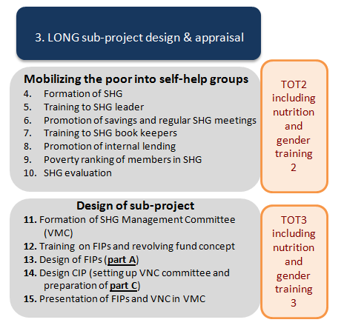
 | Phase 3 LONG sub-project design & appraisal” |  | Step 4: |  | Formation of SHG

Following the identification of the POPs, poor and not so poor households in the PRA exercise using social mapping tool, the POPs shall be covered in the SHGs in the first instance as priority. The groups maybe organized keeping the POPPS in the center of the process. The facilitators shall meet the POPs at their house and interact with them in person and motivate them to join in the groups of their choice to derive the benefits from the project. The POPs shall be encouraged and assured that they can save and participate actively and take up some economic activities to improve their livelihoods. In cases, in which a household of the POPs cannot afford to save, savings in kind may be trialed (a hand-full of rice per each day of the week, the total amount of which can be sold)
The objective of the project is to reach the target families through SHG making the family the central operational unit of LONG. Hence one member of the family only be able to join a SHG. The definition of the family may be taken here as a couple wife and husband or a single woman or single man if they are still unmarried having an age more than 25 years. A widow is considered as one family for this purpose. More families may live in one house like wife and husband and son and daughter-in-law, daughter and son-in-law etc
Married girls of age more than 15 only shall be treated as family. The married girls having age of less than 15 years shall not be covered as family for this purpose. They also shall not join in the SHGs. This will reduce the further burden of savings and loans from SHG on these child girls.
- Women only groups shall be strongly promoted. If a condition like only women shall join in the SHGs then men may naturally opt out of the groups and women are automatically included in the groups. If we allow mixed groups many husbands may don’t allow their wives to join in the groups on the pretext that their wives are busy looking after children etc and they join in the groups and this becomes a hindrance to achieve women empowerment. In mixed groups the participation of women is likely to be limited. As per many of the customary rules, women tend to look to men in decision making.
- Men shall be actively encouraged to participate in all the training activities and education programs taken up in the process of enhancing the livelihoods of the target households. Men can also form men-only groups. Yet, across the world the women SHGs are proved more successful when compared to men groups or mixed groups. Two-third of all SHG members per village shall be women

- If both wife and husband become members of different groups, will create confusion whether women member in a group should be facilitated the Family investment plan or husband who is in other group should be facilitated. Hence this restriction of either women or men groups also saves the time and energies of the facilitators and also saves the limited resources of the project. This also enables to do planning process of family investment plans considering one family investment plan for one family.
- In exceptional cases, in which women explicitly wish to have a male member joining the SHG (e.g. the man possesses a motorbike or other useful assets for livelihood improvement) mixed groups are allowed.
- Two adults out of two families but one household can join the same group or different group. For example, the mother-in-law may join one group and the daughter-in-law may join another group or both of them may join the same group.

SHG – formation - norms
- The groups shall be formed based on the following criteria
- Affinity ( similarity and mutual liking)
- Same social and economical status
- Living in same locality
- The ultimate criterion is self selection of the individual and the group.
The group shall not be formed based on an economic activity they propose to do.
- The group shall have the following norms
- The size of the group shall be between 8 and 16.
- The group shall ideally meet once in a week at a scheduled/fixed time, scheduled/fixed day and scheduled/fixed venue.
- The groups may be facilitated to put small penalties for late attendance and absenteeism without appropriate reason.
- The group shall follow democratic and collective decision making in all decisions.
- All activities shall be discussed and taken up only in the meetings.
- Each group shall maintain specified books and registers for the purpose of proper book keeping.

- The group shall have a fixed agenda and variable agenda in their regular meetings.
- The following agenda may be there in the fixed agenda
- Savings
- Repayments
- Group participatory evaluation – self evaluation
- The following agenda may be there in the variable agenda
- New loans
- Village Nutrition Center
- Other development issues like livelihood improvement, personal hygiene, household hygiene, environmental (village) hygiene, maternal and child nutrition, child education, procurement of common goods etc.
- livelihoods

The formation of the SGH will be formalized by having all members signing a member-ship list (finger-print) and by enabling the SHG to develop, agree and chart own by-laws, rules and regulations.
The development of by-laws and internal rules and regulations is the centre piece of institution building. The by-laws will set out all of the decisions the members reach about how their group will be managed (including SHG sanctions with reference to the LONG rules, see also 2.5.3). The by-laws also define what is expected from the group and what they can expect to receive from the group.
The by-laws are based on agreement among all group members. Only the members can change the by-laws, by voting. It is important to include different ideas from among group members and to balance different ideas. This can be time consuming, but, unfortunately, there are no short-cuts. By-laws cannot be handed down but have to be developed and discussed internally as this is essential to ownership, and, thus, sustainability of the group. If complicated rules are handed down, they are not likely to be implemented.
If necessary, special training should be organized for women and illiterate persons to give them confidence in participating in the development process on group by-laws; it is important that everybody knows about the importance of by-laws, their role in the governance of the organization and how they help to ensure transparency and accountability.
The by-laws are likely to include the following main topics:
- Group vision, mission, and objectives,
- Membership criteria and conditions,
- Organizational structure and management and office bearers,
- Roles and responsibilities,
- Election process,
- Rules for savings and loans,
- Book keeping, recording, and financial reporting,
- Meeting process and rules,
- Ratifying and amending of the by-laws.
The SHGs will receive a standard package of secretarial material to be used for administration and documentation.
It will be beneficial if members can also develop their own bonding exercise (e.g. singing the LONG song) before commencing with each group meeting.
As soon as the SHG are ready to start (being “effective”) they should standardize
their own meeting process (e.g. regularity of meeting, meeting location, imposing fines on members who are absent, late comers and defaulters as a deterrent to other to ensure sustainability of the group).

Box 3: “Cultural and Social concepts for group formation”
Key to the success of SHG livelihood activities is the ability to operate as a group. SHG members will need to be trained in several important topics prior to grant funds being disbursed, to contribute to the success of groups’ activities. Important cultural and social concepts that will need to be introduced include the following:
- Anticipating: A successful SHG will consist of members who are able to anticipate the institutional and organizational needs of the group and the management needs of the SHG’s selected production activity/activities.
  - Examples of anticipation of institutional and organization needs include: early repayment of SHG credit if family funds are available; supporting fellow SHG members when they have a labor shortage (traditionally known as labor exchange); and, support for SHG leadership during crises.
  - Examples of anticipation of production needs include: storing water for dry season production or supplementary wet season production; periodically vaccinating livestock to prevent disease outbreaks; storing nutritional fodder for livestock for use during droughts; and, processing of fish for use as protein during fish deficit seasons.
- Inter-dependence and cooperation: A successful SHG will seek to integrate its production activities with those of other SHGs in the community; in particular any nutritional SHGs. Frequent contact between production and nutritional SHGs will promote the sharing of information, exchange of experience, and strengthening linkages that ensure that production is responsive to community nutritional needs as well as to demand in local markets.
  - Joint meetings should be organized so that the SHGs can learn from each other and apply lessons learned particularly related to institutional development and organizational management. In this way, repeated managerial errors can be avoided. Building inter-dependence among groups also contributes to strengthening the capacity of community-based institutions and the confidence and self-assurance of individual members.
- Knowledge management: Production SHGs can become more effective if they have access to local market and technical production information in a systematic and continuous manner. Such information should be made available through PRF facilitators and/or district agricultural technicians. Production SHGs should be introduced to the concept of the value chain, a SHGs’ position in that chain, and how SHGs can mobilize local resources to address gaps in the value chain. Production SHGs also need to have knowledge of the implications of SHG production on home economics, community food security, local nutritional standards and needs, and overall well-being of the community, including the condition of natural resources. SHGs can play an important role in collecting, collating, and disseminating such information.
- Post-harvest handling: The improved handling of food and agricultural products following harvests is a new challenge for Lao producers. In the past, only small quantities of fruit, vegetables, crops, and livestock produced at the village level ever got beyond village markets; surpluses were scarce. Through a combination of improved market infrastructure and the liberalization and expansion of regional trade, large quantities of Lao products are now reaching urban and regional markets. Post-harvest handling of food and agricultural products at the family and community level to retain the maximum value-added at the local level is a high GOL priority and would bring higher returns to producers. The SHGs can play an important role in introducing post-harvest handling concepts of correct harvesting, drying, sorting, grading, and introducing a differential price mechanism to PRF target communities.

 | Phase 3 LONG sub-project design & appraisal” |  | Step 5: | Training to SHG leader

Before the SHGs is able to develop a proposals for their sub-projects the young graduates and PRF-LONG staff will orientate the group of villagers around principles SHG management and other key aspects of social mobilization. This will be facilitated through various, short orientation sessions (e.g. max. 2 hours each, preferably in the evening in order to accommodate to villager’s busy work schedule).
SHG leader and members will also be briefed on the process and procedures for the access and administration of the SHG grants. This will be essential in order to develop the budget which shall be reflective of PRF’s financial management standards
The main objectives of the SHG management training are:
- To orientate SHG leaders/representatives on administrative and financial requirements and governance and accountability standards in order to develop eligible sub-project proposals and budget (with particular focus on sub-project pre-requisites and own contribution);
- To train SHG leading committees on the basic principles of SHG management including SHG meetings, savings, bookkeeping, women leadership, livelihood and nutrition links, governance and own contribution to empower SHG members to form a strong sub-project development vision;
- To introduce the concept and process of SHG performance rating.

Village coordinators train SHG leaders at the villages on SHG management with focus on administrative and financial requirements.

The SHG operational chart is illustrated in Figure 17 below:

Figure 17: SHG Operational Chart
 | Phase 3 LONG sub-project design & appraisal” |  | Step 6: | Promotion of savings and regular SHG meetings

Savings
Members have to decide on the savings amount themselves. It should be based on the ability of the poorest member to save regularly (for example 1,000 Kip per week). Initially, at least it is not expected that members will withdraw the savings or be paid interest on it. It is recommended that all members save the same amount in each meeting, to be consistent with the principle of equity and to avoid conflicts in the future that might arise if some members felt they owned greater shares in the group than others.
The main objectives of regular savings are:
- To have a common theme to start effective SHG management (regular meetings, group discipline, etc);
- To demonstrate ownership and sustainability;
- To increase financial literacy skills for later uptake of micro-finance activities (if desired).
It is recommended that all members save the same amount in each meeting, to be consistent with the principle of equity and to avoid conflicts in the future that might arise if some members felt they owned greater shares in the group than others. Members need to decide the savings amount themselves; it should be based on the ability of the poorest member to save regularly.
In each group meeting, the treasurer will collect individual savings from all members, including the office bearers, and the bookkeeper will record these transactions in the savings book of the SHG (see example of savings book). The bookkeeper also will record these transactions in members’ passbooks.
Small Short-term Loans
Groups should decide for themselves how they want to make small short-term loans to members. Most groups will want to allow groups to borrow small amounts for short periods of time to address immediate needs, in addition to larger amounts for more long-term investments. The SHG members need to decide in a meeting the rate of interest on loans to be charged to the members based on the SHG’s cost of funds.
Small, short-term loans may be for such things as consumption, medical care, house rehabilitation, etc. and borrowers may be expected to repay loans in just a few weeks. When funds are short and demand is high, members will have to establish priority ranking based on exigency and the poverty status of the potential borrower. The source of funds for small, short-term loans is the funds generated through members’ savings.
Interest rate: Initially, groups are not expected to pay interest or dividends to members on their savings, so the SHG could potentially use this money to make loans to members at zero interest. However, members will expect some return in later years and interest can also help to grow the group fund. SHGs are likely to charge interest rates of between 1 and 3 percent per month on small loans.
Repayment period: The loan repayment period for small loans need not exceed 12 months. It could be paid back in a few or a single large repayment at the end of the loan period.
Rules for Savings and Loans
In developing rules for savings and loans, groups need to think about questions such as:
- When to save and how much?  - Where is the money to be kept? | - Should all members save the same amount every week, two weeks, or month?
- Can members make installments in advance, or lump sum contributions? | - If a member fails to make a weekly installment, can he/she make a commitment to pay later?
- How much interest should be charged on loans? | - Who is responsible for keeping the money safe?
- What will the interest be used for?  - What are the terms for repayment of loans? | - How much money is to be kept in the group for emergencies?  - What are emergencies?
 | - What are the penalties for late or non-repayment of loans?

For the group to function well, all members must respect the rules. They need to make these rules in a group so that they all understand and accept them. Below are some of the savings norms that can be applied as appropriate:
- Every member shall save a minimum of their 1 day earning per month. The amount may be divided into 5 weeks and per week savings may be finalized in the group in their first meeting.
- The saving amount should not be more than the saving capability of the poorest of the poor in the group. Please note that nobody would save from surplus. Savings always shall be little forced.
- The saving shall happen only in their scheduled meeting. No savings shall be collected outside the meeting.
- Every individual member carries an individual pass book which shall be updated by the book keeper for every transaction.
- Weekly savings should be encouraged so that they can have more meetings and more savings.
- In any off season less saving also can be done by the group. But as far as possible we should have uniform savings throughout the year and uniform for all the members. Differential savings are not preferred for the reason of simple book keeping.

Table 3. Sample Format for a SHG Savings Book
Name of the member | Previous savings (outstanding) | Savings in the present meeting | Savings withdrawal, if any | Balance Outstanding
Total group savings:
TOT 2 will strengthen the capacity of young graduates and PRF-LONG staff to train SHGs on starting regular savings and on inter-lending. VG 11 will guide them on savings and short-term loans and by an exercise book. They also will learn to train villagers to use a savings book, attendance and meeting minutes book, ledger for recording small loans, loan book, cash book, bank book and what is recorded in each members’ SHG passbooks.
Regular SHG Meetings:
SHGs are expected to have meetings on a designated day at a designated time; with meetings being conducted at the homes of individual SHG members in rotation or at a public village place. Ideally, groups will meet weekly. SHGs will decide on the regularity and flexibility of their meeting rules, which may need to be adjusted to the seasonal work schedules (esp. during planting and harvest seasons) or to special work schedules of its members.
Proposed activities will depend on the type of the SHG, skills and groups’ activities. The young graduates similarly will need to adapt their capacity building schedules and inputs for remote trouble shooting (e.g. need for conflict mitigation may arise) to SHGs’ members’ work routines.
SHG committee members as well as the livelihood and nutrition activists will be particularly supported to reduce the need for external inputs over time.
SHGs will be introduced to the concept of SHG ranking.
The main objectives of the SHG strengthening are:
- To further train villagers on group administration and financial literacy (e.g. financial requirements and standards), to ensure their application;
- To further train villagers on basic principles of SHG management and the principles and criteria of SHG ranking;
- To monitor SHG’s adherence to by-laws, rules and regulations;
- To provide actionable recommendations for SHG management and conflict resolution if necessary.

 | Phase 3 LONG sub-project design & appraisal” |  | Step 7: | Training to SHG book keepers

Bookkeeping
Bookkeeping is an important function in the self-management of SHGs and their associations, for several reasons:
- Recording of transactions ensures transparency, enforces accountability, and enables members to understand the transactions.
- Recording of group decisions and resolutions will guide the group in implementing such decisions and resolutions with fairness.
- Bookkeeping will help in assessing the financial status of the group as well as that of members.
- Bookkeeping makes rating possible and enhances the credit worthiness of the group; this is important if a group wants to eventually register with the district and gain access to formal credit sources and financial institutions.
To help group members understand bookkeeping, the facilitator can ask questions that include:
- Why do we need to record and keep financial records? | - What are the advantages of keeping records?
- What should be recorded? | - Who will record what?
- When should records be kept? | - Who should keep which records?
- How will records be kept? | - Where will the records be kept?

SHGs are likely to have the following books:
- Attendance and meeting minutes book;
- Savings book;
- Ledger for recording small loans;
- Loan book (including loan terms and conditions, repayment schedules, and member loan accounts);
- Cash book;
- Bank book;
- Individual passbooks for each SHG member to keep track of his or her own transactions
The development of the bookkeeping system for an SHG poses a challenge for facilitators, since many SHG members are likely to be illiterate or have only modest reading, writing and/or numeric skills. Facilitators should explore ways to make financial records more visual (in particular the individual passbooks) so that illiterate members can fully understand and access the information recorded in them. Facilitators may also explore with illiterate SHG members how more literate family members can help them keep their individual records.
Attendance and Meeting Minutes Book
These books should have two sections, one for recording attendance at meetings and the other for recording minutes of the meetings. Groups can develop their own formats for these books. In each meeting, names are called out and attendance marked in the attendance section in the book. The minutes section is the heart of an SHG; it is used to record the proceedings of each group meeting – this is the main book in which all transactions, decisions and resolutions are written down by the secretary. The by-laws, internal rules, and other group rules may be written in the first part of the attendance and minutes book and a few pages may be left blank so that any new rules or amendments can be added.
SHG transactions maybe small today but will not remain small tomorrow. Book Keeping System must be able to accommodate the needs of the future, so as to ensure that there is adequate space in all record Books and those proper systems are maintained from the beginning.
The following books and registers should be maintained by each SHG
Attendance register
To capture the attendance of the every member in every meeting the attendance register is required. This will useful when we evaluate the performance of the groups. One of the critical indicators of a performing SHG is the level of attendance of the members at meetings. A record of attendance is therefore of crucial importance. SHGs with over 80% attendance of members at meetings on average tend to be functioning well.
Minutes (Meetings) register
The Minutes Register is also called the mothers book. This book is of primary importance to the SHG especially to establish that it is a functioning SHG. A well kept Minutes Book can provide information that distinguishes a performing SHG from an indifferent or a poor one.
Cash book
Cash book is a book for recording all transactions relating to receipts and payments of cash. If the SHG also handle cash transactions with bank, the cashbook will have two bank columns one on the receipt side and the other on the payment side, where receipts and payments passing through the banking channels are recorded. Such a Cash Book, with separate columns to enter bank transactions is known as the CASH/BANK book. The Cash/Bank book is book of original entry.
The main objectives of a Cash/Bank book are:
- To find out the total cash receipts and cash payments during a given period.
- To ascertain the balance of cash in hand at bank at any time without actually counting cash and examining the bank pass book. To verify the correctness of cash in hand and at bank.
Savings ledger
The savings ledger will have details of the savings transactions of a member in the group. The register will have two or four exclusive pages for each member in the register. At any point of time the total savings of a member can be known with this savings ledger.
Loan ledger
The loan ledger contains the loan transactions of each member. Four pages are earmarked for each member of the group to record their loan transactions. The monthly installments due to be paid and the details of the payments against dues and interest details paid shall be recorded in this register.
General ledger
The details of disaggregated expenditures are recorded in this register.
Ledger is a book where the various accounts are kept. In the Cash/ Bank book, entries are as made as and when transactions occur. They are written on a daily basis, and the transactions are recorder serially, date – wise and receipt/payment voucher – wise/The cash/bank book contain all types of entries in a day, viz. Purchase of stationery items, payment of honorarium to book keeper, payment of travelling expenses. These items may get repeated on the same day. Hence there is a need to sort out the expenses by type of activity. General Ledger is a book where item wise accounts will be opened and the transactions from the cash/bank book will be posted on a daily basis. The advantage is that at any given time one can know exactly how much has been spent in the year on any particular type of transaction.

The General Ledger is a book that is written based on the entries in the Cash/ Bank book and the transactions of a similar nature are grouped together.
Receipts & payment voucher books
These two pre-printed perforated books are used for the purpose of taking acknowledgement of the person involved in the transaction. The receipts book is used to record the transaction details and give the receipt with the signature of the group treasurer when the group has received the money into group fund such as loan installment or penalty etc. The payment voucher is used when the group pays to somebody from group fund like loan amount, honorarium to book keeper etc.
Individual members pass book
Individual pass book is given to each of the group member. All the savings and loan transactions are recorded in the individual pass book by the book keeper.
Book keeper for SHG: Experience has shown that once an SHG realizes the importance of maintaining records and documents they are willing to hire and pay for these services of a literate person form the village to help them with record maintenance. Once the SHG start getting some incomes through interest on rotation of loans they may pay an honorarium of 10000-15000 LAK per month to write books of accounts and minutes.
Please note that one book keeper can write books of more than one SHG. But generally one book keeper cannot write books of more than3 or 4 groups.
Audit of SHG: As the SHG progresses it is recommended that annual audit of SHG accounts shall be done by trained Master Book Keepers (MBKs).

 | Phase 3 LONG sub-project design & appraisal” |  | Step 8: | Promotion of internal lending

The group should be facilitated from 2nd month onwards to revolve their saving fund among their members if some member requires for any emergency loan or for any credit needs either for consumption or for productive purpose.
Regular Savings and lending operations gather strength to the group. This provides the members of the SHG with an opportunity to acquire the skills to manage its resources. The group decides on the timing of the loans, on the schedule of payments and repayments, and on the interest rates; it assesses when and whether the member needs a loan and whether she/he is able to use the loan effectively and to repay according to the schedule decided on.
The rate of interest generally should be less than the local money lender and more than bank rate of interest. Generally to start with, the groups will fix 2 to 3 % as rate of interest per month for such loans.
Every loan including the emergency loan for illness must have interest. No loans should be encouraged to rotate without interest. The loans without interest will encourage in late repayment and hence cause delay repayments.
The purpose of loans should be discussed in the group if there is more than one member asking for loan and the group shall take a decision based on the democratic decision making for whom they should lend.
The rotation of saving fund is useful in many ways. Capacity building of groups in decision making, book keeping would be enhanced if the saving fund is rotated. The fund also would be increased with interest accrual. The profit through interest thus earned can be given as dividend to the members once in a year.

 | Phase 3 LONG sub-project design & appraisal” |  | Step 9: | Poverty ranking of members in SHG

Social mapping and wealth (poverty) ranking of all households (if not done already in PRF project)
- This is required to identify and target the poorest of the poor households and poor households in the SHGs.
- The households in the village shall be identified into 3 categories: i) Poorest of the poor, ii. Poor, iii. Non-poor.
- The mapping exercise shall be facilitated in such a way that the villagers would identify the criteria for each of the above category in their village context and accordingly identify and rank all the above households into above three categories. Once a category is assigned to a household all the families in that household shall be assigned the same category.
- The following exclusion criteria shall be facilitated for identification of ‘not so poor’
- Households having a tractor or car
- Households having a house with brick walls plus permanent roof
- Households having rice for the whole year (Kinkum)
- The pregnant women and lactating mothers and mothers having children less than 2 years also shall be identified for the purpose of taking special nutrition interventions for them.
Seasonality analysis of livelihoods
- This is required to understand the livelihoods in the village and the accessibility issues
- By end of the exercise we will know who is depending on what livelihoods, who has rice fields who has no rice fields, NTFP status, month wise or season wise variations in livelihoods etc.
Seasonality analysis of food availability
- This is required to understand the availability of the food and vulnerabilities in the access to quality food in different months/ seasons.
- This will also enable the community and facilitators the coping mechanisms being adopted by various households in food off seasons.
Trend analysis on food availability
- The facilitator will facilitate some old people among community to share the knowledge of how certain varieties of food was abundant in their generations and how they are depleted now and the reasons for depletion etc.
Nutritional mapping
- Head counts of numbers of pregnant mothers, lactating mothers and children under 2 years of age in that village in order to separate them out to be the VNC’s beneficiaries.

With the information obtained using the tools above, the SHG meeting will be conducted at the villages facilitated by the LONG village coordinators in order to perform the poverty ranking of members in SHG. The aim of the SHG members’ poverty ranking is to identify the 30% poorest members who will be prioritized for receiving assistance-fund to start their livelihood activities.

 | Phase 3 LONG sub-project design & appraisal” |  | Step 10: | SHG evaluation

The groups should be evaluated after 4 months of SHG formation. The objective is to review and score the SHG’s performance as eligibility check for proposal development and fund release. In order to be eligible for grants (attested by a pre-requisite certificate), an SHG must fulfill the following criteria:
- SHG have conducted at least 8 meetings;
- Attendance of members at meetings Average attendance 95% more per meeting or more. Absence only with prior intimation;
- SHG must be at least 3 months old;
- Regular savings and Rotation of savings fund for loans to members;
- Book keeping and documentation;
- Rules and regulations for group;
- SHG has a good performance rating.
Village coordinators with PRF District team convene evaluation meeting for all SHGs at village using evaluation sheets, score list and LONG field manual

The criteria and scoring indicators for a SHG at the stage of completion of 3 to 4 months is shown annex XX

SHGs with 45 to 54 score can be ranked as very good group and can get loans from VA immediately.
SHGs with 36 to 45 score can be ranked as good but requires some more facilitation and set the things right before loan is given but still eligible for loan from VA.
SHGs with scoring of less than 36 will not be considered for loan and requires lot of facilitation to reach to the desired level.
The group getting minimum score of 36 points should only be considered for doing FIPs and for sub-project support. The other groups should be given continuous and qualitative facilitation by the facilitators.
If the group is not improving to the desired level the reasons should be analyzed for it and appropriate action should be initiated by the facilitator like dividing the group and facilitating the members to join in another group or organizing an exposure visit to well performing group near by the village etc.
The outcomes would be SHGs are scored and identified problems are noted in minutes record book (including work plans for corrective action).
TOT 2: will train PRF-LONG staff SHG formation and management. This will include the training of savings, internal lending, book keepers, and SHV evaluation. Gender aspects of SHG formation, management and evaluation will also be taught.

 | Phase 3 LONG sub-project design & appraisal” |  | Step 11: | Formation of Village Association

The Village Association precursor is called Village SHG Management Committee (VSMC) is the association of all the SHG members in the village. The broad objective of the VA can be poverty eradication and well being of its members. The SHGs are the basic pillars of the VSMC. We cannot imagine the existence of the VSMC without the strong presence of the SHGs in the village.
Broad functions of a VSMC can be listed as below.
- It is an organization of the poor and it promotes and strengthens the SHGs and helps the SHGs to overcome problems if any they face.
- It works as a bridge between SHGs and the LONG project and other outside supporting agencies of Gov, NGO or any other development partner
- It promotes cadre of Activists in the fields of agriculture, livestock, health, nutrition, marketing, horticulture, education etc depending upon the intensity of the issue and resources available with them.
- It promotes transparency and accountability in the implementation of the projects
- It works on forward and backward linkages required for implementation of the FIPs
- It promotes linkages between SHGs and banks to access bulk loans required for implementation of their FIPs.

Structure of the VSMC – organization
It will have a committee for every big activity viz: sub-project (FIPs) implementation committee, VNC committee, Irrigation sub-project committee, rice marketing committee, NTFP marketing committee, etc based on the requirements and relevance.
It will have a VSMC finance committee who will take responsibility of managing its finances.
VSMC will have office bearers like convener and Dy convener to organize the VSMC meetings and to make representation to outside meetings.
The Convener and Dy convener positions will be rotated ( re-elected ) once in two years in their general body meetings. These two individuals can also represent any sub-committee. They are very important for the VSMC and sometimes they are the face of the VSMC when they represent outside. The convener will head the meetings and conduct the proceedings in all VSMC meetings. The Dy Convener will help the Convener in conducting the VA meetings and proceedings. The Dy Convener will conduct VSMC meetings and run proceedings in the absence of the Convener.
Figure 18: SHG Village Association or VSMC
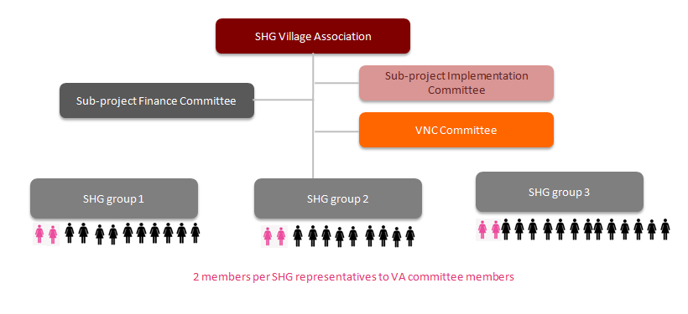

Role of the sub-project implementation committee:
- The sub-project implementation committee: will have two members from each SHG and supervises the implementation of FIPs which are loaned out. They also will supervise the part B training activities. They will also monitor and make sure the repayments back to the SHG and then back to the VA regularly as per agreed terms and conditions. The sub-project implementation will have Head of the committee and he convenes the meetings of the committee and responsible for reporting to the VA in all the matters on behalf of the committee. The committee will oversee the quality of the assets and livestock and other material procured by the individual member using the loan amount taken from SHG.

- Village Nutrition Center committee: The VNC committee will have a head of committee who will take responsibility of organizing monthly committee meetings to discuss and plan the activities. The VNC committee will supervise all the activities around nutrition under the umbrella of VNC. All the VNC members shall be female members from SHGs.

- Village Association Finance committee: The VAFC will have three members selected from group representatives. The Convener of the VSMC shall be one of the three members. The three members will be responsible for all the accounts and cash of the VSMC. Any two members of the committee can sign cheques based on the recommendation of sub-project implementation committee or VNC committee as the case may be. The VAFC will ensure to update all the books and registers of VSMC. All the VAFC members shall be women from SHGs. The VSMC will have a VSMC book keeper to write their accounts and minutes. Once the VSMC starts getting incomes they may pay to book keeper from their incomes. Initially they may start paying 50,000 Kip to 100,000 Kip per month as an honorarium.

 | Phase 3 LONG sub-project design & appraisal” |  | Step 12: | Training on FIPs and revolving fund concept

Socio and economic analysis has to be done for every poor household when we want to enhance their livelihoods in the context of poverty reduction. This is very crucial in providing insights into the household realities. Family Investment Plans of the poor are more effective and increases impact of interventions on the livelihoods of the targeted communities especially the poorest of the poor. Benefits to the poor are not contingent on amount but on appropriateness of investment. Livelihoods consist of the capabilities, the assets - both material and social resources - and the activities required for a means of living.
Livelihoods are sustainable when the poor can cope with and recover from stresses and shocks and maintain or enhance capabilities and assets from the current standard of living.

Village coordinators train SHGs on what can be decided on in FIPs and on conditionality of revolving fund using training manual, IEC and LONG field manual. The facilitator shall explain the paucity of funds and low capacities of the SHG in dealing with large amount of loans and hence convince the group to do family investment plans only for 1/3 rd of the group members. The 1/3 rd members shall be from top in order of their poverty ranking. This means the more poor members in the group will have their FIPs first on priority. The rest can take loans out of the repayments made by the first batch of the members.
The outcomes of the FIPs training are that families have understood opportunities and conditions of revolving fund.

 | Phase 3 LONG sub-project design & appraisal” |  | Step 13: | Design FIPs (Part A)

The activity proposed by the household shall be analyzed for its physical feasibility and financial viability. The village activists and other active members of the group will help the household and facilitator to analyze the activity. At this stage, the plan and cost of individual family investment plans (FIP) were captured.
The FIPs shall be facilitated preferably at the house of the members in the presence of the activists and two or three activists of the village. The information such as the assets, opportunities, loans due, is collected in the first instance. Then the family may be facilitated to identify the livelihood activity which can enhance their incomes.
The template FIPs and LONG field manual will be used during the implementation of this step. the outcome of this activity shall result in individual FIPs of 30% poorest are designed, reviewed by VC and screened by PRF District team
The template of family investment plan is given in annex XXX
- The SHG will endorse the FIPs of its 1/3 rd members after evaluating the proposals in terms of its viability and feasibility and repayment capability of the member and furnish the SHG plan to VSMC for approval.
- The VSMC committee will discuss all the SHG plans and holds a general body meeting of VSMC and discuss the plans of all SHGs and analyze the their feasibility and viability in the village context.
- The VSMC committee will assess the trainings required and estimate the costs for organizing the training and include that part in the sub-project proposal. The PRF-LONG facilitator will help the VSMC to assess the costing for the required trainings for the implementation of FIPs.
- After approval in the VSMC general body meeting, the VSMC will prepare the sub-project based on the FIPs and trainings related to them.

 | Phase 3 LONG sub-project design & appraisal” |  | Step 14: | Design CIP (setting up VNC committee and preparation of Part C)

The objective of the design of village nutrition center investment plan and community investment plans are to capture, plan and cost community investment plans for livelihood and nutrition.
Community Investment Plan (CIP):
Sometimes the entire group or entire village or part members of few SHGs may identify a common activity to improve their livelihoods such as irrigation activity or NTFP marketing etc. The CIP may have both the components, one repayment component and other is grant component. To make the activity more viable the fixed costs sometimes may be supported by the project as grant. The recurring costs and part of the fixed costs shall be part of repayment component. The template of CIP can be seen in annex xx

Village Nutrition Center (VNC):
At this step, the VNC location is confirmed and the costing of the VNC center is concluded. The VNC IP shall include the five main activities: daily meal, income generation activities, home garden, livelihood linked nutrition education and convergence with GOL’s service. The costs shall also include cooking equipments and minor renovation costs in order to set up a VNC. The cost shall vary depending on the number of the numbers of beneficiaries of this VNC such as numbers of pregnant and lactating mothers and children under age of two.
Village coordinators convene village organization meetings to design VNC IP and CIP using template of VNC IP and CIP provided in the annexe XX and XX. The outcomes of the activity are that the VNC IP and CIPS were designed, reviewed by VC and screened by PRF District team.

Figure 19: VNC sketch map shows the possible set up of the VNC.
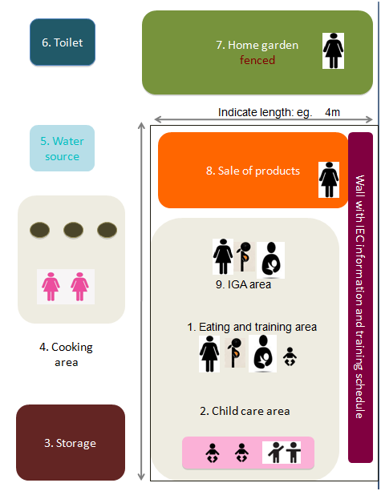

 | Phase 3 LONG sub-project design & appraisal” |  | Step 15: | Presentation of FIPs and VNC to VSMC

Figure 20: Sub-project design and components
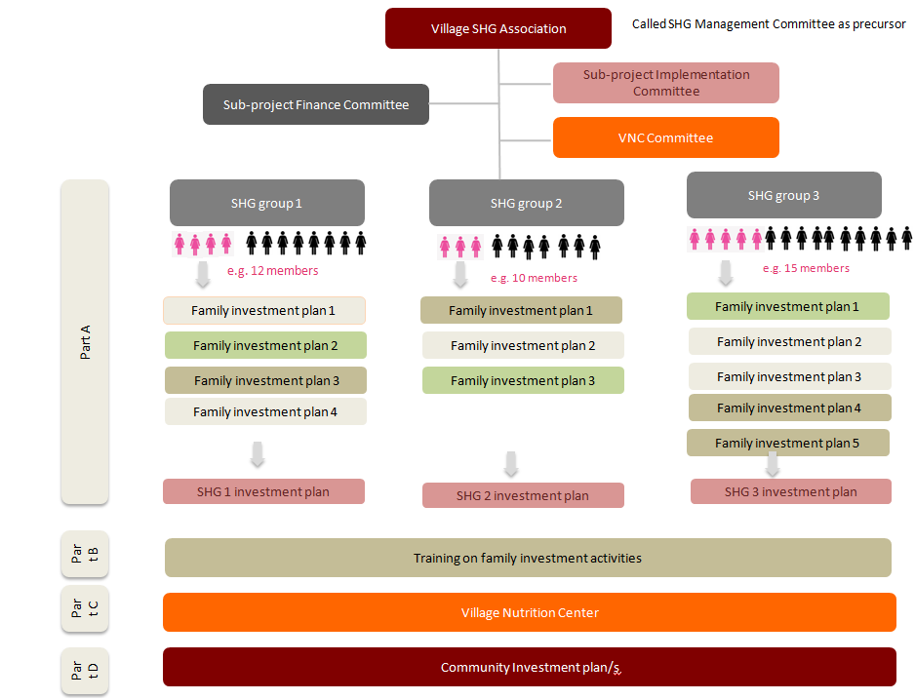
According to Figure 20, the sub-project shall have three components:
Part A: Aggregation of all the FIPs in the village. Each SHG will submit their SHG investment plan which includes the FIPs of its 1/3 rd members. All the loans proposed by the 1/3 rd members will constitute the part A of the sub-project proposal. The VA association may sometimes propose both FIPs plus CIP for part A.
The template for this part A is given in annexXXX
Part B: The costing for trainings identified to support the implementation of FIPs will be part of part B of sub-project proposal. The cost of venue, resource person, material required for training etc. The entire training expenditure should be grant to the community and nothing shall be paid back to the VA or SHG. The VA will organize the trainings. All the payments regarding training expenses shall be made by the VA during implementation of these capacity building activities.
The template for this part B is given in annex XXX
Part A plus Part B together for a village shall not be more than the allotment eligibility of village
Part C: The costing required by the Village Nutrition Center will be part of Part C. The part C will have both recurring and fixed costs. The grant part can be used for i) recurring costs like raw material for Income Generation Activity (IGA); ii) fixed costs like cooking equipment, weight measuring tools, material for building accommodation for VNC. The idea is the IGA should earn some incomes so as to pay wages for pregnant and lactating mothers who will work in IGA and buy their 1 meal from their daily wages. The template for this part C is given in annex xxx .
Proposal flow:
After the proposal is prepared by the VSMC it submits the same to PRF district coordinator - LONG. The dist PRF team shall put all the proposals of all project villages in dist coordination meeting for their endorsement and technical support.
After endorsement in Dist Coordination meeting the Provincial coordinator will review and send the proposal to LONG National Manager for final approval and for the release of funds. Quarterly reports will be sent to the ED.
The FIPs and VNC are consolidated into a proposal and the proposal will be presented to VSMC. One day village appraisal meeting with village organization, village coordinators, PRF District team and relevant authorities will be conducted in order to screen the proposal for quality check using template containing selection criteria (see annex XXX). At the end of the screening meeting, the sub-project is appraised and selected activities certified for physical and financial viability by the LONG village coordinators.
The VSMC will constitute sub-project implementation committee with one member from each group. There should be minimum 50 % women in the committee. The sub-project implementation committee will oversee the implementation of the Family Investment Plans by all the members taken loans. They will give feed back to the VA on the grounding and quality of the FIPs and CIPs.
VSMC also will constitute sub-project finance committee with one member from each SHG to release the money to the groups from VSMC account. The Finance committee will elect 3 members as joint signatories on cherub.
According to Figure 21 below, the screening and appraisal processes will be conducted in the village. Step 15 will involve only the stage one –initial screening and technical review of the sub-project proposals using review guidelines and technical screening notes and review form with screening criteria list including financial and physical viability, see annex XXX. The village coordinators assist the villagers by ensuring the proposals consist of the following:
- Part A: FIP/HHIP from each family/hh in SHG
- Part B: Training plan/s
- Part C: VNC investment plan
- Part D: Community investment plan/s

After the completion of the sub-project screening activity, FIPs will be updated based on requests from VC and LONG District Team, the SHG proposal including summaries of parts A,B,C,D was designed and the presentation to VSMC will be prepared.
Figure 21 : Appraisal Overview
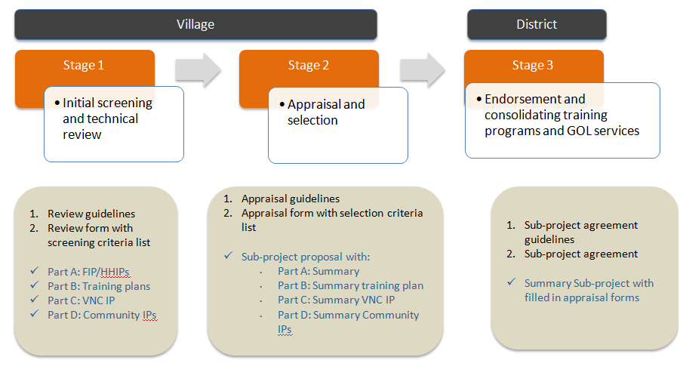

TOT 3 will train PRF-LONG staff on FIP, CIP, VNC and the sub-project agreements. The PRF-LONG sub-project agreements can be seen as supplementary agreements to the larger PRF II agreements.

A summary of phase 3 is presented in Table 3.
Table 4. Summary Phase 3: LONG Sub-Project Design and Appraisal
12 Steps/activities (A) | TOT/components (C) | IEC materials | Village implementation (VIG) and technical guidelines (TG), forms
Step 4. Formation of SHG | TOT2. A: “Orientation SHG management and elements of SHG performance rating”  TOT 2.B “Capacity building and strengthening of SHG”  TOT 2.C “Performance rating of SHG and community feedback”  -SHG performance rating systems  -Sanctions  -Community feedback | Specify | - TG 1 “Social mobilization”  - VIG6 “Social mobilization”  - VIG7 “Sub-project proposal and appraisal (including negative list)”  - VIG9 “Livelihood SHG”  - VIG10 “Nutrition SHG and graduation into Village Nutrition Center”  - VIG 14 “SHG exchange visits”
Step 5. Training to SHG leaders | -Women leadership  -Livelihood and nutrition links  -Governance and own contribution  -Remote trouble shooting  -Conflict management  -Safe guards, feedback and conflict resolution mechanism  -SHG meetings  -Savings and loans  -Bookkeeping | Specify | VIG6 “Social mobilization”  - VIG11 “Savings and loans”  - VIG 4“PRA with livelihood and nutrition focus”  - PRA report template  - VIG 12 “SHG performance rating and community feedback”  - VIG7 “Sub-project proposal and appraisal (including negative list)”  - VIG9 “Livelihood SHG”  - VIG7 “Sub-project proposal and appraisal” (including negative list)  - Form “Sub-project proposal, budget and procurement plan”  - Form “Sub-project agreement (and supplementary agreements)”  - Template proposal  - Template budget  - Template procurement plan  - Template workplan with milestones
Step 6. Promotion of savings and regular SHG meetings |  | --
Step 7. Training to SHG book keepers |  | --
Step 8: Promotion of internal lending |  | --
Step 9. Poverty ranking of members in SHG | C1: Sub-project design  C2: Project appraisal system  C3: Project agreement  C4: Formalization of SHG | Specify | - VIG7 “Sub-project proposal and appraisal” (including negative list)  - Form “Sub-project proposal, budget and procurement plan”  - Form “Sub-project agreement (and supplementary agreements)”  - Template proposal  - Template budget  - Template procurement plan  - Template workplan with milestones
Step 10. SHG evaluation |  | --
Step 11. Formation of VSMC |  | --
Step 12: Training on FIPS and Revolving concept |  | --
Step 13. Design of FIPs (part A) |  | --
Step 14. Design of CIP (setting up VNC committee and preparation for part C) |  | --
Step 15: Presentation of FIPs and VNC to VSMC |  | --

Phase 4: Sub-project Implementation by SHG

Phase 4 consists of seven key steps:
Step 16: Sub-project proposal by VSMC and submission to PRF District;  Step 17: District coordination meeting;  Step 18: Sub-project approval by and agreement with PRF, and money transfer to VSMC;  Step 19: Training to sub-project implementation committee and sub-project finance committee;  Step 20: training to beneficiaries on sub-project activities (part B) including training to VNC committee and focal person;  Step 21: Sub-project activities: Implementation (part A+C), Training(part B) and Monitoring (A+C);  Step 22: Repayments (part A+C); | 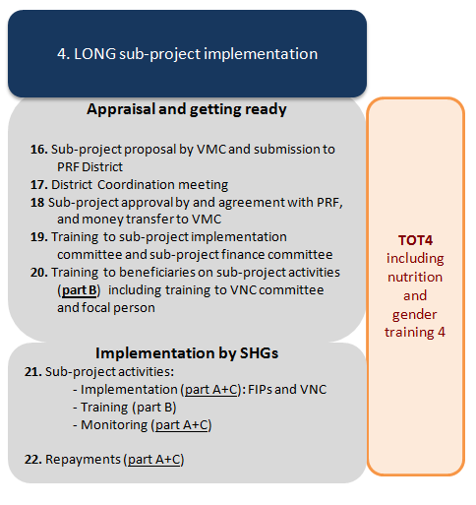

 | Phase 4 LONG sub-project implementation” |  | Step 16: | Sub-project proposal by VSMC and submission to PRF District

According to Figure 21, at stage two of the sub-project selection processes the sub-project proposals will be presented to the VSMC.
The outcomes of the sub-project proposal presentation to the VSMC are:
- Sub-project is appraised (including all listed FIPs) and selected activities certified for physical and financial viability and recommended for project support
- Agreement on selection of FIPs for first round of loan (batch 1)
- Recommendations before final proposal submission to District Team
- Documentation of appraisal including scoring
- Approval by village head

At step 16, the appraised and selected sub-project proposal will be submitted to PRF District team by VSMC.
The LONG district team will need to ensure the documentations are below:
- Appraisal guidelines
- Appraisal form with selection criteria list (Annex 2)
- Summaries of
- Part A: FIPs
- Part B: Training plan/s
- Part C: VNC investment plan
- Part D: Community investment plan/s
- Sub-project proposal (see Murali Annexure III)

The LONG district team together with the VSMC prepared the proposal presentation and agreed on the representatives from each SHG to attend the District coordination meeting.

 | Phase 4 LONG sub-project implementation” |  | Step 17: | District Coordination meeting

As illustrated in Figure 21, the stage three of sub-project proposal selection will be conducted at the district where the village organization’s representatives, PRF Provincial Coordinator, District LONG Coordinators, VC, District Governor, representatives from relevant sectors will be attending. The objective of the District coordination meeting is to endorse selected sub-projects and consolidate trainings and GOL support services together.
District Governor together with PRF Provincial Coordinator will convene the meeting and the selected sub-project proposals will be endorsed by the District Governor. At this meeting, the representatives from each SHG will have an opportunity to present their proposal. The proposals will be judged by an executive juror panel comprised of representatives from relevant provincial and district sectors.

The documents needed for this activity are:

- Sub-project proposal summary and appraisal form
- Sub-project agreement guidelines
- Sub-project agreement (into which Governor may add pre-requisites, special recommendations, etc)

The sub-project agreements shall be endorsed and signed by the District Governor.

Following the district coordination meeting, LONG team shall ensure:

- Consolidation of trainings into coordinated training program per District or Kum ban
- Consolidation of GOL services with work plan
- Circulation of nominated of GOL focal points to relevant stakeholders at all levels
- Announcing results to relevant stakeholders at all levels

 | Phase 4 LONG sub-project implementation” |  | Step 18: | Sub-project approval by and agreement with PRF, and money transfer to VSMC
In step 18, the PRF central will make appropriate scrutiny and approve the sub-projects proposal endorsed by the District Governor. The agreement will be signed between the VSMC and PRF. The grant will then be transferred into the VSMC’s bank account.
Fund flow (see Figure 22)
- The PRF Vientiane will release the money directly to the account of the VMSMC with information posted to Provincial and District Coordinator. If online transfer is not possible, a cheque shall be written on VSMC and be sent to District coordinator for transfer of the same to the VSMC. The PRF will open accounts in more banks in VTE so that the cheques of the same bank where VSMC has an account are written on VSMC name and sent directly to VSMC through district team.
- The VSMC will write cheque to the SHG against their SHG investment plan.
- The SHG office bearers will draw the money from banks and post it in cash book and ledgers and disburse the loans to their members against the FIPs.
- The Member will repay interest installment every month and repay installment of principle amount as per agreed terms to the SHG.
- The SHG will repay the half of the interest income and main full principle amount back to VSMC.
- The SHGs again submit their FIPs for next phase to VSMC. The VSMC shall release the next loan to SHG after scrutiny in the VSMC committee and approval by the general body of VSMC.

Figure 22: Fund Flow
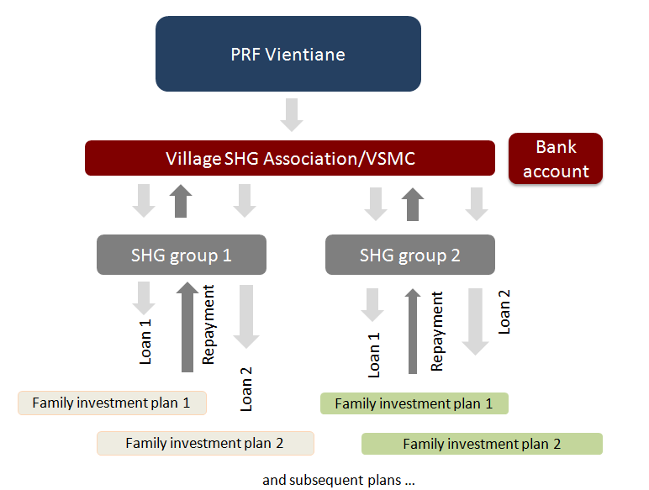

 | Phase 4 LONG sub-project implementation” |  | Step 19: | Training to sub-project implementation committee and sub-project finance committee

The objective of step 19 is to train finance, VNC and implementation sub-committees. Village coordinators train sub-committees on how to support the implementation of FIPs, CIPs, and VNC and technical trainings. After the training the committees are enabled to manage the implementation of the family investment plans, the community investment plans, the nutrition center and to support and organize the various technical trainings at village levels and elsewhere. They are also trained on basic procurements and financial management.
Training to committee members of various committees should be organized with in the village or outside the village depending upon the distances and numbers. The community resource persons can also participate as resource persons and share their experiences.
The VC s should be able to identify best performing SHGs and low performing SHGs and also best performing VA s and low performing VAs. Where ever the VA committees or SHGs are not up to the mark, they can be taken to the best performing VAs/SHGs. The VC should always as a strategy promote and groom some SHGs and some VAs with all best practices by spending more time with them over a period of time and keep them ready to receive people from outside for the purpose of exposure visits.

Training on Procurement
SHG and young graduates are required to follow the process, rules, and regulations outlined in PRF’s procurement manual in administering SHG grants. This includes the acquisition of goods, undertaking civil works, and procurement of services using SHG grants. A complementary LONG manual for “Procurement by SHG” will be developed (as Annex to PRF’s procurement manual).
Guiding principles for procurement are:
- Transparency;
- Equal opportunity to all suppliers;
- Accountability;
- Ensuring value for money;
- Avoid procurement of teams from friends and relatives;
- No undue benefit to anyone.
The sub-project proposals will include a procurement plan and budget. The training on steps, rules and regulations for the young graduates and PRF-LONG staff are included under TOT4.
For details see PRF Procurement manual, Annex on LONG procurement

 | Phase 4 LONG sub-project implementation” |  | Step 20: | Training to beneficiaries on sub-project activities (part B) including training to VNC committee and focal person

The objective of step 20 is to implement consolidated training schedule agreed and prepared from District Coordination Meeting. The LONG team hired trainers from GOL or other organizations to provide technical training to SHGs and sub-committees. It is expected that beneficiaries and all sub-committees received and paid for regular technical training to effectively implement their FIPs, CIPs and VNC activities.

 | Phase 4 LONG sub-project implementation” |  | Step 21: | Sub-project activities Implementation

Quick Hits
“Quick hit” livelihood activities are those that can be introduced easily and that bring results quickly. The purpose of ‘quick hit’ activities is three-fold: (i) to have development practitioners gain the confidence of producers; (ii) to instill confidence in producers that they are able to generate outputs that bring benefits to them and their communities; and, (iii) to promote cooperation among self-help groups. These ‘quick hit’ activities are introduced simultaneously with medium- and long-term activities.
Indicative quick-hit nutrition-linked livelihood improvement activities could include one or more of the following:
- Poultry production by improved management of local breeds; introducing vaccinations, supplementary feeding, and, enclosed foraging areas.  - Reduced livestock mortality by vaccinations. | - Improved dry season rice varieties: replace indigenous varieties of rice seed with improved varieties (potential for a 20 percent increase in rice yield within one cropping season)
- Construct pens for improved management of livestock; reducing livestock mortality. | - Mungbean production after rice (55-65 days).  - Linking farmers with surplus crops to existing markets.
- Repair irrigation systems with community labor. | - Simple processing of NTFPs (e.g., drying, sorting).
- Increasing production of selected vegetables for sale to iterant traders or in existing markets.  - Wet season vegetable production.  - Introducing niche market crops for existing markets. | - Expand production of woven products and other community specialty products (dried fish, dried fruits, curry pastes from chili peppers) for sale in existing markets.
- Introduce simple post-harvest technologies (for value added processing) to increase prices received for surplus farm products (e.g., chipping and drying of cassava; hand-sorting of peanuts and soybeans; sun-drying of chili peppers) | - Introducing small-scale irrigation systems (i.e., drip irrigation, multiple-use water systems, water storage systems, electric pump irrigation) to boost crop production for food security and sale in local markets.

Livelihood Activities of Individual SHGs
Activities of the livelihood SHGs will aim to increase income from crop cultivation and livestock raising that also will contribute directly to food security and increasing access to a diversity of nutritious foods.
The sub-project proposals of the SHG will be developed by the producer groups themselves, with support from PRF facilitators and district agricultural extension and industry and commerce technicians. It is proposed that the menus of potential nutrition-linked livelihood development activities (proposed above) be used as a guide for stimulating community discussions on expanding crop production. According to CDD principles, the community should be encouraged to come up with their own livelihood development ideas.
The PRF facilitators and district technicians should ensure:
- That producers discuss how the livelihood improvement activities are linked to improving community food security and nutrition and more balanced family diets;
- The availability of local markets for production outputs;
- The production technology is either available in the community or accessible from district agriculture technicians or provincial subject-matter specialists;
- That any potential for local food processing to retain value-added at the community level, is included in the proposal, specifically processing that could reduce local seasonal shortages and increase prices offered by traders.

The role of the district agricultural extension technicians is to:
- Raise awareness of potential technology constraints to production;
- Take note of the production inputs required to implement proposed livelihood development activities;
- Be aware of any special post-harvest handling needs that could improve food storage capacity and selling prices;
- Providing producers and their families with training in post-harvest technology (if needed;
- Report to concerned district officials about the proposed livelihood activities, as part of the normal district and provincial monitoring program.
The role of the district industry and commerce technician is to:
- Identify the existence of local markets for any commodities to be produced by the SHGs; the quality standards required by that market; seasonal price variations; and, the seasonal quantities required to meet local market needs;
- Identify collectors, aggregators, iterant traders, or other middlemen who will purchase from the SHGs at the village level; the quality standards required by these traders; prices paid during various seasons; and, any price differential offered for premium or semi-processed products;

Box 1: “Example Linking livelihood to improved community nutrition”

The SHG members each agree to cultivate a minimum of 200 square meters of at least one of several beans rich in protein, namely: soybeans, black beans, red (kidney) beans, white beans, mungbeans, peanuts, chickpeas, fava beans, cowpeas, lima beans. A portion of the production of beans will be contributed to the nutrition SHG in the village. The nutrition SHG will use the beans to prepare nutritious food at the FFC. The portion of beans to be contributed will be decided just before harvest of the crop and following negotiations between representatives of the livelihood SHG and the nutrition SHG.

Box 2: Example “Identifying local markets”

The district industry and commerce office (DICO) has identified five traders in the district market who sell several types of beans in the district market and two visiting traders (iterant traders) who buy beans at the farmgate for delivery to a major collector. The names of the five traders at the district market are: (i) Ms Inpeng; (ii) Ms Noy; (iii) Ms Pou; (iv) Ms Nida; and, (v) Ms Thip. The cell phone numbers of each of these buyers / traders are available from the DICO. The two visiting collectors who buy at the farmgate are Vietnamese Mr Nguyen and Mr Khuang. They come to the village once each week to purchase various products for export to Vietnam. The price paid by each buyer depends on the season of the year. The best prices are during the wet season and again just before the Chinese/Vietnamese new year celebrations. The worst prices are in March through June.

Grants to the SHGs
After grants are made available to the SHGs PRF facilitators will work with the producers to prepare a detailed production plan taking into consideration all socioeconomic and agro-ecological conditions.
Specific production factors that should be considered will include the availability of the following:
Socio-economic factors | Agro-ecological factors
- Family / local labor | - Land availability / status of forests
- Availability of trained vaccinators | - Water for irrigation
- Capacity to manage irrigation water | - Availability of seed and plant material
- Access to clean water for households | - Livestock breeds
- Access to clean water for livestock | - Cold chain for vaccines
- Capacity of livestock tenders | - Availability of grazing areas, forage, fodder
- Existing sources of protein in the village | - Status of NTFPs
- Opportunities for off-farm income | - Current crop production
- Handicrafts produced in the village
- Status of existing savings/credit schemes

Specifically related to linking production to nutritional gains, the following topics will need to be introduced during livelihood improvement training sessions:
- Natural resources management to support mixed farming (e.g., fisheries, water, watersheds), sustainable collection of non-timber forest products, agroforestry, and integrated pest management (IPM).
- Mixed farming: Aiming to minimize risk due to natural disasters and market volatility through the production of food crops and livestock for markets but also to meet each family’s nutritional needs. Mixed farming includes the production of a diversity of food crops, field crops, tree crops (through agroforestry and tree crop production), and small and large livestock, as well as (whenever possible) fisheries.
- Rotational cropping of both upland and lowland rice fields with legumes (peanuts, garden pea, mungbeans, cowpeas, red/kidney beans, black beans, etc.), to enrich soils and to increase the productivity of rice and provide legumes as a source of protein for family nutrition.
- Year-round vegetable production, including vegetable growing during the wet season when vegetables are not traditionally grown, but when market prices are highest.
- Production of a diversity of oil/fat crops and staples for existing markets and for home consumption to boost the local supply of nutritional foods. Crops in high demand in regional markets include peanuts, white sesame, Job’s tears, soybeans, mungbeans, and fodder maize (field corn).
- Promotion of non-farm activities linked to local and regional markets, in particular where tourism provides income generating opportunities. In locations where tourism is present, non-farm activities in the village can be linked to a SHG operating a small and clean food stand that sells health food and drinks, using local farm products. Vegetarian and vegan foods are increasingly popular among young tourists, as are local varieties of organic tea and exotic drinks (e.g., using Job’s tears and tree bark). Sweets can be sold using rice, bean, cassava, and maize flour, mixed with coconut juice.
- SHGs can pursue non-farm income generating activities in more remote locations with fewer tourists by organizing to produce local products made from NTFPs, including bamboo and rattan; brooms using broom grass; and, mulberry paper using bark from the mulberry SHGs also can organize to provide services to adventure tour and travel companies that serve to eco-tourists, by serving as ecological guides in biodiversity conservation forests, and providing camping and home-stay services to visitors.

Implementation of VNC
Figure 23: Village Nutrition Center
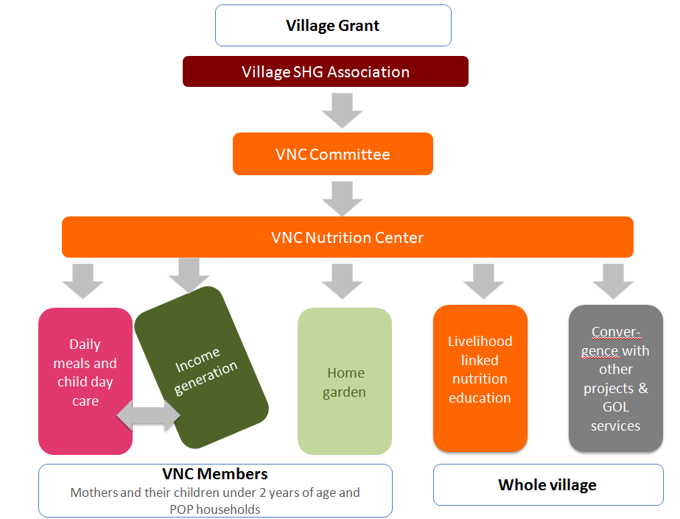
Nutrition activities implemented by the VNC members revolve around the adoption of good practices in five key themes. An indicative menu-list includes:
- Improving household time economies:
  - Daily labour and time savings (e.g. rice milling);
  - Daily child day care for children < two years of age;
  - Mother care during pregnancy and breastfeeding.
- Improving food preparation and/or processing (for home consumption or sale):
  - Balanced family diets for daily routine;
  - Balanced diets for pregnant and lactating mothers and children < 2 years of age;
  - Drying and fermentation of foods to reduce seasonal shortages;
  - Quick fix for meals prepared in fields and during time of hard labour (harvest);
  - Healthy meals, sweets, snacks and drinks (for field, forest, school, off-farm employment).
- Own food production (for home consumption):
  - Staples: Intercropping in rice systems and the production of non-rice staples with higher protein, beta-carotene, and mineral content (e.g. amaranth, millet, job’s tear, sweet potato);
  - Vegetables: Increasing and diversifying production of micro-nutrient rich vegetables (e.g. amaranth, penny word, phak tamnin, gourd, moringa, pumpkin);
  - Fruits: Increasing and diversifying production of micro-nutrient rich fruits (e.g. papaya, mango, pineapple, tamarind, jackfruit, soursop, plum);
  - Legumes: Promoting the introduction and intercropping of staples with legumes for (e.g. soybean, pigeon pea, garden pea, wing bean, mung bean);
  - Meat/fish: Production of small-live stock and aquaculture (e.g. chicken, ducks, frogs, fish);
  - Oil/fats: Production of fatty seeds (e.g. peanuts, sesame, coconut, mak kabob).
  - Promoting IPM and/or the sensible usage of pesticides and other agro-chemicals to avoid environmental and human health risks.
- Wild food collection (for home consumption):
  - Promoting the sustainable harvest and consumption of nutritious wild plant foods (e.g. leaves, buds, mushrooms, shoots, saps, flowers and fruits) for increased micronutrient intake);
  - Promoting the sustainable harvest and consumption of edible wild insects and meats (e.g. crickets, mole-crickets, beetles, bamboo worms, squirrels, rats, shrews, etc) as an alternative to meat and in areas where livestock production is low, where insects are culturally accepted and input of agro-chemicals is low.
  - Promoting the domestication of edible, nutritious non-bamboo NTFPs.
- Food purchases:
  - Making savings in food expenditures (reducing expenditures on MSG, sweets, sugar sweetened beverages, snacks and meats; higher investments into bean protein, and producing/buying home-made seasonings including fresh herbs, leaf powders, spices and sweets, snacks and beverages, etc);
  - Healthy food choices (types of foods, quality of foods, hygiene, etc);
  - Forming shopper groups (joint purchase foods in large quantities to reduce travel cost and price at market).
The VNC manual will be developed outlining technical background information, implementation arrangements and proposed targets for community monitoring. Dietary objectives per SHG differ per age and stage in life cycle, local cuisines, taste preferences and identified gaps. Indicative key dietary objectives are to:
- Increasing caloric intake from non-rice foods (particular during pregnancy and lactation);
- Increasing micronutrient intake (focus iron, zinc, vit A, vit C and iodine);
- Increasing protein intake (animal protein and/or bean protein);
- Increasing dietary fat intake (particular among Khamu, Makong, Tri, Katan and other Austro-Asiatic communities);
- Reducing intake of sugar from manufactured sweets, sugar sweetened beverages and snacks;
- Increasing absorption of nutrients (combining the rights foods, reducing intake from nicotine and other substances in cigarettes and tobacco).

The VNC will be a self-managed “community hub” (CDD platform) for:
- Nutrition profiling: Discussing nutritional problems and identifying vulnerable households and individuals to enroll in activities at the VNC. During the nutrition profiling also dietary gaps are identified and an inventory of local available food items will be established (including food sources such as from own production, wild collection and purchase and month of availability).
- Meals and child day care: Providing daily meals for pregnant, lactating mothers, children < 2years and vulnerable households and offering child care for children < 2 years. This includes the regular demonstration of best practices in food acquisition (from own production, wild collection, purchase), in food preparation, storage and child feeding. These activities are facilitated by the chair of the SHG (nutrition activist), a trained cook, and a shopper, etc who will receive a monthly stipend. Arrangements can also include women rotating on a voluntary basis working under supervision of one the above-mentioned activists.
- Livelihood linked nutrition education: This includes regular learning and exchanging information on livelihood, nutrition and well-being (peer education) but also the organization and convening of the nutrition linked livelihood education events at the village on a fixed schedule (see earlier description in POM). The behaviour change communication could include special educational events for grandparents, young children and men (e.g. “what to cook when mom is in the field”) on demand. The usage of IT (mobile phones) will be trialed to support capacity building at village level.
- Income generation activities: Income shall be generated from the production and sale of foods. These are light activities into which pregnant, breastfeeding mothers can engage as well as vulnerable people (e.g. disabled people, elderly, chronic sick). Potential products for sale could be: lunch boxes, field boxes, school boxes, healthy sweets/snacks/drinks, daily food items. Before or after participating in educational sessions, or having a meal, women could engage in these income generation activities.
- Quarterly growth monitoring for children < 5 years: This could be undertaken by DOH GOL (on invitation by SHG) on a fixed appointment or by trained villagers.

Key objectives of the VNC are:
- To mobilize women from SHG (max 12 women) into a larger group of villagers reaching out to all villagers (including all caretakers such as husbands and grandparents);
- To provide intensive support during the 1,000 day window of intervention;
- To increase convergence between behavior change communication and regular practice;
- To establish a platform for effective cooperation with GOL and other service providers;
- To establish a platform through which women can get mobilized across village boundaries.

Table 5. Targeting and Objectives of FFC
Elements/activities | Target group | Objectives
1. Nutrition profiling | Female representatives of all households in village | Identifying pregnant and lactating mothers, children <2 years and vulnerable households
2. Meals and child day care | Pregnant and lactating women, CU<2 years and vulnerable households | Improving food and nutrient intake and related practices through-out 1,000 day window and establishing of safety net for vulnerable households
3. Livelihood linked nutrition education | 1. Universal: All villagers  2. Intensive: Women engaged at FFC and special sessions for husbands, grandparents, etc | Increasing knowledge and capacity around nutrition and links to livelihood
4. Income generating activities | Pregnant and lactating women, vulnerable households, and other women | Improved mother care during pregnancy and breastfeeding, contribution to operational cost of FFC and increasing disposable household income
5. Savings and inter-lending | Pregnant and lactating women, vulnerable households, and other women | Contribution to operation cost of FFC and finance of household investment plans (including access to incentive grants)
6. Quarterly growth monitoring | CU<5 years | Improving child care for CU < 5 years and identifying vulnerable households for counseling

For the start-up women have to decide on a regular meeting place and play ground, which would be appropriate:
- To host 8-20 women and their children;
- To be used as day care for children < two years of age (safe for small children, clean, and inviting environment);
- To be used for cooking demonstrations (clean, close to safe access to water and sanitation, and inviting environment) and large enough for safe storage of food items.

As the VNC includes the sale of food a central location would be beneficial. SHG grant money can be used to build an appropriate annex to an existing village shop or to a private house. To build an individual building is not allowed. The set up of the FFC would also include the identification of garden land for the production of foods and the domestication of edible NTFPs.

The VNC will be continuously managed as a SHG. In addition to the normal office bearers (chair, vice-chair, cashier, treasurer) there will be additional positions such as a cook and a shopper. The cook and the shopper have to work on a day-to-day basis and will be paid a weekly stipend. For both, the cook and the shopper there will be specific trainings in order to prepare safe and healthy dishes and to buy fresh and quality produce for highest return of investments.
Mature SHG can apply for a mobile phone through which they will be able to access nutrition information (hotline and voice) or other forms of coaching to build up their knowledge and capacity around nutrition and livelihood links.
Mechanism will be explored for sustainable finance of the VNCC from payments of the LVH groups (2-5% of income generating activities).
More details on the set-up, finance, management of the family food center will be detailed in the VNC manual, including relevant technical background information.

Negative Activities under LONG:
The project will work out a negative list of activities for FIPs. Some of the activities are listed below.
- Any activity which is illegal like raising opium poppy plants
- Any activity against the World Bank approved safe guards
- Any activity which leads to mass deforestation
- Any activity which promotes junk food and/or empty calories
- Any activity which should not make the children withdraw from the school
- Any activity which brew alcohol or intoxicated material/liquids
- Any activity which leads to degraded soil fertility
- Any activity against the culture of Lao PDR

 | Phase 4 LONG sub-project implementation” |  | Step 22: | Repayments (part A+C)

Murali to INSERT

Table 6. Summary Phase 4: Subproject Implementation by SHG
7 Steps/activities (A) | TOT/components (C) | IEC materials | Village implementation (VIG) and technical guidelines (TG), forms
Step 16: Sub-project proposal by VSMC and submission to PRF District
Step 17: District coordination meeting
Step 18: Sub-project approval by and agreement with PRF and money transfer to VSMC.
Step 19: Training to sub-project implementation committee and sub-project finance committee
Step 20: Training to beneficiaries on sub-project on sub-project activities (part B) including training to VNC committee and focal person
Step 21: Sub-project activities:
-Implementation (part A+C): FIPS and VNC
-Training (part B)
-Monitoring (part A+C)
Step 22: Repayments (part A + C)

TOT 4 will train village coordinators on subproject consolidated technical training and monitoring planning and organization. VNC set up and universal nutrition trainings will also be provided.

Phase 5: Community Monitoring
Phase 5 concerns over community monitoring where monthly VSMC meetings for sub-project monitoring and accountability meetings shall be conducted for progress update and transparency.
Step 23: Monthly VSMC meetings for sub-project monitoring and accountability meetings | 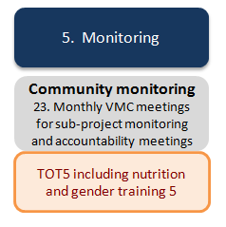

VSMC will have monthly general body meeting every month on a scheduled day. The SHGs give a presentation on their activities in that month. The VA committees submit to the general body the activities they have taken up during the month including expenditure details on the activities. Any SHG member or village community member can put their grievance or give feedback on activities taken up by VA during the month or on past activities. The Village coordinator and District PRF staff (specify who) will attend this meeting without fail.
Community monitoring is a part of the overall M&E framework (see Chapter 10). Community-based monitoring is a process that requires inputs and activities to produce a specific output. This includes a response to monitoring findings (in particular challenges faced by the SHGs) in forms of improvement plans. Community monitoring will be carried out with active participation from SHG members. Key inputs from the SHG are:
Provision of data;
Discussion of results from community monitoring;
Agreement on activities to improve results (improvement plans).
Young graduates and PRF-LONG staff will facilitate the monitoring process at village level and aggregate reports at kum ban level. In order to build up the capacity for self-monitoring among the SHGs, all community monitoring activities shall gradually be implemented as follows:
Year 1: Joint monitoring with facilitation by young graduates and PRF-LONG staff;
Year 2: On-the job training of SHGs until they can conduct their own monitoring;
Year 3: SHGs will conduct own community monitoring and report to young graduates and PRF-LONG staff.
The main objectives of the community-based monitoring are:
To ensure that community members know what activities were planned, whether they were carried out as planned and with what quality, and whether they will lead to the achievement of the project objectives;
To help SHGs reflect on what they have learned from the implementation process and to share ownership of the process;
To increase the overall project effectiveness (including stakeholder learning).

Results Monitoring
Results include outputs, outcomes, and impacts.
In order to measure results or improvements in the situation of the project beneficiaries, it is necessary to establish a baseline at the beginning of the project, together with the community. Then comparative data can be collected over specific periods of time, based on indicators developed by the SHG. They key method for results monitoring is: tracking groups’ self-help capacities.

Further metrics for livelihood and nutrition could be added.
See also Results Framework (Annex 1) “Intermediate result indicators 9, 10, 13“:

- % of SHG members reporting increased livelihood opportunities;
- % increase in income of SHG members;
- % of women in SHGs that have introduced a more balanced diet.

Details are described in the TIG 1 “Social mobilization” and VIG 6 “Social mobilization”.
Operation or implementation monitoring
Operation or implementation monitoring will be carried out according to the project steps. Focus may include the following three activities:
Formation and strengthening of SHGs;
Grant process;
Subproject implementation (LVH and NUT SHG).
These monitoring activities can take place during regular meetings or during meetings designated for monitoring. Indicative agenda items for a SHG monitoring meeting are:
SHG will review its books (including the minutes and attendance book, savings book, loan ledger, etc.);
Young graduate will observe the meeting and fill out a monitoring form;
Young graduates will lead the SHG in discussing possible actions and support that may be needed (compiled into an actionable improvement plan);
At the end of the meeting, young graduate will present his or her findings and help the SHG reflect on gaps or constraints.
The young graduates will send the completed monitoring form to the PRF-LONG District staff for review and data entry.
Performance Rating
SHG performance self-rating is an additional, specific tool for the ongoing operation and implementation monitoring activity.
See also Results Framework (Annex 1) “Intermediate result indicator 5”: % of SHGs getting satisfactory performance rating.

The SGH performance rating will be conducted after the SHG has reached its 10th meeting and within the period of 3 to 4 months. The next rating will be conducted after ten subsequent meetings.
The SHG performance self-rating serves four main objectives:

To review and score the performance of SHG;
To identify problem/mistakes of the group that may need to be improved;
To develop actions and/or improvement plans;
To confirm if the group is eligible to receive further LONG installments and/or grants.
The seven main criteria for performance rating are:
- Meetings and attendance;
- Savings;
- Bookkeeping;
- Repayment;
- Women leadership;
- Livelihood and nutrition activities;
- Governance and own contribution.
Table 7 gives an overview of the performance rating criteria and respective score from 0, the lowest, to 4, the highest.
Identified problems/mistakes are noted in the minutes book together with actions and/or improvement plans which are followed up in all subsequent SHG meetings. The lack of improvement may result in the cancellation of the sub-project agreement or release of further installments. Such SHG will also not considered eligible in the next cycle.
Table 7. Performance Rating Indicators
Components | Score
 | 4 | 3 | 2 | 1 | 0
1. Meetings
Regularity of meetings (last 10 meetings) | 10 meetings held | 7-9 meetings held | 5-8 meetings held | <5 meetings held | No records
Attendance at meetings (last 10 meetings) | >90% | 75%-90% | 50-74% | <50% | No records
2. Savings
Regularity in weekly savings by members | 100% | 75-99% | 50-74% | <50% | No records
Percent of amount that should have been saved by the entire group | >90% | 75%-90% | 50-74% | <50% | No records
3. Bookkeeping
Correct recording of minutes and cash book (procurement) | Up to date and correct recording | Up to date but incorrect recording | Not up to date, but correct recording | Not up to date, incorrect recording | No records
Correct recording of savings book | Up to date and correct recording | Up to date but incorrect recording | Not up to date, but correct recording | Not up to date, incorrect recording | No records
4. Repayment
Number of times the equivalent of the entire group fund has been loaned to members (fund rotation) | 2 times or more | 1.5 times or more | 1 time or more | less than 1 time | No records
Percent of members who have received loans | >60% of members | 40%-60% of members | 30%-39% of members | <30% of members | No records
5. Women leadership
Positions held by women | 4 positions | 3 positions | 2 positions | 1 positions | 0 positions
6. Livelihood / nutrition activities
Progress made as agreed in the SHG work plan | All milestones achieved | Most milestones achieved | Half milestones achieved | A few milestones achieved | No milestones achieved
7. Governance and own contribution
Adherence to community development rules | Rules followed by all SHG members | Rules followed by more than 50% of SHG members | Rules followed by less than 50% of SHG members | Rules followed by only 1or 2 SHG members | Not followed at all
Own contribution of capital cost of subproject by SHG | 20% and above | 15-20% | 10-14% | 5-9% | 0-4%

A summary of phase 5 is provided in Table 7.
Table 8. Summary Phase 5: Community Monitoring
3 Steps/activities (A) | TOT/components (C) | IEC materials | Village implementation (VIG) and technical guidelines (TG), forms
Step 23. : Monthly VSMC meetings for sub-project monitoring and accountability meetings  Results monitoring  Act 1: TOT for YG/PRF/GOL at D  Act 2: Results tracking at V  Act 3: Improvement plans  Act 4. Follow-up at V | TOT 4.C ”Community monitoring”  C1: Results monitoring  C2: Implementation and operation monitoring (focus SHG performance rating)  C3: Improvement plans  C4: Follow-up at village level  C5: Sanctions  C6: Cancellation of sub-project agreements | -- | - Monitoring forms (e.g. SHG performance sheets, community score cards)  - Template improvement plans
Step 2. Implementation and operation monitoring
Act 1: TOT for YG/PRF/GOL at D
Act 2: SHG performance rating at V
Act 3: Improvement plans
Act 4. Follow-up at V

TOT5: Training on community young graduates and PRF-LONG staff are trained on how to conduct results tracking, operation and implementation monitoring. Over time, villagers will implement community monitoring by themselves and report to young graduates. Special focus will be given on sanctions and how to appropriately deal with cases in which cancellation of sub-project agreements may be indicated.

Roles and Responsibilities in Field Implementation

Basic Skills for Field Staff
General Skills and Attitudes
Beyond compliance with the procedures and steps outlined in the LONG Operations manual, the success of LONG will depend to a large extent on the ability of the field staff (in particular the young graduates) to provide quality facilitation throughout the project process. Based on experiences from other countries, there is a need to provide comprehensive training to key staff, especially the field staff, who work directly with the communities on a daily basis. Trainings shall be given to all partners directly involved in the field operations.
All field staff will help the community members identify problems, analyse and develop options, take decisions, implement solutions and adjust successfully to an ever changing, dynamic environment; more specifically they will:
Enable and empower poor people, strengthen their self-confidence and inspire them to use their assets in optimized ways;
Help people to help themselves by simply being present, listening, and responding to people’s needs;
Support individuals, groups and organizations through participatory processes.

Quality facilitation is founded on certain basic attitudes:
Empathy and politeness;
Interest in genuinely working with the poor;
Unconditional positive spirit;
Unconditional trust in the potentials of poor people.

Key skills are described below:
Talking to and Understanding the Community
Field facilitation staff requires a set of skills enabling them to communicate effectively with the poor, who are often illiterate. Field staff’ role is not to command or to teach but rather to help the poor to understand, learn and explore ways of improvement on their own. This requires good personal communication skills as well as group-centred skills.
Personal Communication Skills
Field staff need to be oriented towards personal development and learning. Personal communication skills geared towards helping the poor gain confidence, helping them understand, inspiring them to learn, and creating positive feelings are key. These skills include:
- Active observing and listening;
- Asking and answering questions;
- Probing;
- Paraphrasing (rewording, summarizing, and bringing things to the point);
- Flexibility in changing methods and sequences, not always sticking to a pre-set sequence and technique;
- Visualizing & drawing to put discussion points into the big picture;
- Encouraging dialogue.

Group-centered Skills
The facilitator needs to know how to inspire and communicate well with different people at the same time and make all of them feel that they are an important part of the group. Facilitators need to be able to identify and respond to group dynamics in order to encourage openness and confidence to speak out freely as well as foster group cohesion and inclusive decision-making processes. These skills include:
- Trust and confidence building;
- Providing and receiving feed-back;
- Encouraging full participation;
- Building group dynamics and team work;
- Monitoring group roles and stages;
- Promoting mutual understanding;
- Fostering inclusive solutions;
- Supporting problem and conflict solving;
Learning from the Community
The approach to facilitation of community development applied by LONG will involve learning from the community. (In this, it shares the values with the “appreciative inquiry” approach.) The following principles are key to this approach:
- Local people know about their situation better than outsiders; therefore, they should lead the development process;
- It is the people’s right (and duty) to analyze their situation, think and plan for a better future, implement their own initiatives, and evaluate their results;
- An enabling environment should be created that helps participants (SHG members) enjoy participating and feel comfortable expressing their ideas;
- The development process must be simple and fun so that illiterate people enjoy participating and develop their dormant potentials;
- People with different backgrounds and experiences have different ideas, needs, and desires. Facilitators must respect this diversity, listen to all, and not reject anything;
- All comments and ideas must be listened to actively. Facilitators should learn from and appreciate people;
- Indigenous knowledge and practices must be respected and learned from.

Facilitating Meetings
Much of the interaction between field staff and poor people will happen during meetings, especially at the group level. Being able to manage meetings in an inspirational manner is very important. Key principles and suggestions for doing this include:
- Meetings should always be enjoyable events, in which people like to participate;
- After each meeting the participants should have specific – usually simple – tasksthat they can easily achieve before the next meeting;
- The facilitator also has tasks to achieve before the next meeting, so that everybody can enjoy the satisfaction of “mission accomplished” at each session;
- Participants, not the facilitator, decide on the venue, day, time, and agenda of their meetings;
- The facilitator listens, appreciates, probes, and inquires.
What you should not do as a facilitator:
Do not judge;
Do not project your own perceptions on others;
Do not assume that people need your help;
Do not think you know better that others;
Do not do things that meeting participants should do themselves (such as writing minutes);
Do not write on flipcharts if most of the participants are illiterate;
Do not talk to the flipchart while turning your back to the participants.

8

Facilitating Community Processes
Field staff need to be aware that developing and strengthening institutions of the poor has to be a “bottom-up” process. Initially, this process appreciates existing potentials, what poor people have and can do, and explores with them the next small steps of what they can take to achieve small improvements. Facilitators will “facilitate” this process in such a way that the poor will feel the satisfaction of having learned and achieved something.
The facilitation process needs to be planned and implemented in small steps of learning and implementation. Even simple activities should be planned so that there is an opportunity to appreciate their accomplishment. Planning and evaluation help to increase commitment and provide platforms for joint learning. Facilitators should predominantly use visuals as they are easier to understand and to recall than written words, which in any case are of little use while working with illiterate people.
Community facilitation is an interactive process shared between the facilitator and SHG group members. The process should be led by elected group members with the facilitator playing a supporting role through the use of questions, suggestions, examples, etc. Facilitators should also register their commitments and tasks in the work plans of the groups and be accountable to the group for their tasks (see also community score-cards).
More details are provided in the TG 2 “Social mobilization”.

Human Resources Set-Up
The organization of LONG will be closely aligned with the organization of PRF, with LONG being a unit with PRF. This section gives an overview of the different roles and responsibilities for LONG at the different levels, including:
- PRF-LONG team at the central level;
- PRF-LONG team at provincial level;
- PRF-LONG district teams;
- LONG village coordinators (young graduates);
- Village activists and SHG facilitators.

Figure 24: Organization Chart of PRF-LONG

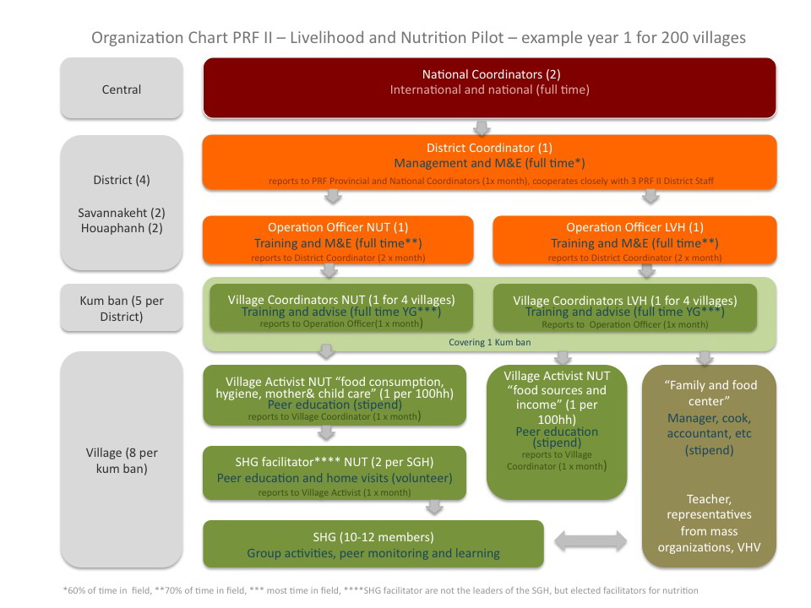

Central Team
Staff at the central level has the overall responsibility for the pilot, including planning, implementation, and results.
Key responsibilities include, but are not limited to:
Effective and timely development and implementation of:

Work plans (Central, Provincial and District level);
Budgets and procurement plans;
Training plans;
Field tools (including technical guidelines, village implementation guidelines, forms, IEC, etc);
Other planning tools;
Monitoring plans;
Reporting schedules.

Key functions include:
- Overseeing and coordinate all PRF/LONG activities at central level;
- Recruiting and management of PRF-LONG staff and PRF-LONG consultants at central, provincial and district level (including capacity building and staff performance review);
- Providing guidance and leadership to implementation of staff at provincial and district level;
- Ensuring implementation is in compliance with the PRF’s LONG Operations Manual;
- Ensuring adherence to administrative procedures of the Project (consistency with PRF procedures and regulations from World Bank and other donors);
- Ensuring the management information system captures and monitors all aspects of the program;
- Preparing of regular progress reports;
- Performing regular internal audit;
- Regular correspondence with GOL and donors
- Coordination with the NLCRDPE and line Ministries at central level during program implementation.

Provincial Teams
The LONG project will not have specific staff based staff at provincial level but draws from the PRF structure. A team of PRF-LONG staff is based in the capital of each participating province.
PRF Provincial team key responsibilities include:
- Overseeing and coordinate all PRF/LONG activities in the province;
- Support provincial authorities and relevant departments, including NLCRDPE to assist in program implementation;
- Consolidate M&E data and provide regular reporting to the PRF Central Office;
- Provide support to the PRF/LONG District team;
- Ensuring compliance with all PRF/LONG Program principles and procedures;
- Participate to grievances investigation and resolution and prepare the Provincial Feedback and Resolution monthly report.

The tasks of the Provincial team include regular monthly meetings and relevant on-the-job training with relevant line departments and PRF District teams. Transport is provided to enable such fieldwork, which includes the supervision of district coordinators.
The PRF Province team meets monthly with district coordinators to collect reports, discuss progress and problems, and provide on-the-job training. These meetings are also used to evaluate facilitator performance and to provide guidance.
There is no specific LONG staff based at the provincial level, but as required, the PRF provincial coordinator may assign specific tasks to the PRF provincial team to assist the LONG team at the district level to supervise, implement and monitor specific LONG activities.
The Provincial Team is led by the Provincial Coordinator who reports to the PRF Executive Director. The Provincial Coordinator is the key person at the provincial level for the coordination of the LONG activities, and therefore will apply the same principles as the PRF activities in term of coordination and reporting to the provincial authorities, concerned sector and the PRF Executive Director.

District Teams
PRF/LONG district teams play a key role in the program as they are the main link between the communities and PRF structure and provide direct support to communities to plan and implement kum ban development plans, PRF-LONG sub-projects and livelihood and nutrition activities of the SHG.
PRF District team key responsibilities include:
- Provide support to targeted kum ban and communities on all aspects of the PRF Program and LONG pilot project;
- Train, assist and supervise kum ban facilitators, kum ban teams, village representatives and village teams as well as LONG operations officers, village coordinators, village activists, SHG facilitators and SHG members;
- Supervise and monitor the entire PRF process at the kum ban and village levels (finance management, procurement, sub-projects selection, etc.);
- Provides regular reports on program progress and problems encountered to the PRF Provincial Coordinator;
- Supporting district authorities and relevant offices, including NLCRDPE;
- Ensures compliance with all PRF/LONG principles and procedures;
- Participate to grievances investigation and resolution and prepare the District Feedback and Resolution monthly report.
District teams meet regularly with kum ban facilitators and village coordinators to collect reports, discuss progress and problems and provide on-the-job training. These meetings are also used to evaluate facilitators’ performance and to provide guidance. Additional meetings are organized to support and monitor sub-project implementation.
District Team members must be able to speak the language(s) that are most common in the District. They are expected to live in or near the district centre. They are provided with appropriate transport or a transport allowance sufficient to allow them to spend at least 65% of their time in participating kum bans and villages.
The district level team members report to the PRF District Coordinator who reports to the PRF Provincial Coordinator.

Village Coordinators
Based on the Government’s Graduate Deployment Program, the project also includes provisions for including young graduates (high school and above) from project areas as village coordinators. They will be selected following the WB recruitment guideline through a competitive process.
Village Coordinators (as the kum ban facilitators for the PRF) are community resource persons to support the LONG activities implementation. Ideally, they will be based at the kum ban level with frequent visit to the PRF district offices to benefit from guidance and support and provide regular reporting of their activities. For each kum ban, there will be a Village Coordinator covering the Nutrition activities (VNC) and one Village Coordinator covering the livelihood activities (VLC) covering each around 4 villages. He/she is expected to work with and provide close support for villages through Self-help Groups (SHGs), mobilization, prioritization, SHG establishment and strengthening and grant implementation by the SHGs. The VLC and VLC will report to the LONG District Manager for or her/his designate.

Village Livelihood and Nutrition Activists and SHG Facilitators
At the village level, community will select village activists to support the nutrition activities and SHG facilitators to support the SHG members. They will be actively trained to be able to fulfill their responsibilities and used as leaders to provide trainings to other farmers and participate to the monitoring of the livelihood and nutrition activities. Their specific responsibilities will be further defined during the start-up phase.
The VSMC with the support of project facilitators shall promote a cadre of volunteers in the areas of agriculture, livestock, education health and nutrition, marketing etc for the purpose of capacity building of the community in respective fields.
In every village one can find the persons who have aptitude and active in one of the above field. In the VA meeting people can identify such persons to take the responsibility of such activity in the village as a volunteer.
Thus one VSMC may promote livestock/veterinary volunteer, Nutrition volunteer, Agriculture volunteer depending upon the project interventions through HHIPs in the village.
The functions of the volunteers are given below.
- They will receive trainings on skills and knowledge organized by the project.
- They will serve the community needs charging very nominal fees as decided by the VSMC.
- They will be provided by some equipment and some tools by the VSMC or project to deliver such services required by the community.
- They will organize required trainings and education sessions in the village based on their work plan with the support of project and line departments.
The project shall not promote any such volunteers if the line ministry or other development agency has already promoted and available in the village.
The project will work closely with line departments and other resource organizations in building the capacity of these volunteers in providing necessary services to the community in implementation of the activities for their additional incomes.
Box 4: PRF-LONG Young Graduate Program
Evidence from other countries suggests that autonomous and sustainable support organizations are needed to undertake social mobilizations at the village level to harness people’s potentials. LEAP in Cambodia, Gemi Diriya in Sri Lanka, or SERP in India for instance trialed various approaches through different INGOs before designing a national CDD model. The political context in Lao PDR however does not allow working with NPA and INGOs.
Hence, in order to fill this resource gap and mobilize a pool of genuine activists, a young graduate program is tailored under PRF-LONG. Young graduate programs are part of the GOL’s efforts to build up the capacity of unemployed or underemployed youth to acquire sustainable self-employment or employment in rural development (including agriculture, health, nutrition) and to meet the increasing demand for skillful staff in GOL service provision and/or community development. Graduates would have some basic skills in either agriculture, rural development, health/nutrition, or other fields including social sciences, rural economics, or development studies.
This program aims to mobilize committed, pro-active and innovative young graduates to fill in the positions of Village Livelihood Coordinators (VLC) and Village Nutrition Coordinators (VNC), especially those native to LONG target districts and able to speak one or more of the local languages (e.g. Khmu, Hmong, Tri, Makong, Katang, Pakoh). Each Livelihood Coordinator (VLC) or Village Nutrition Coordinator (VNC) will cover about 4 villages (as a team).
The VNC and VLC will be based in kum ban offices which shall meet the below criteria:
Minimum facilities (meeting room, separate bedrooms for women and men, latrine, cooking place, water supply /bath place).
Successful demonstration of development activities initiated either under PRF I or LUFSIP in more than two villages
Local communities belong to ethnic groups which are meeting the GOL’s and World Bank definition of Indigenous Peoples (OP 4. 10)
Demonstration of strong kumban leadership and ownership for community development
He/she is expected to unravel community needs and to facilitate the development of a clear village vision for improved livelihood and nutrition, to facilitate events and trainings, to mobilize communities to take charge of their own development, and to build and strengthen self-help and ownership. This is mainly to work with and provide close support for villagers through Self-help Groups (SHGs) establishment, social mobilization, need prioritization, SHG strengthening and grant implementation by the SHGs. The VLC and VLC will report to the LONG District Manager for or her/his designate.
About 15 candidates per district will be identified at the first round to participate in a field test. Identified candidates will be staying and working in the kum ban office with frequent visits to villages for at least one month. Candidate performance evaluation will be conducted by the PMT with inputs and recommendations from PRF district offices and the visited communities. Based on the joint evaluation, it is expected that 4-6 candidates will be selected as VLC and VNC for that district. This employment opportunity will be selected through a competitive process and opened to a wide range of interested young graduates including those who have been already contracted by district government offices to apply.
PMT and provincial offices will organize a 2-3 day orientation training for the selected candidates to undertake the initial field test. The training aims to inform the young graduates of PRF II and LONG project’s objectives, implementation process and results. The training will also discuss their TORs and formative research process that the candidates are expected to undertake during the field test visit to selected project villages. Supervision and reporting arrangements will be agreed at the training. The participants will be clarified on logistic arrangements and support to be provided by the PMT, provincial, district and kumban offices throughout the course of their stay in the project sites.
The Young graduate will be hired based on a one-year contract, which is renewable subject to annual performance review. The VLC and VNC are expected to spend at least 80 percent of their working days in the community working with village Self Help Groups and village Nutrition Center. To motivate and keep young graduates working with the project in the rural remote area, they will receive a monthly salary at between 100-200 USD per person per month depending on their qualifications, experiences, and remoteness of villages to be visited and working circumstances. This proposed amount of salary should cover the cost for life and health insurance to be paid to a local insurance service provider (to be deducted from the salary pay roll and paid by the PMT). Their salary will be reviewed subject to their annual performance assessment to be conducted by the PMT with inputs to be provided from the district offices.
In addition, the young graduates would also receive daily allowance at 3 USD to cover meals for their field trips to work and assist Self Help groups and village Nutrition Center in the villages. This allowance may be paid directly to host villages or households in which the young graduates will be staying with. The unit costs of daily allowance and gasoline are based on the PRF rates specified in the project operation manual. The project will cover transport costs and provide vehicles (motorbikes) for the purposes of project implementation. Village coordinators shall be responsible for their personal needs, belongings and equipment necessary for field visit including, but should not be limited to food, sleeping bags, clothes, mosquito nets insect repellents. These shall be clearly specified in the employment contract to be signed between the young graduate and the PMT.

Capacity Building
The capacity building addresses five types of stakeholders:
- Villagers;
- Young graduates;
- PRF-LONG staff;
- GoL at all levels (including kum ban officials);
- Volunteers;
- Other local service providers.
Indicative training blocks of the capacity building program include:
 | Phase 1 “Orientation” | TOT 1

# | Themes | Components
1 | LONG Orientation | - LONG introduction  - Village history  - CDD sensitization  - Livelihood sensitization  - Nutrition sensitization
Participants: YG, PRF, GOL
Training objectives: Train YG and PRF-LONG staff on LONG village introduction, village history profiling and village sensitization.
Training outcomes: YG and PRF-LONG staff are enabled to introduce the LONG project, establish village history profiles and to effectively role-out village sensitization on CDD, livelihood and nutrition (including the appropriate usage of IEC) for a more livelihood and nutrition focused PRA within the LONG project framework.
Location: District
Training length: 5 days (with practice session in village)

 | Phase 2 “Planning ” | TOT 2

TOTs during Phase 2: Planning
# | Themes | Components
2 | PRA | - PRA with focus on livelihood and nutrition links
Participants: YG, PRF, GOL
Training objectives: Train YG and PRF-LONG staff on PRA.
Training outcomes: YG and PRA staff are enabled to conduct PRA in villages with specific focus on soliciting potentials for leveraging effective linkages between livelihood and nutrition improvements.
Location: District
Training length: 5 days (with practice session in village)

3 | Planning | - Development of village livelihood and nutrition plans  - SHG formation
Participants: YG, PRF, GOL
Training objectives: Train YG and PRF-LONG staff on the development of village livelihood and nutrition development plans and on facilitating the formation of SHGs.
Training outcomes: YG and PRA staff are enabled to lead the development of village livelihood and nutrition development plans and guide on the formation of SHGs around common livelihood and/or nutrition interests.
Location: District.
Training length: 5 days (with practice session in village)

 | Phase 3 “LONG subproject design & appraisal ” | TOT 3

# | Themes | Components
4 | Social mobilization | - Overview SHG management (incl. women leadership)  - Capacity building and strengthening of SHG  - Community monitoring
Participants: YG, PRF, GOL
Training objectives: Train YG and PRF-LONG staff on effective social mobilization within Lao development context.
Training outcomes: YG and PRF-LONG staff are enabled to orientate, train and supervise SHGs on effective group management (including SHG meetings, savings, bookkeeping, women leadership, livelihood and nutrition links, governance, own contribution) and to conduct community monitoring.
Location: District
Training length: 5-7 trainings in 3 blocks, 3-5 days each (with practice session in village)

5 | LONG sub-projects | - Sub-project design  - Sub-project appraisal system  - Sub-project agreement and non-negotiables  - Formalization of SHG
Participants: YG, PRF, GOL
Training objectives: Train YG, PRF and GOL staff on LONG sub-project design, sub-appraisal system, sub-project agreement and non-negotiables according to PRF and principles of CDD.
Training outcomes: YG and PRF-LONG staff are enabled to guide SHG in the development of eligible LONG sub-project proposals (including development of budget, procurement plan, workplan with milestones) and train SHG on non-negotiables and sanctions. PRF-LONG staff is enabled to appraise and sign LONG sub-project proposals. YG and PRF-LONG staff is trained on how to formalize pre-SHG into registered SHG.

Location: District.
Training length: 5 days (with practice session in village)

 | Phase 4 “Sub-project implementation by SHG” | TOT 4

# | Themes | Components
6 | Universal livelihood linked nutrition education | - Overview malnutrition/nutrition and household time economies  - Balanced diets  - Food consumption during the lifecycle and nutritional needs  - Mother and child care (including growth monitoring)  - Hygiene and food safety (including both at home and for sale of foods)  - Linkages agriculture and nutrition  - Linkages income generation and food expenditures  - Linkages natural resource management and nutrition.
Participants: YG, PRF, GOL
Training objectives: Train YG and PRF-LONG staff on role-out of a nutrition behaviour change strange strategy with links to livelihood.
Training outcomes: YG and PRF-LONG staff are enabled to effectively role-out a nutrition behaviour change strategy with links to livelihood according to a fixed event schedule, to evaluate each event and to establish actionable linkages to SHG through training of village nutrition activists.
Location: District.
Training length: Monthly trainings, 3-5 days each (with practice session in village)

7 | Savings and loans, grant access, financial management, and procurement | - Savings  - Short-term loans  - Grant access  - Financial management  - Procurement
Participants: YG, PRF, GOL
Training objectives: Train YG and PRF-LONG staff on SHG savings and short-term loans, grant access, financial management and procurement.
Training outcomes: YG and PRF-LONG staff are enabled to guide and supervise villagers how to start regular savings and interlending, how to access grants (incl. different installments), administer those grants and how to do proper procurement in according to PRF FM and procurement standards.
Location: District.
Training length: 2-3 trainings, 2-5 days each (with practice session in village)

8 | LVH activities by SHG | - Issue based TOTs - see from menu list
Participants: YG, PRF, GOL
Training objectives: Train YG, PRF, GOL and service providers on issue-based livelihood improvements (details to be decided later).
Training outcomes: Service providers together with support from YG, PRF-LONG staff and GOL staff are enabled to role-out issues based livelihood trainings for SHG.
Location: District
Training length: various trainings, 2-5 days each (with practice session in village)

9 | Nutrition activities by SHG  (to be linked with TOT6 and technical background information) | - Creating a nutrition vision  - Improving household time economies  - Improving food preparation, cooking and/or processing (for home consumption or sale) along the life cycle  - Own food production (for home consumption)  - Wild food collection (for home consumption):  - Food purchases
Participants: YG, PRF, GOL
Training objectives: Train YG, PRF, GOL and service providers on issue-based nutrition improvements (to be decided later).
Training outcomes: Service providers together with support from YG, PRF and GOL staff are enabled to role-out issue based nutrition trainings. YG and PRF-LONG staff are trained to lead mature SHG to graduate into village family and food centers and make them an actively used knowledge and training hub.
Location: District.
Training length: Various training rounds, 2-5 days each (with practice session in village)

 | Phase 5 “Community monitoring” | TOT 5

10 | Community monitoring | - Results monitoring  - Operation and implementation monitoring  - Community feedback
Participants: YG, PRF, GOL
Training objectives: Train YG and PRF on the implementation of community based monitoring.
Training outcomes: YG and PRF-LONG are enabled to effectively role out community-based monitoring and advise on next steps to improve performance of SHG management, livelihood and nutrition activities.
Location: District.
Training length: 1-3 trainings, 2-3 days (with practice session in village)
The following trainings and other capacity building activities should take place under LONG (have these trainings be planned and costed for in the procurement and work plan)
Facilitation and handholding:
Facilitation by Village coordinators and District PRF staff is one of the most effective methods of capacity building to SHGs. The VCs shall use pictorial charts and hand outs extensively (need to design urgently) to convey the messages to SHG members and committee members of various committees. The VCs should attend maximum number of scheduled meetings of SHGs in her/his jurisdiction villages.
The VCs should observe various practices in SHGs related to savings, rotation of saving fund, loan process, repayments, HHIPs, agenda setting in group meetings, by-laws, book keeping, minutes writing, attendance, prioritization of loans, process of conflict resolution etc during their scheduled group meetings.
The VCs should meet activists and volunteers in person and try to know their problems In group management and the services they are delivering.
Trainings to SHGs :
One or two formal trainings should be organized to all the group members on group management and group sustainability and poverty alleviation strategy of PRF using pictorial charts and other IEC material. Two groups may be merged as one team and half day training may be given by the VC in a undisturbed setting in one of the places in the village or little outside the village.
Training to convener and Deputy Conveners of VAs
The Conveners and Dy conveners are most important leaders of the VSMC. They need two or three day training outside the village may be at Kumban level or at dist level depending upon the distances. They are the visionaries for their villages in eradicating the poverty of the members of the SHGs and VSMC.
Subjects like poverty alleviation strategy through livelihoods enhancement and sub-projects, SHG sustainability, VSMC sustainability, linkages, transparency, conflict resolution, leadership qualities, role of volunteers, role of PRF, role of Conveners and Dy conveners shall be discussed in the training program.
Training to Committee members
Training to committee members of various committees should be organized with in the village or outside the village depending upon the distances and numbers. The community resource persons can also participate as resource persons and share their experiences.
Exposure visit to SHGs and VA committee members
The VC s should be able to identify best performing SHGs and low performing SHGs and also best performing VA s and low performing VSMCs. Where ever the VSMC committees or SHGs are not up to the mark, they can be taken to the best performing VSMCs/SHGs. The VC should always as a strategy promote and groom some SHGs and some VSMCs with all best practices by spending more time with them over a period of time and keep them ready to receive people from outside for the purpose of exposure visits.
Training to Book keepers
The project team shall give training to book keepers of all the SHGs at Kumban level or at dist level depending upon the number and distances. Five day training is required for this purpose. The training should be given based on the principles of handholding and sample exercises. By end of the training they should be able to write all the books of accounts and prepare receipts and payments statement and balance sheet of a SHG. The training should start with assessing their mathematical skills and writing skills. If required basic mathematics shall be taught to the trainees.
They should carry all their live books of their group to the training. The trainer should see the books of all the book keepers and give his/her feedback if there are any mistakes and improvements required are found.
Please note that one book keeper can write books of more than one SHG. But generally one book keeper cannot write books of more than 4 groups.
Trainings to barefoot specialists ( Volunteers) - are those the activists
Trainings should be given to subject matter bare foot specialists (volunteers) on their subject. The no of days training to be given to them depends upon the subject and practical. The resource persons from line departments should be identified to impart these trainings. The payments to the resource persons and for training materials shall be made by the VSMC.
Exposure visits to Volunteers
The training to the volunteers shall be sometimes included the exposure visits. The line department resource persons or project staff can organise these exposure visits. Demonstration plots in case of agriculture activities, graded animals or artificial insemination in livestock, market study or market linkages could be some of the activities for exposure visits.
Training to Master book keepers
A cadre of Master book keepers can be promoted out of best book keepers of SHGs and VAs. They can be used as resource persons to give training to new book keepers and or to do auditing of the SHGs. The resource fees for the MBKs should be paid out of training funds of the project.
Community resource persons
A cadre of community resource persons can also be promoted from the active persons in SHGs and VAs so that their services are used when the project is expanding to new villages or new districts. The messages through community resource persons will go fast and easily if the resource persons are from their own community rather than the semi-urban or urban village coordinators.

Safeguards, Feedback and Resolution Mechanism

Social and Environmental Safeguards Policy Framework
The World Bank (WB) has categorized the PRF II covering the LONG component as a ‘Category B’ project and out of the ten safeguard policies, four policies are triggered: Environmental Assessment (OP 4.01); Pest Management (OP 4.09); Indigenous Peoples (OP 4.10); and Involuntary Resettlement (OP 4.12). Given the Project’s Community Driven Development (CDD) nature, which is designed and implemented through a participatory planning process and the types of small civil works that will be supported under the project, it is not anticipated that the Project activities will create many major adverse impacts that cannot be managed by communities themselves. However small-scale civil works and livelihood activities may require minor land acquisition and/or may require use of pesticide for agricultural production, which may create other minor negative impacts on local environment and local people although such impacts would be localized, temporally, and can be mitigated through good planning and construction practices.
In line with the above environmental and social Safeguards policy (OP 4.01, OP 4.09, OP 4.10, and OP 4.12), four safeguard instruments have been prepared as a standalone documents to be applied for both PRFII and LONG’s activities:
Environmental and Social Management Framework (ESMF), and
Simplified Pest Management Plan (PMP)
Compensation and Resettlement Policy Framework (CRPF),
Ethnic Group Policy Framework (EGPF)
Safeguards-related policy provisions in the above listed safeguard frameworks will be adopted or adapted as necessary during the course of the preparation, design and implementation of LONG activities. The livelihood activities would be subject to screening against a negative list of ineligible activities, including activities that may cause adverse environmental or social impact such as land acquisition or restricted access to resources, conversion of natural habitat or forests for agricultural purposes, or use of pesticides.
Given that LONG targets at poor villages in which diverse ethnic groups meeting the Bank’s definition of ‘Indigenous People’ are concentrated, the Policy OP 4.10 would be applied for this pilot project. Livelihood activities will explicitly promote active engagement of ethnic group communities, with specific facilitation and monitoring arrangement provided to ensure that they can benefit in a culturally appropriate and gender sensitive manner. Criteria for livelihood self-help group composition will be established to ensure the inclusion of marginalized and poor members of the community, and the fair and transparent distribution of livelihoods benefits.
For further details, please refer to the PRFII Project Operations Manual and feedback and agreement forms (Annex 9 to PRF Project Operations Manual).

Feedback and Resolution Mechanism

LONG will feature the same Feedback and Resolution Mechanism (FRM) as PRF II. As part of the MIS (Monitoring and Information System) the FRM are set up to receive feedback from the communities, assuring that the voices are heard from the poor and vulnerable, and the issues are resolved effectively and expeditiously.
Such a system is expected to enable the PRF to be fully responsive to its beneficiary communities and empower the ethnic groups and poor in villages who are the principal target of LONG. PRF’s FRM is adopted from ISO 10002, the international complaint-handling standard. FRM features multiple uptake channels including the hotline, feedback boxes in all PRF villages, website, FRM committees at village, district and provincial levels, and linkages to traditional intermediaries (such as newhom).
More details are provided in PRF II manual.

Partnerships and Project Coordination at Local Level

Coordination with Line Ministries and Agencies
As the PRF, LONG is a multi-sectoral program working in the poorest areas of the country, it is important that LONG coordinates with government line agencies both at horizontal and vertical level. The PRF-LONG Government counterparts at the different levels are shown in Table 9.
Table 9. PRF-LONG Coordination Arrangements with GOL Line Ministries and Agencies
PRF/LONG Government counterpart at
National level
NLCRDPE
Ministry of Planning and Investment
Ministry of Finance
Ministry of Agriculture and Forestry
Ministry of Health
Ministry of Commerce and Trade
Mass organizations (LWU, LFNC, LYU)
Provincial level
Provincial Governors and Vice Governors
Representatives of the NLCRDPE
Departments of all relevant line ministries
Mass organizations (LWU, LFNC, LYU)
District level
District Governors and Vice Governors
Representatives of the NLCRDPE
Offices of all relevant line ministries
Mass organizations (LWU, LFNC, LYU)
Kum ban level
Kum ban committee
Village level
Village heads
Village sub-Units heads
Mass organizations (LWU, LFNC, LYU)

Government authorities, mainly at the provincial and district levels are responsible for ensuring coordination of LONG activities with those carried out by all GoL agencies. LONG staff will inform Government authorities and concerned sectors and consult with them in a timely manner of relevant LONG activities. This is especially relevant in order to avoid duplication of poverty reduction initiatives, to make optimal use of resources and to ensure that the impact of LONG activities is sustainable beyond the lifespan of the PRF Program.
The PRF/LONG encourages the active involvement of Government officials (as well as those of mass-based organizations) particularly with respect to supervision and technical advice during planning and implementation of PRF/LONG sub-projects and activities. Towards this goal, the Program can pay travel costs and/or per diems to GoL officials in order to facilitate their participation in relevant supervisory or advisory as well as training activities.
The coordination between PRF/LONG and the line ministries has been defined in a Joint Declaration on Coordination under the aegis of the President of the NCRDPE Board, and endorsed by the concerned sector that will be directly involved with the LONG pilot project:
Ministry of Health;
Ministry of Agriculture and Forestry;
Ministry of Public Work and Transport;
Ministry of Commerce and Industry.
The Agreements of coordination with sectors has been expanded on the 6-pronged approach to coordination proposed by the PRF (including planning; technical standards; logistics; implementation; monitoring, evaluation and O+M; as well as cooperation with all local interventions). This platform for coordination will constitute a potent instrument for the PRF/LONG as part of the Government’s National Rural Development and Poverty Eradication Program. The PRF/LONG will cover the costs incurred by the sectors for the services provided, beyond their normal activities.
For the LONG activities, specific collaboration modalities will be established, in particular with the Ministry of Agriculture and Forestry, Ministry of Health based on the MoU signed in the framework of the PRF II. Similarly, close collaboration with other relevant organizations in the project areas will be set during the first year of the LONG pilot project.
The PRF/LONG is entitled and directly responsible to undertake and maintain working relations as well as coordination activities with the concerned sectors, within the framework of the Agreements of coordination with sectors and in close cooperation with the Cabinet of the NLCDRPE, in particular at the local level.
At the higher level, LONG will follow the PRF coordination arrangement with the NLCRDPE and guideline and the PRF decree (Annex xx).

Relationships with Other Projects
PRF-LONG staff are should also actively look for relationships with other project and development partners that are active in project areas or that are working on or has experience with similar projects.

Bank Linkages

The fund available in LONG will not be sufficient to take up livelihood activities for all the project target households. We need to mobilize some funds from banks and other financial agencies like Microfinance Institutes who are willing to provide bulk loans with bank rate of interests.
The household also needs to take up multiple livelihoods over a period of time with the financial support through loans from SHG. The household may start with a small activity or activity with small magnitude. Once they gain experience and confidence and capacity they may go for a bigger activity or same activity with bigger magnitude.
Taking the above considerations it is required to link the SHGs with banks and other financial institutions for bulk loans. The PRF should continuously debate with policy makers of banking institutions and convince them to lend to SHGs or VAs to alleviate their poverty.
The present policy of the Nayobay Bank (which is established by the GOL to help the poor with loans for enhancing their livelihoods) is not congenial to suit the requirements of the poor. They are taking 6 months time for processing the loans and only one time in the month of July they receive the applications from district.
Taking 28,800 targeted households under LONG, we should facilitate funds approximately $ 7 to $ 8 million into system to really to create concrete impact in enhancing their livelihoods and improve incomes and come out of poverty. This figure is arrived taking at least half of the households taking up two loans (total of about $300) over the next 2-3 year period.
To sensitize and make the bankers understand the financing the SHGs and VSMCs we need to organize an exposure visit to the bankers very frequently. We also should work closely with bankers to develop policy guidelines for banks on the procedures and principles to finance the banks.
The rates of interest of banks are varying from bank to bank. The Nayobay Bank has lowest rates as of today but not feasible to access in the present policy. Hence we need to start with any other national or private bank till the policy of the Nayobay Bank is changed to more flexible. To start with the grant money from project and bulk loan from bank should go to the VSMC / SHGs to implement the FIPs. The bank loan should be returnable where as the grant money would be retained with VSMC.
Alternatively, there are Agriculture Promotion Bank and Lao Development Bank whose operate nationwide with reasonable interest rates.

Monitoring and Evaluation
A comprehensive and ongoing monitoring and evaluation (M&E) is integral to the project implementation. Solid M&E provides information that helps improve project management, assess development effectiveness and demonstrate results. In LONG, the emphasis will be on monitoring results and lessons that can be used for ongoing improvements in implementation and eventual scale-up of the pilot. For the most part, LONG will rely on the existing PRF M&E system.
M&E for LONG will include:
Regular progress monitoring by project staff;
Community-based monitoring by SHG;
Special studies;
Evaluation.

Progress Reporting

PRF/LONG project staff will monitor and track project progress against the planned activities on monthly basis. PRF’s Management Information System (CMIS) will do the necessary processing of primary data once entered and make it available to all levels of project management in the analyzed form. Monitoring is a continuing function that provides management and other stakeholders with valuable feedback on what is working, what isn’t and why, and early indications of progress and achievement of objectives. Such monitoring needs to be more than just a reporting mechanism, and serve as a management tool and as a means for advancing the progress. See PRF Manual for details.

Project Monitoring Reports
- Quarterly reports, provided to the World Bank no later than 45 days after the end of the period.
- Annual reports integrating results on the progress achieved in carrying out the Project no later than two months after the reporting period. The annual report should clearly report on Project Indicators and the results framework.
These report should be added as a separate sections to PRF’s quarterly reports and annual reports.
In addition, the PRF-LONG district team is responsible to provide monthly monitoring reports to the central PRF-LONG tem.

Community Monitoring
LONG will integrate community participation in the monitoring system (for details Chapter see 5.5).
Community-based self monitoring provides one means to collect and systematically capture data that reflects
the performance and
the operation of institutions of the poor.
It is seen as a strategy and process for integrating community participation and to empower them to oversee and monitor performance of their groups to ensuring that the function is in the way intended.
The advantages can be summarized into key areas:
Self-educative system and permits the community groups/members to take lead role in learning;
Self-improving because the community groups/members learn from each other and work towards collective social and economic well-being;
Involving higher levels of progress monitoring;
Improving training and support efforts among community members;
Providing regular feedback, reporting or making solutions to unforeseen problem as soon as they arise;
Setting realistic targets or range for targets and data for monitoring saving, credit and other community activities;
Enhancing voice and empowers participation during process of implementation;
Promoting transparency and accountability in the function of community.
Planning and adequate preparation is a key to effective community self-monitoring. It is a community driven activity and should be promoted as such. The areas for self-monitoring will be agreed upon with the communities themselves and tested during the pilot.

Special Studies
Special studies will focus on particular thematic or operational innovations of the pilot such as assessing methodologies of self-help group formation and management (including the experiences of women-only vs. mixed-gender groups, of new group formation vs. supporting existing village associations), the financial sustainability of SHGs and access to credit, approaches for ensuring ethnically inclusive nutrition and livelihoods support, and participatory nutrition profiling.

Evaluation of Pilot Results

An evaluation will be conducted upon the completion of the pilot, building on the broader PRF impact evaluation. Specific LONG evaluation will assess livelihoods pilot outcomes, impacts and efficacy.

Results Framework and Monitoring

LAO PDR: POVERTY REDUCTION FUND II – JSDF PILOT

Project Development Objective (PDO): to pilot an innovative livelihood focused community driven development (CDD) program in five poverty reduction priority districts within Hua Phanh and Savannaketh provinces enabling 28,800 households in rural areas to improve their livelihoods and wellbeing through group-based activities.
PDO Level Results Indicators* | Core | Unit of Measure | Baseline |  | Cumulative Target Values** |  |  |  | Frequency | Data Source/  Methodology |  | Responsibility for Data Collection |  | Description (indicator definition etc.)
 |  |  |  |  | YR1 | YR 2 | YR3
Indicator One:  Direct Project Beneficiaries¹ |  | Number | Baseline will be completed in Yr1 |  |  |  | 28,800 |  | Quarterly & annual project reports | Project MIS |  | PRF consultants |  | Type of activities funded for households that are members of self-help groups, and community members benefitting from nutrition-linked livelihood activities
Sub-indicator One:  Total number of beneficiaries of which 50% are women |  | % |  |  |  |  | 50% |  | Quarterly & annual project reports | Project MIS |  | PRF consultants |  | % of women benefitting from project activities
Indicator Two:  Decision-making on allocation of grant resources involve at least 50% women, and 60% poorest community members³ |  | % |  |  | 50% women, 60% poorest | 50% women, 60% poorest | 50% women, 60% poorest |  | Quarterly & annual project reports | Project MIS |  | PRF |  | Ensure that decision-making process is participatory
Indicator Three:  % of targeted HHs that adopt improved pro-nutrition livelihood activities |  | % |  |  |  |  | 60% |  | Final evaluation | Project MIS |  | PRF consultants |  | Measure the extent to which targeted HHs² adopted improved pro-nutrition livelihood activities
INTERMEDIATE RESULTS
Intermediate Results (Component ONE): Formation of Self-Help Groups & Capacity Building of Local Service Providers
Intermediate Result Indicator Four:  Number of Self-Help Groups supported |  | # |  |  | 50 | 200 | 400 |  | Quarterly & annual project reports | Project MIS |  | PRF |  | Number of self-help groups supported by the project
Intermediate Result Indicators Five:  % of SHGs getting satisfactory performance rating⁴ |  | % |  |  |  |  | 60% |  | Quarterly & annual project reports | Project MIS |  | PRF |  | Assess quality of performance of SHGs
Intermediate Result Indicators Six:  % of leadership positions in SHGs that are held by women⁵ |  | % |  |  |  |  | 50% |  | Quarterly & annual project reports | Project MIS |  | PRF |  | Assess women’s participation in SHGs
Intermediate Result indicator Seven:  % of SHGs that express satisfaction with quality of services provided |  | % |  |  |  |  |  | 70% | Twice during pilot: baseline and final. | Impact evaluation | Contracted firm |  |  | Gauge satisfaction by beneficiaries with services provided on pro-nutrition livelihood activities
Intermediate Result (Component Two): Community Asset Creation
Intermediate Results Indicators* | Core | Unit of Measure |  | Baseline | YR 1 | YR 2 |  | YR3 | Frequency | Data Source/  Methodology | Responsibility for Data Collection |  | Description (indicator definition etc.)
Intermediate Result Indicator Eight:  #/type of livelihood activities supported by seed grants |  | text |  | For CDD programs, there is no pre-set list of activities to be funded. The activities will depend upon SHG priorities. However, the project will be reporting upon #/type of activities each quarter |  |  |  |  | Quarterly & annual project reports | Project MIS | PRF consultants |  |  | Type of activities funded
Intermediate Result indicator Nine:  % of SHG members reporting increased livelihood opportunities |  | % |  |  |  |  |  | 70% | Twice during life of pilot | Impact evaluation | Contracted firm |  |  | Assess the increase in livelihood related opportunities
Intermediate Results Indicator Ten:  % increase in income of SHG members |  | % |  |  |  |  |  | 10% | Twice during life of pilot | Impact evaluation | Contracted firm |  |  | Measure increase in income from livelihood activities supported by SHGs
Intermediate Result (Component Three): Leveraging pro-nutrition livelihood activities
Intermediate Results Indicators* | Core | Unit of Measure |  | Baseline | YR 1 | YR 2 |  | YR3 | Frequency | Data Source/  Methodology | Responsibi-lity for Data Collection |  | Description (indicator definition etc.)
Intermediate Result Indicator Eleven:  #/type of nutrition activities supported by project |  | text |  | For CDD programs, there is no pre-set list of activities to be funded. The activities will depend upon SHG priorities. However, the project will be reporting upon #/type of activities each quarter |  |  |  |  | Quarterly & annual project reports | Project MIS | PRF consultants |  |  | Type of activities funded (includes both activities supported by seed grants and universal nutrition activities)
Intermediate Result indicator Twelve:  Behavior change strategy related to nutrition with links to livelihoods, designed and rolled out in target villages |  | # |  |  |  |  |  | 1 | Quarterly & annual project reports | Project MIS | PRF consultants |  | Assess implementation of nutrition component
Intermediate Result indicator Thirteen:  % of women in SHGs that have introduced a more balanced diet |  | % |  |  |  |  |  | 50% | Twice during pilot: baseline, and final. | Impact evaluation | Contracted firms |  | Assess the extent to which SHGs formed around nutrition activities are applying acquired knowledge, attitude and practices on nutrition
Intermediate Result (Component Four): Monitoring and Impact Evaluation of pilot activities

Intermediate Results Indicators* | Core | Unit of Measure |  | Baseline | YR 1 | YR 2 |  | YR3 | Frequency | Data Source/  Methodology | Responsibi-lity for Data Collection |  | Description (indicator definition etc.)
Intermediate Results indicator Fourteen:  Progress reports prepared on time |  | Annual progress report |  |  | 1 | 1 |  | 1 | Annual | Project reporting system | PRF PMT |  | Annual progress reports
Intermediate Results indicator Fifteen: MIS improved to produce necessary information for monitoring program effectiveness and results |  | System |  |  |  |  |  |  | Minimum 1 time during life of project | Reports | PRF PMT, WB |  | Progress reporting and Computerized management information system

ANNEX: PRF-LONG Problem Tree

This annex presents the PRF-LONG problem tree. The problem tree shows the limited opportunities for livelihood development, nutrition improvement, and sustained well-being at three levels: household level, village level and KB/district levels.
Household level
Low livelihood security: including aspects of lack of financial literacy, unavailability of farm credit, low technology application in agricultural production, poor knowledge and limited access to and experience with markets, low level of awareness of the need for more effective management of natural resources, etc;
Low food and nutrition security: including poor household time economies, inappropriate knowledge, attitude and practices in food consumption, care and hygiene, high dependence ratio and absence of family planning, unexploited potentials to lever better nutrition through adapted agriculture, natural resource management, savings and food choices on markets;
Low level of knowledge, attitude and practices (especially in the fields of agriculture, marketing, NRM, food consumption, care and hygiene), including loss of local knowledge over time, language barriers, absence of linear thinking to explain causalities of problems and potential solutions, opportunistic behaviour, etc.
Low empowerment and no voice: including lack of effective self-help organizations, no democratic development processes to participate in, unbalanced ratio between active and inactive villagers with few committed, pro-active and capable villagers demonstrating leadership, fading traditional support structures, etc;
Low access to and trust in services: including poor service delivery resulting into low demand of and cooperation with GOL service providers, little trust in strangers and people from other ethnic groups, etc;
Village level
Lack of effective village organization: including top-down facilitation of village meetings, absence of effective community organizations and joint decision making, etc.
Lack of assets: including lack of or decrease in natural assets (land, forest, livestock, NTFPS, water) as well as low financial assets;
Unfavorable technologies: unfavorable rice production technologies (seeds, soil and pest management, etc), food and cash cropping irrespective of best-fit agro-ecological potentials, high post-harvest losses;
KB and district level
Weak GOL institutions with low responsiveness and top down development approach: including the implementation of central level policies (NSEDP, village consolidation/resettlement, land development) without considering and adopting to local context, decentralization but low devolution of real power to local service providers and communities, low governance;
Low asset investment including: limited GoL budget and resources to support sustainable village development;
Lack of human resources: including lack of trained GOL staff capable, willing and active for regular extension activities, high turn-over of GOL staff, low levels of facilitations skills to empower and organize local communities, salaries and other incentives cannot create motivation for public servants to fulfill their assigned duties.
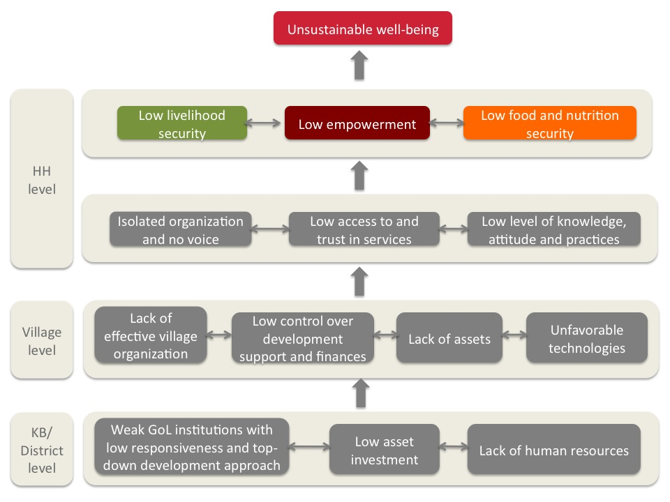

Annex: Overview of livelihood development approaches

Northern region

Indicative farm models of nutrition-linked livelihood development activities for target communities in upland areas of northern Laos are based on agroforestry farming systems, integrated with livestock raising.
Indicative farm models for target communities in northern Laos with lowland areas for paddy production are based on increasing both wet and dry season rice production by upgrading small-scale irrigation systems and introducing improved varieties of rice seed, in particular for irrigated dry season rice production. Most lowland rice farmers also have upland gardens (suan), where fruit trees can be cultivated, and where cattle can be grazed. Fruit tree seedlings can be purchased from communities specializing in fruit tree production. Upland gardens also can be used for improved pasture development. Cut-and-carry fodder gardens can be established in or near home plots for feeding large livestock.

Indicative nutrition-linked livelihood improvement activities
that support nutrition objectives
Indicative livelihood activities for Upland North | Indicative livelihood activities for Lowland North
- Upgrade existing small-scale irrigation systems to ensure supplementary irrigation water for wet season rice production.  - Home plot gardens; introduce legumes and oil seeds (for oil, fats, and protein); expand to upland gardens (suan) if successful and if demand is sufficient. | - Improved dry season rice varieties.  - Upgrade existing small-scale irrigation systems.  - Expand dry season irrigated rice production and diversify cash crop production.  - Rice seed multiplication of improved rice seed varieties.  - Gardens in home plots and upland gardens (suan).
- Introduce improved breeds to increase livestock productivity.  - Fodder gardens and improved pasture to improve livestock nutrition.  - Cattle pens for improved management of large livestock.  - Improved vaccine chain management to prevent contamination of food sources and disease outbreaks in small and large livestock. | - Improved vaccine chain management to prevent contamination of food sources and disease outbreaks in small and large livestock.
- Village tree seedling nursery, including fruit trees, bamboo, rattan, other edible shrubs.  - Agroforestry: Diversified fruit tree production integrated with domesticated NTFPs, including shoots, leaves, tubers, nuts, fruits, berries, mushrooms.  - Expand production of existing horticulture crops linked to markets: coffee, tea, yang bong trees (for bark). | - Home plot gardens; introduce legumes (as protein supplements); expand to upland gardens (suan) if successful and if demand is sufficient.
- Handicrafts produced under contract (to ensure markets).
- Silkworm raising for silk thread and for silkworms for consumption (for protein and fatty acids)
- Weaving.

Southern region

Farm models proposed for target communities in upland areas of southern Laos are based on agroforestry farming systems, integrated with livestock raising. Farmers in many southern Lao communities already are growing indigenous tree crops (yang bong) from which they obtain bark (used to make incense), and bananas (kuay nam). Farmers also are raising livestock (cattle and buffalo), some only for home use but many also for commercial sales. Farmer capacity building is needed for establishing and managing tree nurseries to expand production of the indigenous yang bong tree and to purchase and multiply banana shoots for expansion of banana plantations. Farmers also have requested assistance to upgrade and expand cattle and poultry, as well as goats (a secondary priority). A vaccine awareness program is urgently needed, supported by innovative ways to pay for vaccination services.

Indicative nutrition-linked livelihood improvement activities
that support nutrition objectives
Upland South
- Intensified agroforestry on upland gardens (suan) for communities without land for rice production.* Inter-cropping legume crops with bananas to increase availability of high-protein crops and to diversify diets.
- Intensified small livestock raising in pens; improved vaccination coverage.
- Intensified diversified vegetable production in home plot gardens.
- Improved large and small livestock management; penned livestock raising.
- Improved pasture development.
- Establishment of fodder gardens to feed large livestock.
- Expansion of existing banana production; integrated with legume crops.
- Expansion of existing yang bong trees as basis for agroforestry; inter-crop with edible NTFPs (bamboo, rattan, other edible shrubs, tubers, fruit trees, berries, mushrooms).
- Commercial production of cassava linked to local processing factory; retain some cassava as livestock feed.
- Processing of cassava: chipping and drying.

* In some target locations in Sepone District, Savannakhet Province, all land used for rice production by some villages has been confiscated by the GOL and allocated to industrial tree concessionaires. This is the case, for example, in Ban Alaignai, an ethnic Makong village, where 3,000 ha has been allocated to a Chinese concessionaire for rubber and Eucalyptus plantations, careful consultations will be necessary with communities and district officials to identify land that may be available for food production and livestock grazing.

Examples from the SERP project in India or the Gemidiriya project in Sri Lanka (e.g. the honey-bee approach) can lead on this..
More details will be provided in the LONG IEC strategy. Film/video may be developed at a later stage.
Note: Bamboo has a very low nutritious value. Focus shall be given to vegetables (leaves) , fruits and nuts.
For example: 12 members should save 120,000Kip in 10 weeks (based on 1,000Kip per week per member). Savings of 100,00Kip are 83%.
See 4 leadership roles in self-help group: chair, co-chair, secretary, treasurer
Reflective of LONG community development rules, see POM chapter 4.3.2.
Could be cash or in kind (for details refer to grant agreement form).
These safeguards documents have been disclosed (both in English and Lao) at the World Bank InfoShop as well as at PRF offices in Vientiane, provinces, districts, and villages and at the World Bank office in Vientiane. The documents are considered living documents and could be updated in line with the changing situation or scope of the activities. Close consultation with the World Bank and clearance of the revised safeguards documents will be necessary.
- Project beneficiaries are defined as households that have members in a self-help group, and households that are benefitting from pro-nutrition livelihood activities - Targeted households are households that have one member in a self-help group - This indicator is taken from PRFII RF. Decision making process refers to the LONG PRA and livelihood and nutrition development plans. - Performance rating criteria is outlined in the POM. - Self-help group leadership positions are defined in the POM.

