Poverty Reduction Fund Donors Support Mission
By: PRF
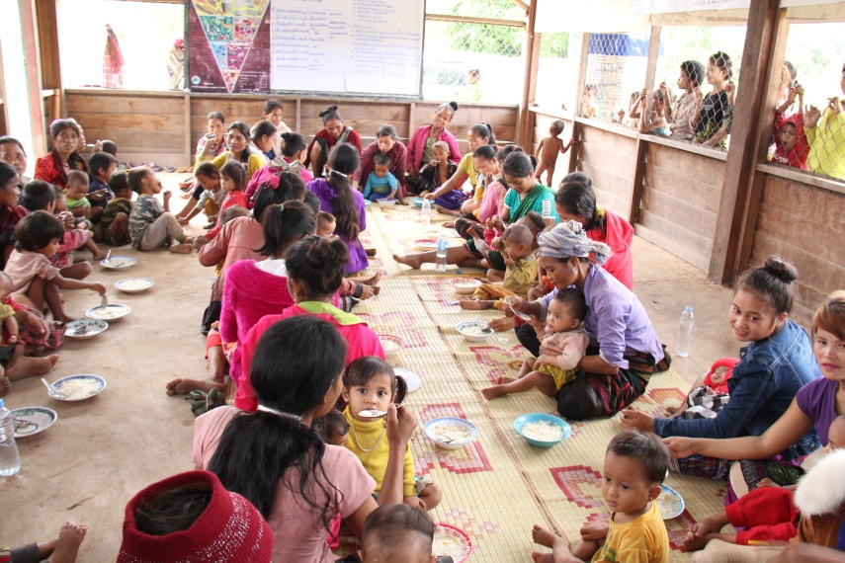
The Poverty Reduction Fund (PRF) Project’s donors (World Bank and Swiss Agency for Development and Cooperation) have conducted a support mission from October 18-31 2017, including a one week field visit in Savannakhet Province to follow up the project activities. The field visit gave the opportunity to foresight four main different types of activities:
- The participation to an accountability meeting following the construction of a dormitory for teachers and students in Tamluang village (Nong district). During this meeting, the Village Implementation Team members present to the all community members participating a summary of the work accomplished a Public review of expenditures (LAK 200,000 million for the students dormitory and LAK 280,000 million for the teachers dormitory) and of villager’s contributions. During this meeting, any participants can raise issues found during the sub-project preparation and construction period for the village mediation committee to take action. Finally, the community members were invited to a secret voting in order to express their level of satisfaction towards the quality of the infrastructure built as well as the process used.

2. The visit of a Village Nutrition Center (VNC) in Palor village (Nong district) built by the community members themselves using community contribution (18% of the overall costs) and PRF contribution (LAK 74 millions). To ensure the building will be sustained, the community has set up a maintenance committee composed of 11 members (including 2 females) and established a maintenance fund for this purpose. The infrastructure was preliminary used by pregnant women, lactating women and children under 24 years old to improve their nutrition knowledge and learn new recipes using local food that can fulfill their specific nutrition needs during the 1,000 days window. The infrastructure is currently used for other training purposes.
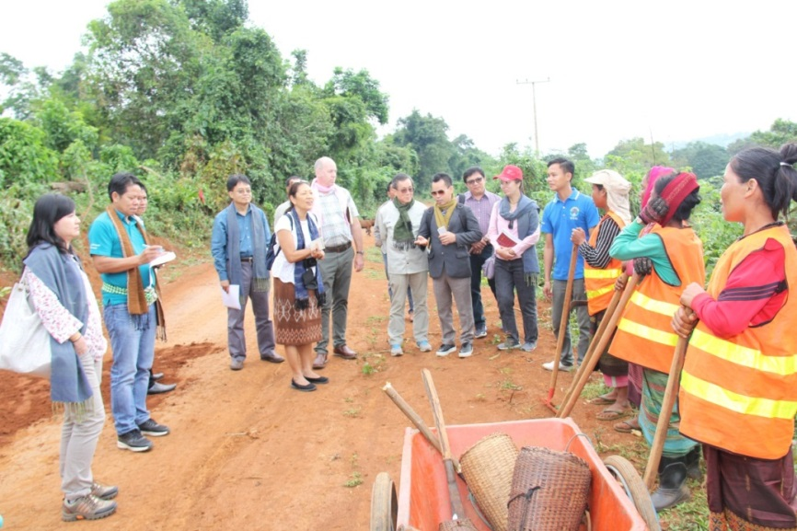
3. In Palor village, the PRF has also supported the set up and capacity building of eight Self Help Groups (SHG) with a total of 97members, and contribute to a fund up to LAK 78 million that can be used as loan by the SHG members to invest in livelihood linked nutrition activities. Up to now, 85 SHG members, in majority women, has benefited from the SHG fund to develop activities such as poultry raising, goat raisin, pig raising, fish raising, banana plantation or trading. In parallel to the SHG loan, the SHG members have started to save on their own and create a fund that can be used for emergency case (sickness, food shortage, etc.). These SHG members hold regular meetings to exchange their experiences and knowledge follow up on the livelihood activities progress and help each other to solve issues.
4. The visit of a road maintenance Group (RMG) at Salaen village (Sepon district). The role of the RMG is to prevent (major) damage by ensure proper working of road elements (drainage, slope protection) and carrying out minor repairs to avoid further deterioration. The RMG visited is composed of four of the poorest women in their community (widow, divorced) working part-time to maintain around 2.5km of road. They are paid around LAK200,000 per month in average to carry out maintenance activities. They are contracted on a performance basis, which means that they have to comply with certain performance standard at all time. The work inspection is carried our once a month by the district office for the public work and transport. The RMG have received the necessary training as well as the equipment to fulfill their responsibilities.
After the field visit, Mr. Erik Caldwell Johnson, Senior Social Development Specialist and PRF Task Team Leader stated that “the PRF has a good mechanism and approach to strengthen the community. The community members dare to speak out during meetings to express their ideas, they are responsive to develop their village and can do the routine maintenance of their infrastructure supported by the PRF by themselves, which help to improve sustainability”. He finally added that, “in the future, if the sub-projects supported by the PRF don’t need high construction technique, the community should be given the opportunity to build it by themselves”.

