Scaling up and Mainstreaming of CDD programs: Practitioners Discussion Forum

By: HATTHACHAN PHIMPHANTHAVONG (Ph.D)
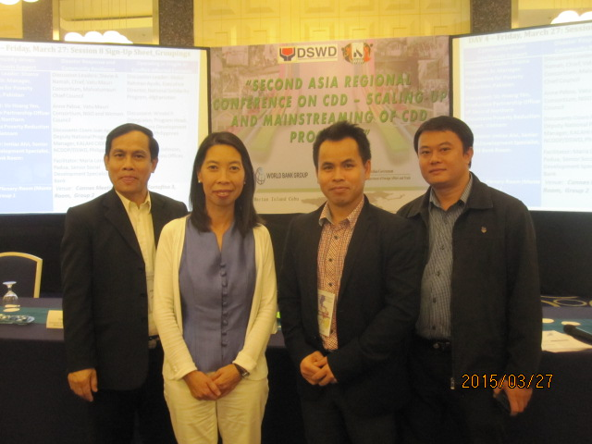
Getting women and ethnic groups to participate our development process is an effort for Community Driven Development (CDD) through the implementation of the Poverty Reduction Fund project (PRF). In order to ensure the effectiveness of the work, the donors (World Bank, DFAT, and ADB) had organized the 2nd Asia Regional Conference on CDD – Scaling-up and Mainstreaming of CDD programs, held on 24-27 March 2015 at Cebu city, Philippines. More than 100 participants from 15 countries attended the conference.
Workshop Goals:
As a follow-up to the East Asia and Pacific Regional Community Driven Development Conference held in Bali, Indonesia in November 2013, this workshop aimed to:
- Provide a venue for a regional exchange of knowledge and peer-to-peer learning on a set of topics common to CDD programs working in East and South Asian regions;
- Facilitate a dialogue among different players – policymakers, practitioners, implementers, researchers – working on CDD programs;
- Identify key challenges and discuss successful approaches to sustaining, mainstreaming, and scaling up CDD programs;
- Identify useful steps and activities that will advance the concept of a regional CDD community of practice.
Workshop format and dynamics:
- This was an interactive workshop with select presentations and panel discussions on the theme being discussed, giving highlights of specific country experiences, challenges faced and lessons learned, followed by open discussion.
- In some sessions, participants were divided into smaller groups for in-depth discussions on specific topics.

The 4-day conference was divided in to 8 sessions:
Session 1: Scaling up CDD: Experiences and Challenges
Session 2: Sustainability: Linking CDD with front line sectoral agencies and basic service delivery.
Session 3: Sustainability Part 2: Sub-national structures/local government linkages.
Session 4: Policy issues and challenges to sustaining CDD.
Session 5: Improving impacts and understanding from the field.
Session 6: Voices from the field.
Session 7: Action plan for way forward.
Session 8: Operation challenges and opportunities (breakout sessions)

Throughout the four day workshop the delegates from each country presented their experiences and challenges of scaling up their CDD programs in various contexts (e.g. low-income/fragile environment), together with their experiences in institutionalizing CDD approaches into legal, policy and/or regulatory frameworks. The discussions also covered country experiences in linking CDD programs with sectoral agencies, as well as activities to enhance front line delivery to ensure the sustainability. The delegates from Lao PDR discussed the implementation of PRF particularly its procedures to encourage high number of women and ethnic groups to participate in all processes of their community development, including techniques to identify, engage, and address the needs of vulnerable and marginalized groups in the decision making process. The Lao delegates also discussed ways to ensure cost effective implementation where the poorest are benefiting from the support of PRF. Key method to address the risks of elite capture through the sub-project selection process were also presented. Lastly, the Lao delegates described the types of training that was provided to have quality community facilitators to ensure effective community participation in planning, decision making, and operation and maintenance.

The Lao delegates raised some important issues including how to ensure the quality of community participation, the quality of sub-project construction, harmonizing CDD with government systems, and special techniques to reach ethnic minorities. Delegates from other countries discussed how to increase awareness and ownership by the community, improving the capacity of local level government and also local staff, strategies for staff recruitment and training, decentralizing responsibilities to the local community, information sharing with line ministries and other development partners, and strengthening quality control of operation and maintenance through training and capacity building. It was interesting to note that most sub-projects in the Philippines were implemented by the local community and sub-project costs were much lower compared to other agencies.

