National Lessons Learned Workshop
Integration of Village Development Plans (VDP) and District Socio-Economic Development Plan (DSEDP)

A workshop was held in Vientiane, Lao PDR on 18th November, 2016, co-chaired by the Ministry of Planning and Investment (MPI) and National Committee for Rural Development and Poverty Eradication (NCRDPE), to share the experience and the lessons of the pilot integration of the Village Development Plans (VDP) and the District Socio-Economic Development Plan (DSEDP). Broad national stakeholders including the Ministry of Public Works and Transport, the Ministry of Health, and the Ministry of Natural Resources and Environment, Lao Women Union, Lao Front of National Construction, National University of Laos, and Nayoby Bank, as well as Development Partners (DPs) including the World Bank, SDC, UNICEF, UNFPA, UNESCO, GIZ, JICA, KOICA, WFP, Helvetas, participated in the workshop. In addition, village representatives, district and provincial officials who participated in the pilot also joined the workshop and presented their experience, while the MPI and NCRDPE presented the GoL procedures on village and district planning processes. The Workshop closed with the agreement that the DSEDP process should be strengthened and mainstreamed as the integrated planning platform with a strong linkage with the participatory VDP process.
Background
The Participatory Planning Manual (PPM) developed by the MPI provides how the VDPs are prepared and consolidated into the Kumban Development Plan (KDP), and how priorities identified in the VDP and the KDP are incorporated into the District Socio-Economic Development Plan (DSEDP). Nonetheless, separate village planning processes are carried out in many villages under donor-funded programs, which are loosely connected with each other and are rarely integrated in the DSEDP. Few DSEDPs include activities funded by DPs or the private sector, and few VDPs are developed by villagers with the knowledge of government priorities and funding envelops. Such weak coordination often resulted in a considerable duplication of resources which could have been used to generate tangible poverty benefits, and missed opportunities for synergies which could have enhanced the impact of development interventions. In order to address such shortcomings and strengthen the DSEDP as an integrated and participatory planning platform, the MPI and NCRDPE, with the support of the Poverty Reduction Fund (PRF), started a pilot to integrate VDP/KDP and DSEDP processes in selected districts of Houaphan, Savannakhet, Luang Prabang, and Oudomxay provinces in 2016.
The Integrated DSEDP Process and Key Innovations
The integrated VDP-DSEDP procedure consists of different steps. It starts with the capacity development of provincial and district officials, followed by the Feedback Meeting where village representatives present their VDPs or KDPs and receive feedback from district officials. Based on the feedback received, the VDPs or KDPs are revised. In the meanwhile, district officials develop the sector plans taking into account the VDPs, which are subsequently consolidated into the draft DSEDP. The pilot process ends with the presentation of the draft DSEDP by the District Planning Office (DPO) to the District Governor in which village representatives also participate and provide comments.
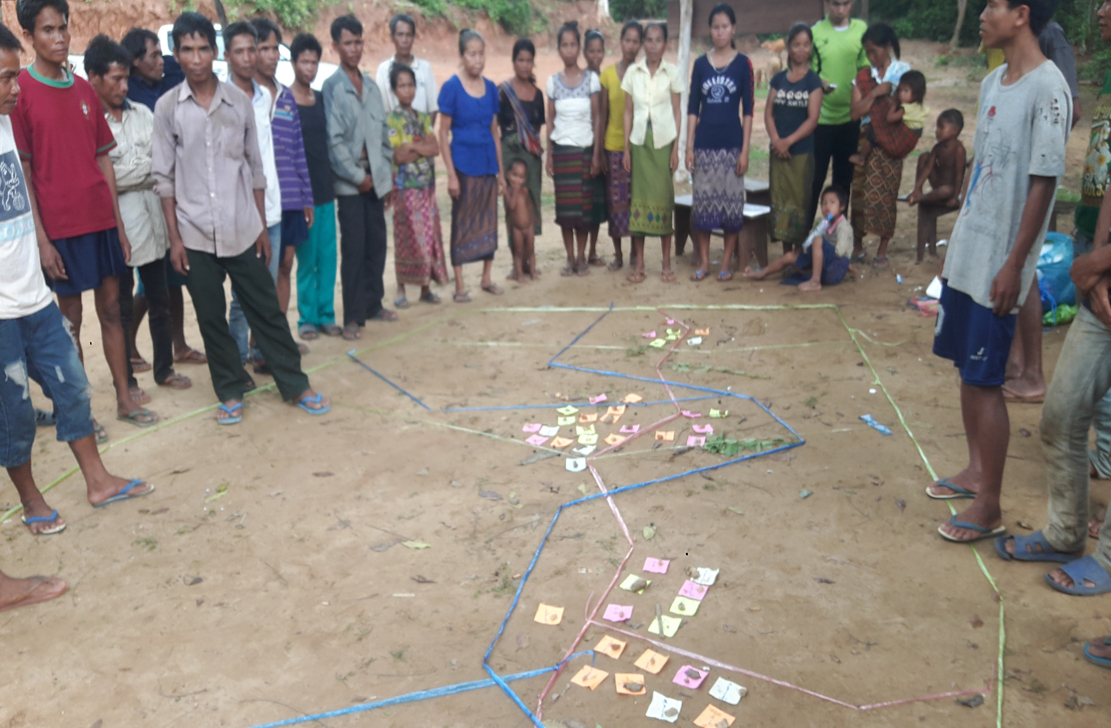 | 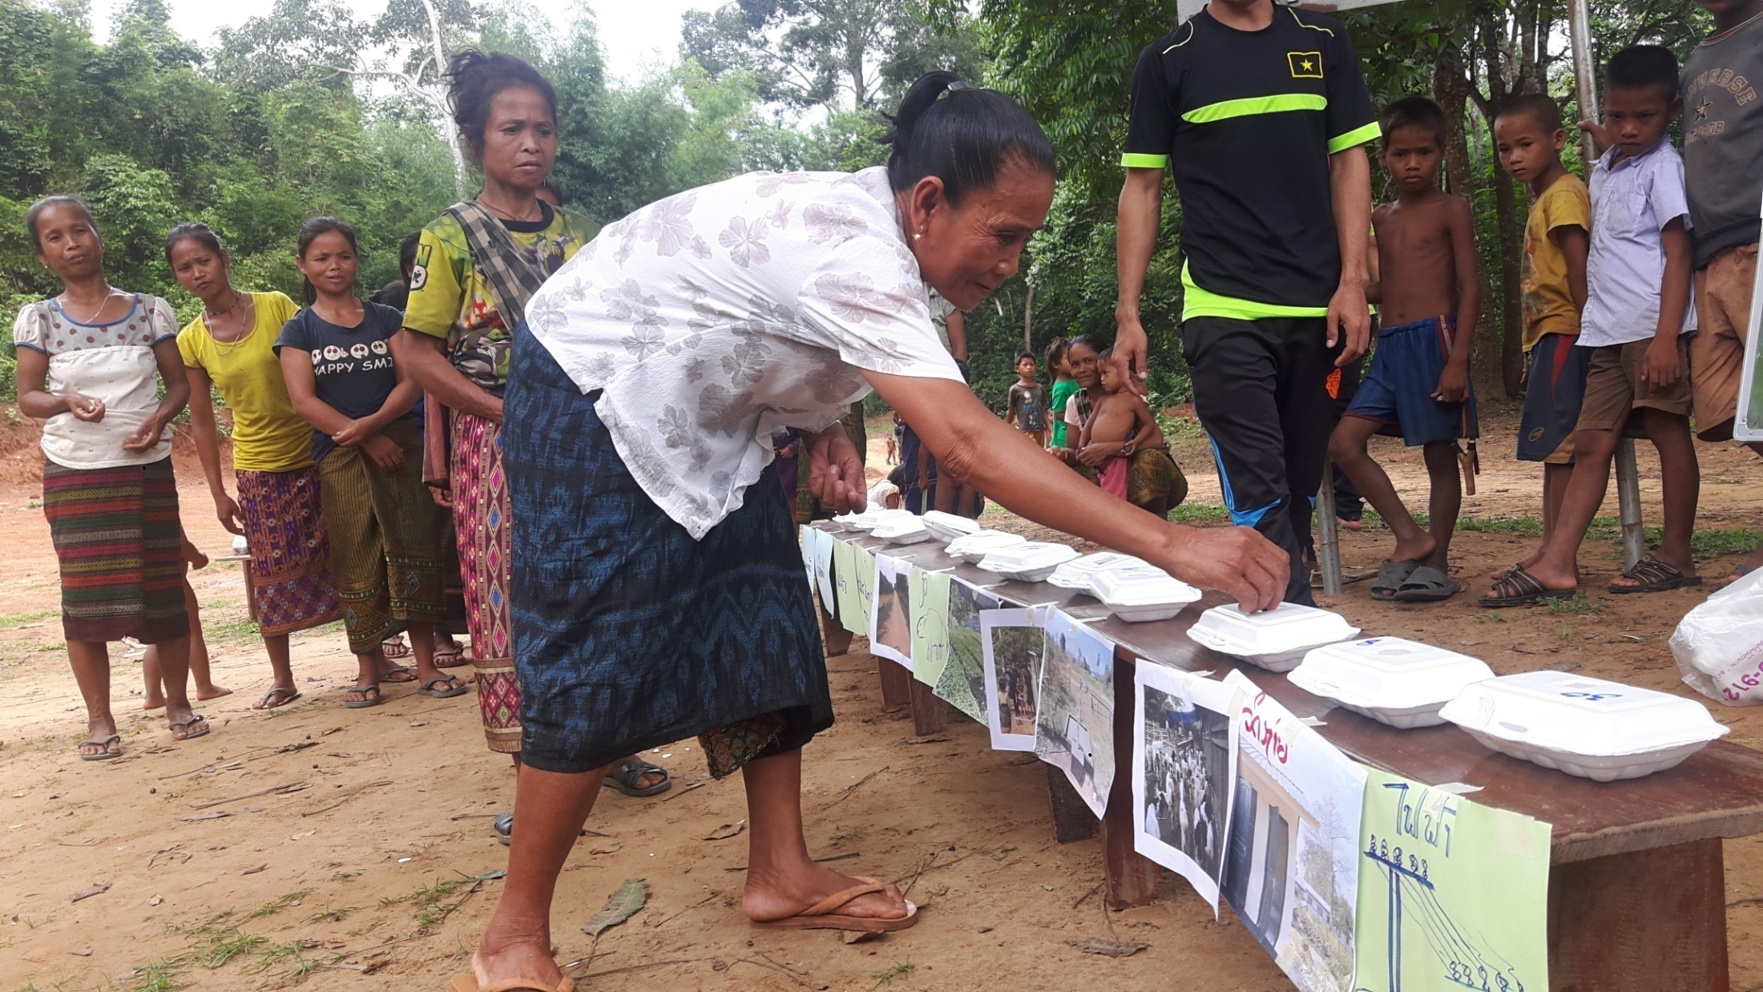 | 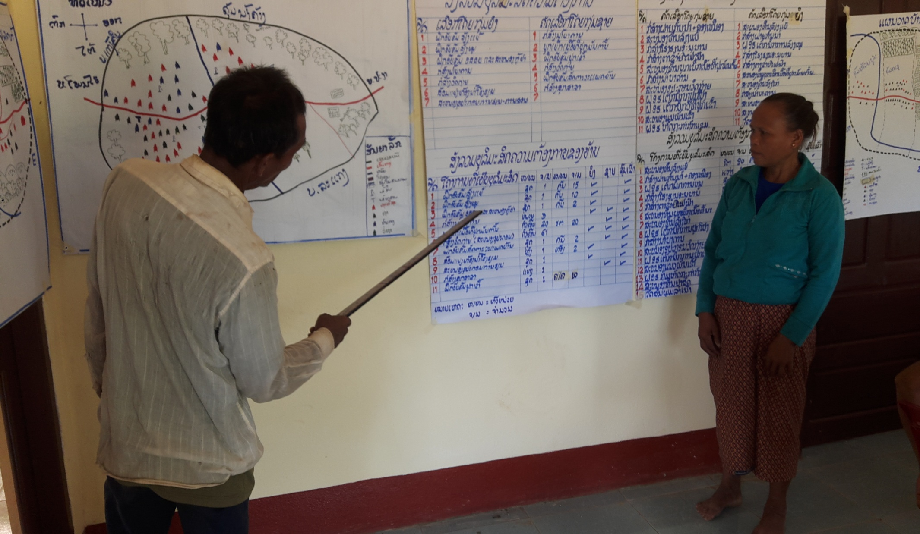
Village social mapping for VDP | Women voted for their priorities in VDP | Village delegates presented VDP
Key innovations introduced under the pilot include the series of face-to-face meetings between village representatives, district officials and DPs active in the district in the VDP/KDP and DSEDP processes, which allows more participatory discussions on priority issues and trade-offs based on the shared information about priorities and budget envelop of each stakeholder including the government agencies.
“We are pleased to represent our Kumban to the district governor and sector officials. At the meeting, we explained the priorities from each village in the Kumban; we also explained whether the priorities were proposed by men or women or both. After presentation, we got the feedback from the district governor, district officials, and other participants. This was the first opportunity for us to present our KDP to the district authority – a Kumban representative of Xamneua District, Houaphan.
As important output of this pilot is the DSEDPs as the integrated planning platform that is participatory and inclusive, linked to VDP/KDP. All activities that participants of the pilot plan to implement, including the PRF, are addressed in the DSEDP, helping avoid duplications and improving synergies. Going forward, the DSEDP should continue to be used by the district authorities and DPs as the source of priority investments from which they select their own investments.
“We organized two meetings to invite village and kumban representatives. In the first meeting, kumban representatives presented their priorities and our district officials provided the feedback. After this meeting, district officials drafted the DSEDP, taking into account priorities from villages. In a second meeting, we invited village and kumban representatives to get their feedback on the draft DSEDP. Based on the endorsed DSEDP, the district has identified our public investment plan to submit to the province and then to local national assembly. We hope that other development partners support us in implementing this DSEDP” – Mr. Sychanh Latsamy, Governor of Phonxay District, Luang Prabang.
Key Results and Lessons Learned
- All participants of the workshop and the pilot supported further mainstreaming the participatory DSEDP platform as it will help minimize parallel KDP/VDP processes on the ground, strengthen the links of VDPs/KDPs to DSEDP, improve the quality of DSEDP, and create synergy. The participatory and inclusive processes used under the pilot not only increased the acceptance and ownership of the DSEDP among stakeholders but also created a platform for further coordination and collaboration beyond the development of DSEDP as such.
“It is important to have one integrated district SEDP process, that starts from village and ends with the district meeting to endorse the DSEDP. This DSEDP should include both the priorities from villages and policy targets. This DSEDP should have both infrastructures, income generating activities, and capacity building for farmers in order to accelerate rural development and poverty eradication. Having this integrated process exists, there should not be multiple planning processes at the local level. The Government and donors could then work together to support the implementation of the DSEDP” – Mr Chit Thavisay, Director General, Planning and International Cooperation, NCRDPE.
- Village and kumban representatives appreciated the process which gives them an opportunity to present their priorities to and receive feedback from district officials and other stakeholders, and provide comments to the draft DSEDP. In all pilot districts, this was the first time that village representatives participated in an official meeting to discuss DSEDP and provided comments.
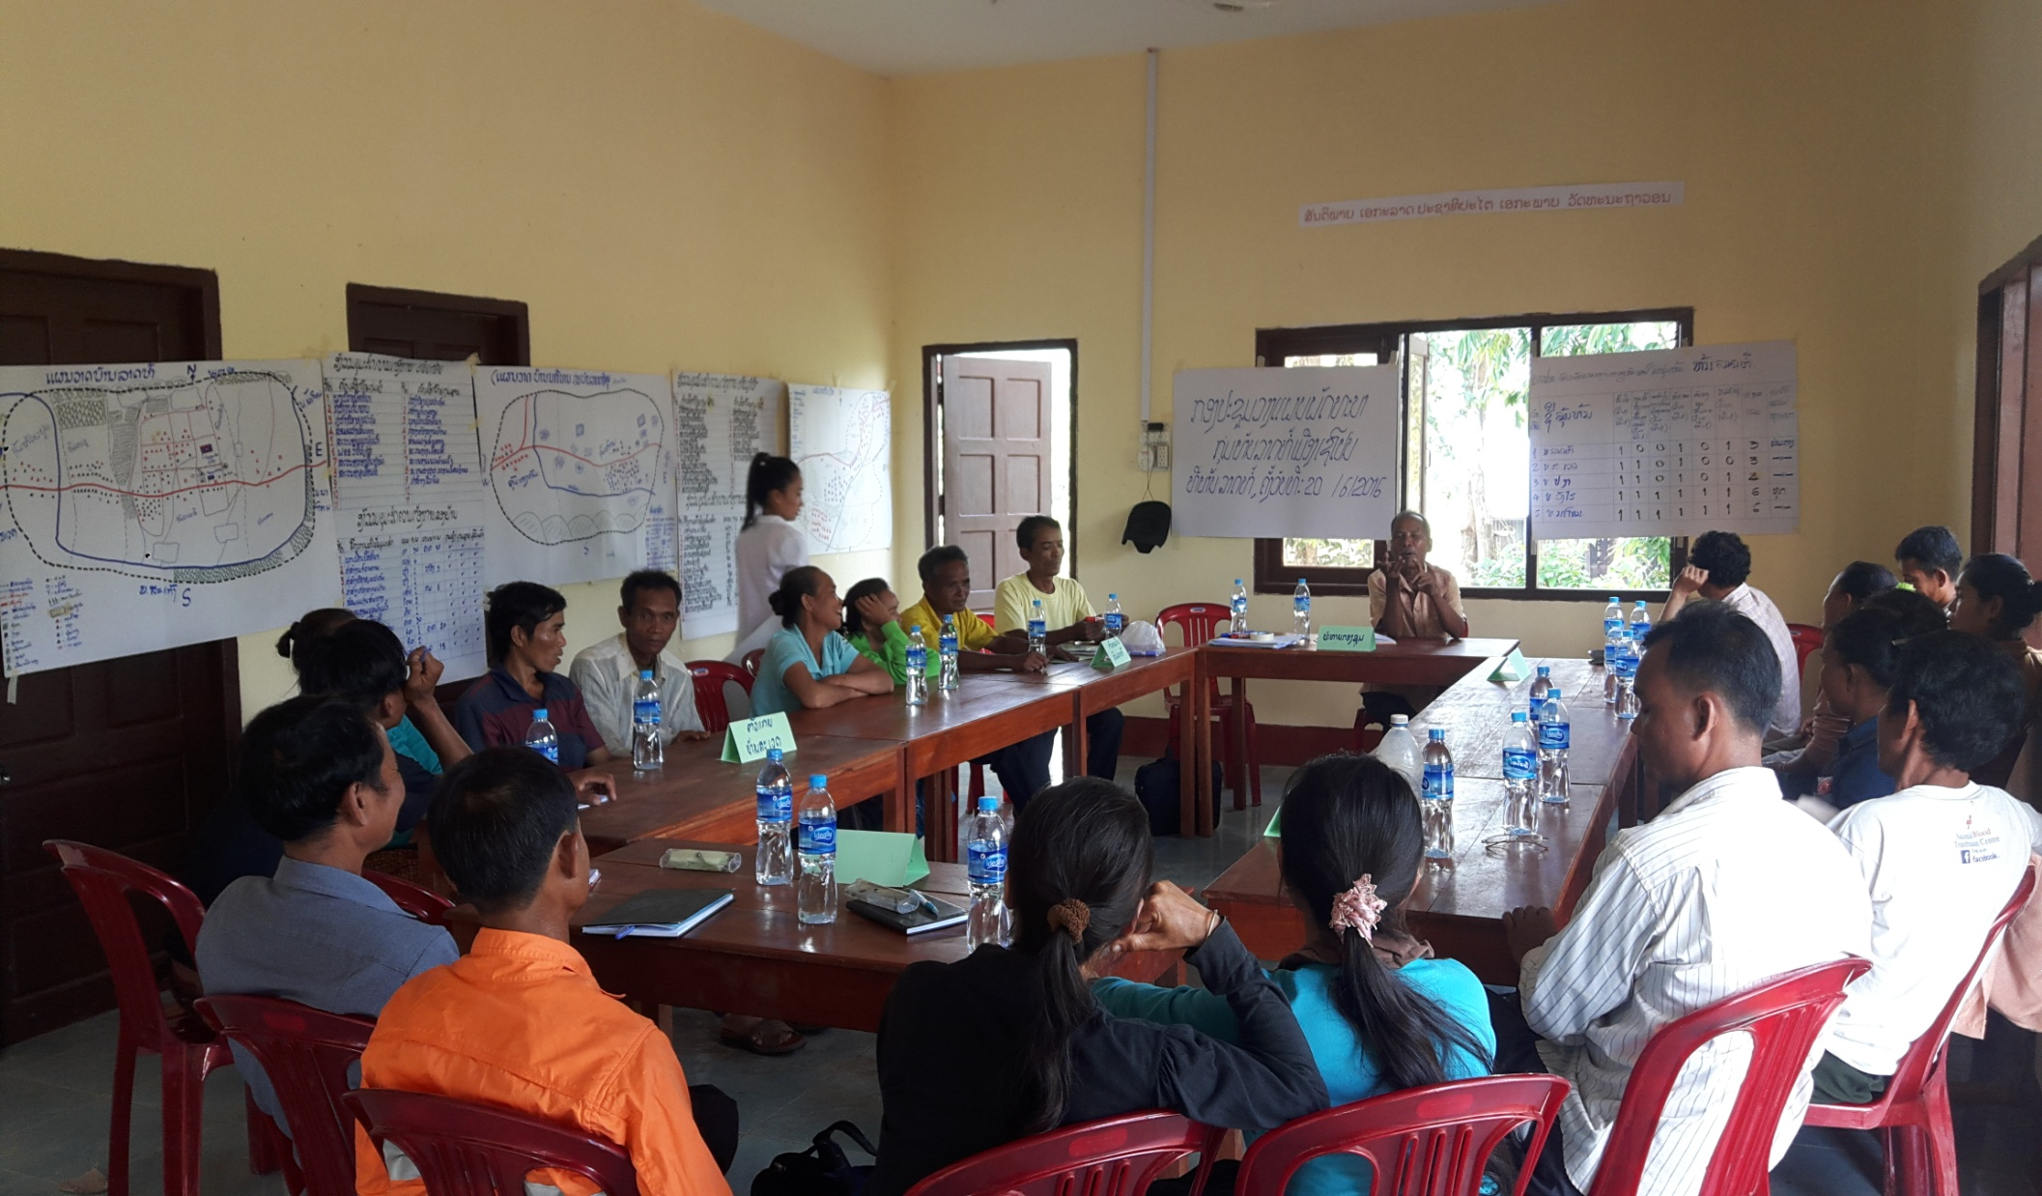 | 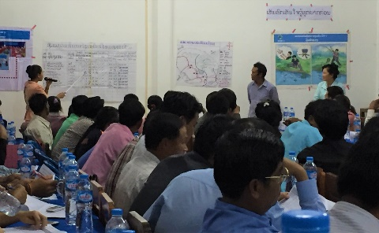 | 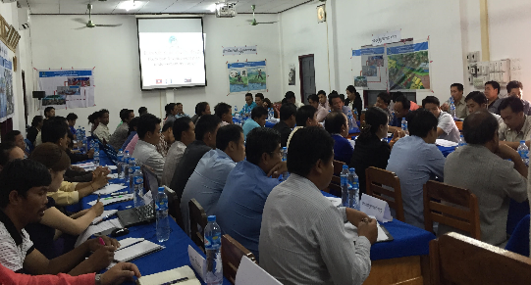
KDP meeting to develop KDP | Village delegates at Feedback Meeting | Annual District DSEDP Meeting
- This pilot provided useful experience for the GoL officials to develop the DSEDP in a participatory and transparent manner. It was reported that a level of consultation was carried out with villagers in the development of DSEDPs in previous years. But this pilot brought the level of engagement a step further by having many face-to-face interactions between village representatives, government officials, and DPs in the VDP and DSEDP planning process.
“The pilot is to support our objective to have one single planning process (one plan) which links between the targets of the sectors and the needs of villagers. Therefore we would like the Development Partners to use and support this integrated planning process” – Ms. Chanfong Keobounyong, Deputy Director of Provincial Rural Development Office, Luang Prabang
- Some development partners and NGOs active in the pilot districts participated in the process as observers. They expressed a strong support to, and expressed an interest to participate in, developing inclusive DSEDP process would help minimize duplication of activities.
- Critical to the success of the pilot is the training provided to district officials at the initial stage which increased their ownership. Going forward, the capacity of district officials should continue to be strengthened so they can facilitate Feedback Meeting and the Annual DSEDP Meeting in a participatory manner and manage the DSEDP process as the common planning platform for rural development.
“We are the owner of the planning process and activities implementation, we can do the plan and implement the activities. We would like PRF and other Development Partners to support us the capacity building on planning process, especially training of trainers, facilitation skills. We also would like PRF and other Development Partners to fund for implementation of certain activities in our DSEDP” – Mr. Khamsone Boundouangchanh, Head of District Planning Office, Xamneua District, Houphan.
- Under the pilot, village representatives presented three highest priorities to district officials to ensure all representatives have sufficient time for presentation. As a result, villagers tended to select large investments which may not necessarily reflect their most essential needs.
The Way Forward
Participants of the workshop agreed on the following next steps. (i) Stage 1: Develop a formal procedure of the integrated DSEDP process for endorsement by the MPI in the first quarter of 2017. (ii) Stage 2: Implement the adopted procedure in all the PRF target districts in 2017; the MPI and the NCRDPE will work with other Development Partners for their participation in and support to the integrated DSEDP process in other districts. (iii) Stage 3: Develop a draft Government Decree or Prime Minister’s Decision on the integrated DSEDP process. The MPI and the NCRDPE will submit the draft to the GoL for adoption in 2018. Once approved, the MPI will issue a ministerial circular, or expand the MPI’s existing Guidelines, to provide detailed processes and procedures of the integrated DSEDP process.
“Planning system of Laos is a combination of top-down and bottom-up processes. This pilot represents a good experiment of how to link the top-down targets and the bottom-up proposals from villages in an interactive and participatory manner. Therefore, we will document the process and take it forward. We will base on the existing PPM and DSEDP Guidelines of MPI and formalize this integrated local planning process” – Mr. Lienthong Souphany, Deputy Director General, Department of Planning, MPI.

Annex – Integrated DSEDP Procedure
Key activities | Expected outcomes
Step 1 - Capacity building  Master training (for key persons) and ToT training for provincial/district staff; Training for district planning teams in the pilot districts; | DPI planning officials, district planning teams understand are equipped with principles and skills to facilitate participatory planning process of PPM, DSEDP Guideline, the procedure of the pilot.
Step 2 - Facilitation of VDP  District planning teams (joint by PRF staff to backstop) go to all villages to facilitate village planning process using the GoL’s PPM with some minor modifications based on good practices of Deepen Community Driven Development (CDD) exercised under PRF | - District planning teams are deployed to the field for the period required;  - Village meetings are organized according to PPM;  - VDPs are prepared with active participation of villagers; a list of three first priorities are selected per KDP.
Step 3 - Facilitation of KDP  District planning teams facilitate the development of KDP using the GoL’s PPM | - Villagers elect their representatives for KDP meetings;  - KDPs are developed from VDPs and agreed by village representatives.
Step 4- VDP/KDP Feedback Meeting  District Governor organizes VDP/KDP Feedback Meeting, where Kumban representatives present the VDP/KDP priorities and get feedback from district sectors, other GoL participants (MPI, NCRDPE, DPI and PRDO), other stakeholders (PRF, other development partners). | - Kumban representatives present their priorities with as much details as possible;  - Feedback from district sectors and other stakeholders for kumbans to revise their VDPs/KDPs.
Step 5 - Drafting DSEDP  District Planning Office (DPO) coordinates with other district sectors to draft the DSEDP with reflection of both the top-down policy targets and the bottom-up VDP/KDP | - Coordination between DPO and other district sectors;  - Draft DSEDP reflects both VDPs/KDPs and policy targets of the authorities.
Step 6 - DSEDP Meeting  District Governor organizes the DSEDP Meeting to (i) review the implementation of the DSEDP in the last cycle; (ii) present and discuss the draft DSEDP to get the feedback from Kumban representatives, district sectors, other GoL participants, and other stakeholders (PRF, other development partners) | - Lessons learned from the implementation of the DSEDP in the last cycle are identified and addressed in the draft DSEDP;  - Feedback from participants on the priorities in the DSEDP;  - DSEDP is endorsed.
Step 7 - Implementation of the DSEDP  Based on the approved DSEDP: (i) District authorities develop the PIP; (ii) PRF identifies its investment plan; (iii) Other development partners expected to draw their interventions; | - PIP is developed in consistence with DSEDP;  - PRF investment plan is identified from the priorities listed in DSEDP;  - Interventions of other development partners operating in the district are drawn from DSEDP.

