Field Report on the Super Clean Cook Stove training
(Mimi Moto) for the community acceptance study

At Nakham village and Piengyam village, Xiengkhor District, Houaphan Province
Date 28th March to 2nd April 2018
- Training purpose

- Awareness on the issue of using traditional stove and the outcomes of using super clean stove for community members;
- Train the community members on how to operate the super clean cook stove (Mimi moto) as well as the basic maintenance (demonstration + practice by cooking);

- Location
Level | # of mini moto distributed | # of Pellet Bags distributed (15kg/bag) | Remark
Nakham and Piengyam villages in Xiengkhor district | 40 | 1,030 | One households dropped out from the cook stove acceptance study
PRF District office | 2 | 4 | For testing among PRF staff, forestry and agriculture office, Lao women union and demonstration
PRF Provincial office | 7 | 14 | 3 stoves for PRF and forestry and Agriculture Department staffs for testing and 2 stoves for spare in case of issue in the village  2 stoves for Nalae district in Louangnamtha provincial for PRF staff and Agriculture and Forestry office testing and demonstration
PRF Central office | 1 | 2 | For testing among PRF staff and demonstration
Total | 50 | 1,050

PRF distributed the pellets to each targeted households (13bags/households) to be used as a fuel for the Super Clean cook stove (for a 3 months consumption on the basis of 2 kg per day). The remaining 510 bags are stored in the warehouse of Phiengyam and Nakham villages for the next round of super clean cook stove households testing.

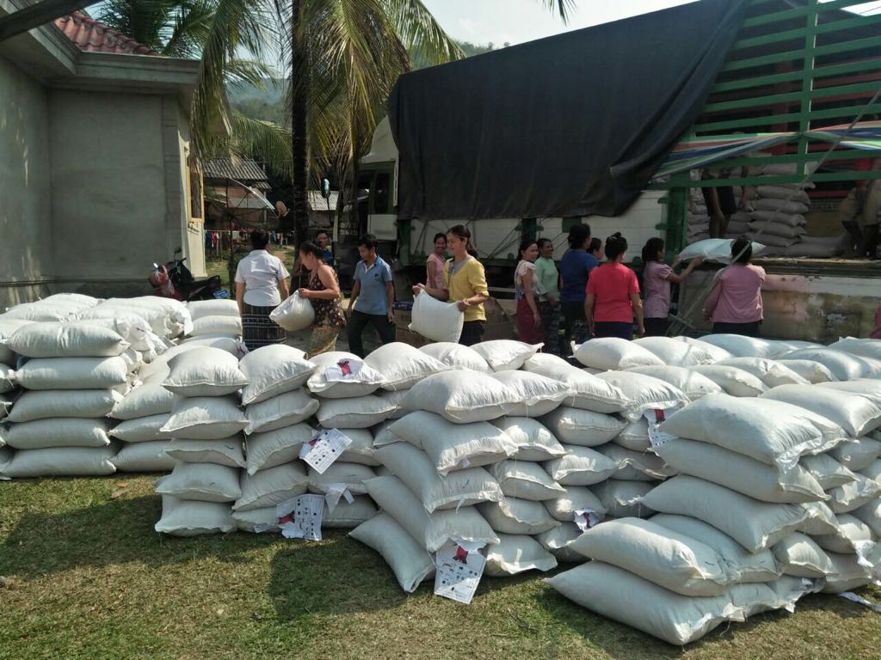
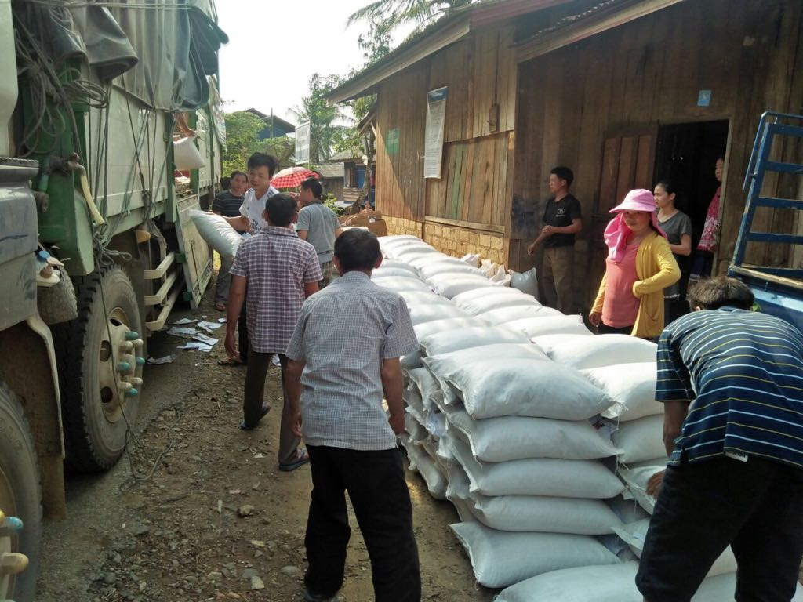
Pictures of transporter delivering the cook stove and pellet to Nakham and Phiengyam villages

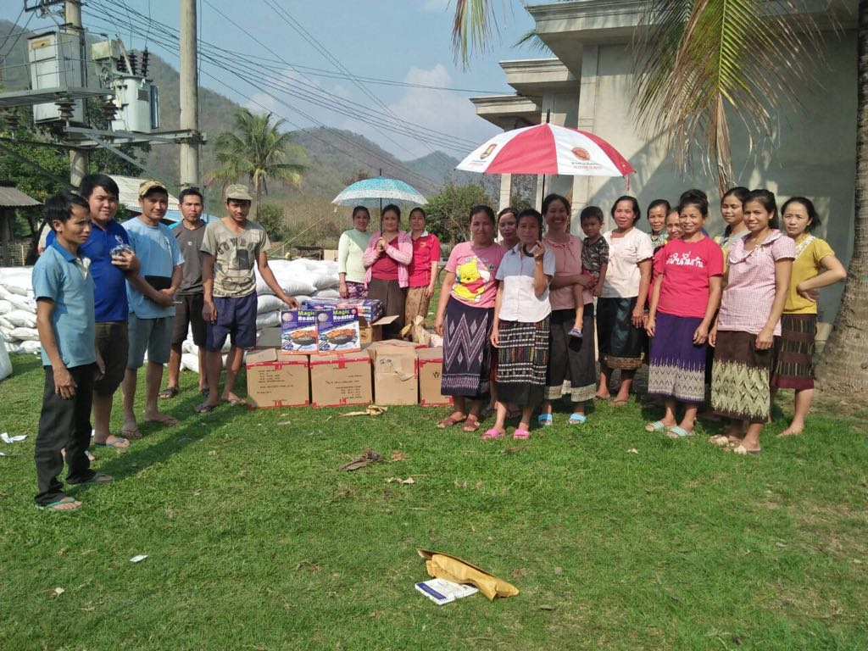
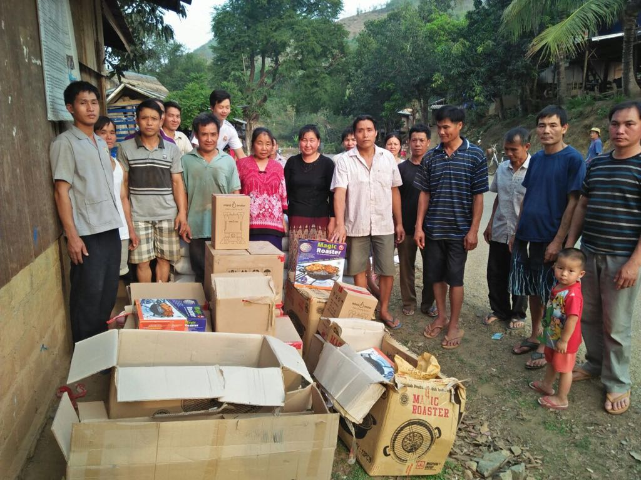
Target Households receiving the super clean cook stove at Nakham village and Piengyam village

- Training participants

Village level:
- 20 households in Phieng yam village (20% of participants are men).
- 20 households in Nakham village (60% of participants are men).
- Lao Women Union village representative;
- Village’s authorities.
Note: One household in Phiengyam village dropped out from the community acceptance study because of they have moved to live in Vientiane capital (Miss Air, #33). They were replaced by a new household who is interesting to use the super clean cook stove (Mister Ami and Miss Nyong).
After the training in Nakham village, one targeted household request to drop out because they worried that issue may happen with the cook stove and could lead to future problem. The wife did not come to the training, so during the meeting, the PRF team explained to the husband that the testing will also help the person who are cooking in the family (notably his wife). Therefore, he invited PRF district staff and the village authority to talk to his wife to persuade her to test the super clean cook stove as planned. After further discussion, the wife agreed to receive the super clean cook stove and happy to use it.
District level:
- PRF CD staff from Nalea District, Louangnamtha province (Mr. Khamlack) - the trainer;
- Nalea District staff from the Forestry and Agriculture office, Louang Namtha province (WFP coordinator) - the trainer;
- PRF CD and LN staff from Xiengkhor district, houaphan Province
- Xiengkhor district (Houaphanh Province) staff from the Forestry and Agriculture office, Lao Women Union representative, and Energy and mine office.
Province level
- Houaphan province PRF head office and CD officer;
- Houaphan province representative from Forestry and agriculture department.

Central level
- PRF CD and LN staffs (Ms. Chaipasird and Ms. Sonemany)

- Details of the training

  - Opening speed by village head men
  - Introduction on the background of the super clean cook stove
- What is the issue?

- Household air pollution (HAP) is a major cause of early death among women. Women, men and children exposed to household pollution due to cook stoves;
- More than 95% of rural population and 91% of urban population in Laos use cook stove for cooking and heating;
- Traditional cook stoves using wood or charcoal do not burn fuel efficiently and as a result, emit toxic particles and pollutants that are highly damaging to health. Typical emissions from traditional cook stoves are comparable to second hand smoke from 400 cigarettes per hour.

- What are the consequences?
Indoor air pollution is a major issue in Lao PDR ranking number one in causing lost healthy life years. Every year, smoke kills more people than Malaria, HIV/AIDS and Tuberculosis all together.
- Main smoke impact: Respiratory diseases; Pneumonia; Headache; Lung cancer; Heart disease; Stroke; Baby lung altered; Baby brain altered; Baby weight lower

- What can be done?
The advance biomass super clean cook stoves (Mimi Moto) have shown a great potential in achieving a very high thermal efficiency and very low emission of carbon monoxide (CO) and particulate matters (PM 2.5) that is found in the smoke.
- What are the potential benefits of using Mimi Moto Cook stove?
- Near total elimination of harmful HAP emissions for mothers and family members;
- Use pellets – no need to change fuel type;
- Grilling is easy and food test is the same;
- Faster cooking time which means more time for other chores, more time with family, or more discretionary leisure time;
- Modern and attractive design – highly aspirational product;
- Longer life – no need to buy a new stove every year (life duration of around 5 years);
- Safe and sturdy.

- How the testing is organized?
During the two months the Super Clean is handed over to 40 target HHs in two villages and they have the responsibility to:
- Use the cook stove on daily basis and for every meal
- Follow the instruction on the cook stove use based on the training that you have received
- Keep the cook stove in a safe place at home
- Use only pellets as a fuel (no wood or charcoal)
- Call the PRF team if you have any issue with the cook stove and ask for technical assistance and get a technical assistance from PRF staff in case of problem with the cook stove to ensure no interruption in the daily use of the Super Clean cook stove;
- Allocate some time (around 1-2 hours) to answer the questions from PRF staff during monitoring session every 3 days and the survey team (end line survey).

  - Super clean cook stoves demonstration
A demonstration was conducted in two sessions (Big group and small group). The big group demonstration was conducted after the introduction speech and led by the CD and Forestry and Agriculture staffs from Nalea district, Louangnamtha province. These two trainers have been trained by the WFP staff in Nalea district on using super clean stove by the Mimi Moto representative.
As a next step, a demonstration for small group was conducted after all participants understood how to operate the super clean cook stove. The small demonstration/on the job training has separated the households into 4 small groups of 5 households each. Each groups benefited from the assistance of one trainer hand In the small group session, each households has used the super clean cook stove under the supervision of the trainer to check that they could use it properly. Demonstration by Nalea district and Central team + boiling water for coffee break during the training in Phienyam village
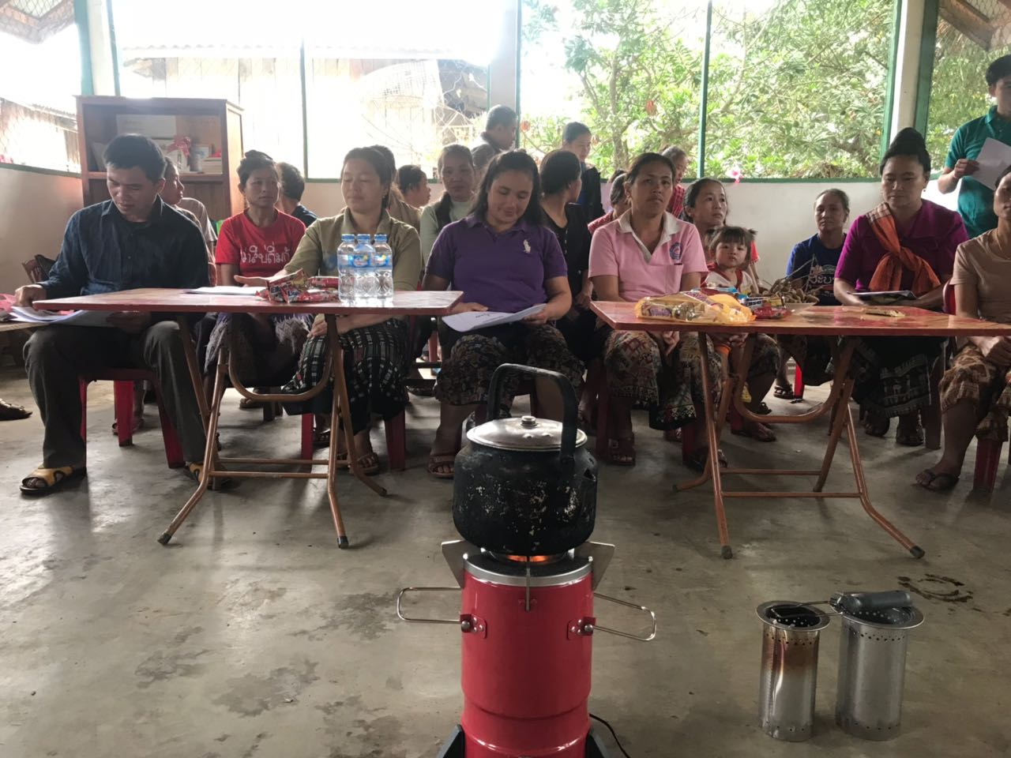
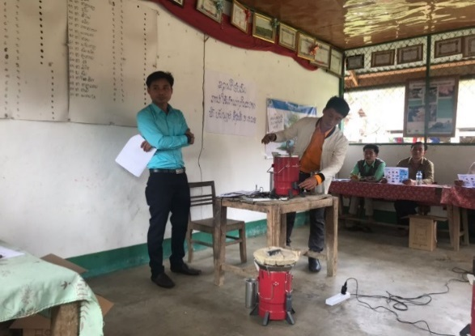
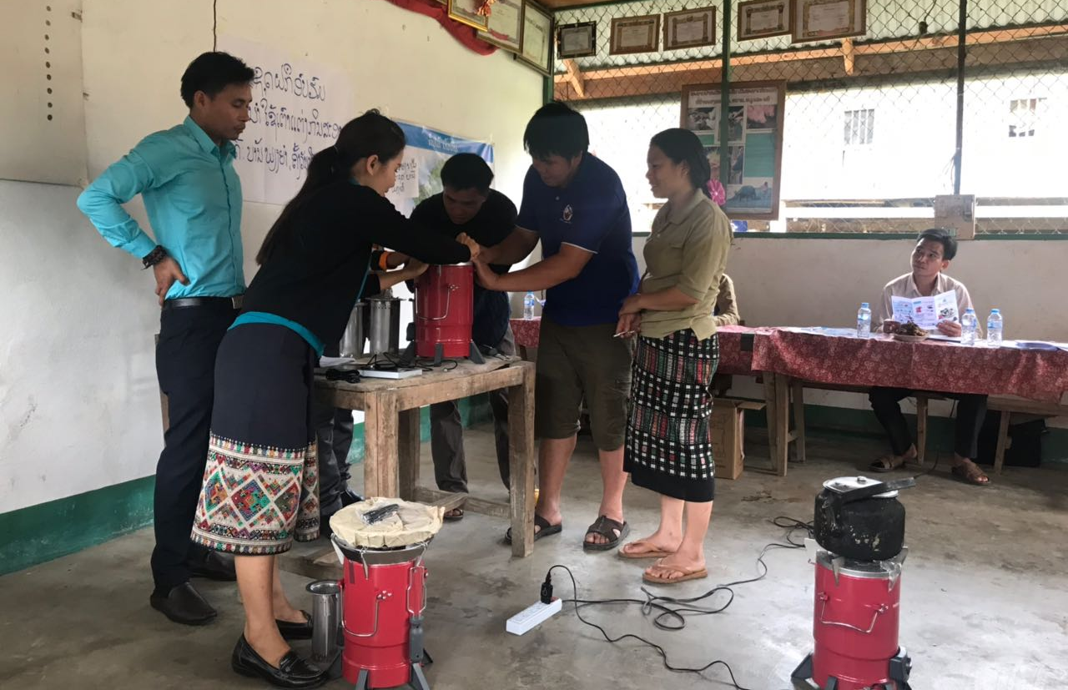
Demonstration by Nalea district and Central team + boiling water for coffee break in Phienyam village
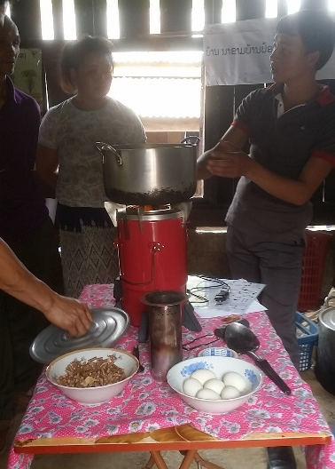
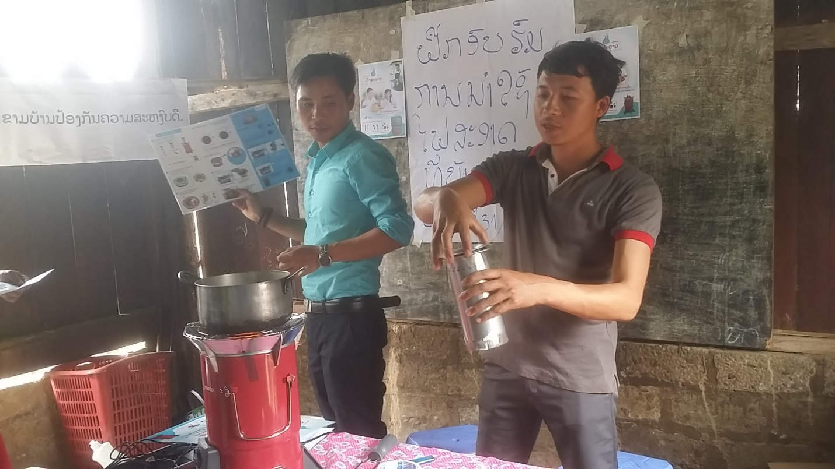
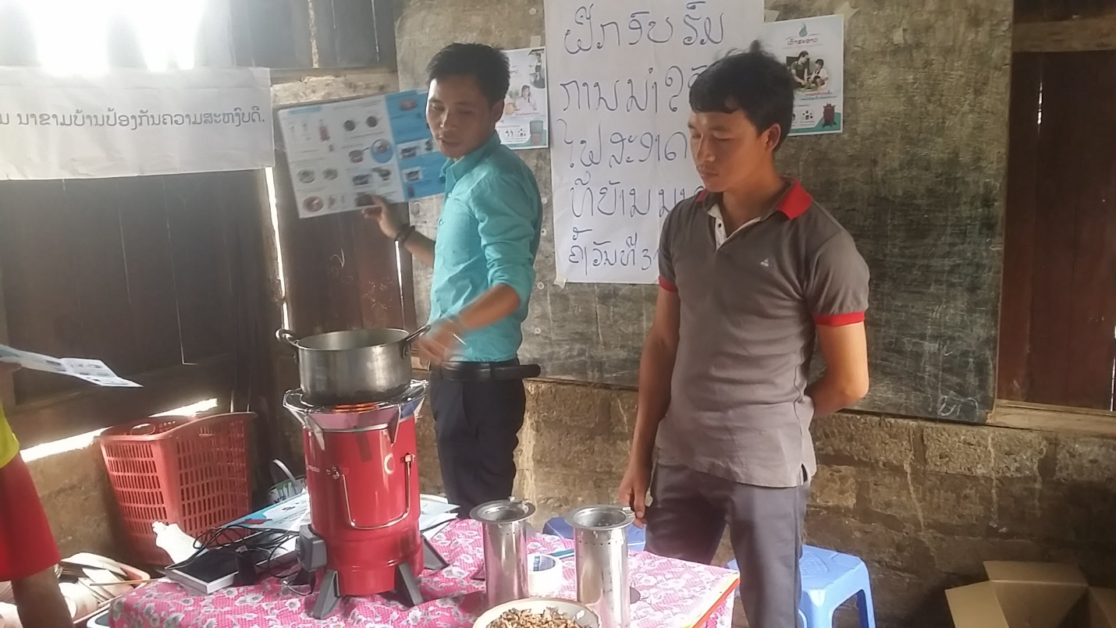
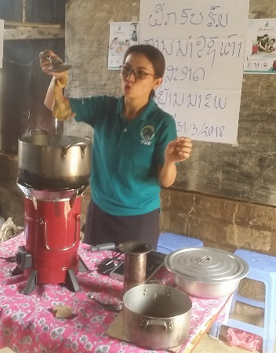
Demonstration by Nalea district team and cooking for lunch in Nakham village

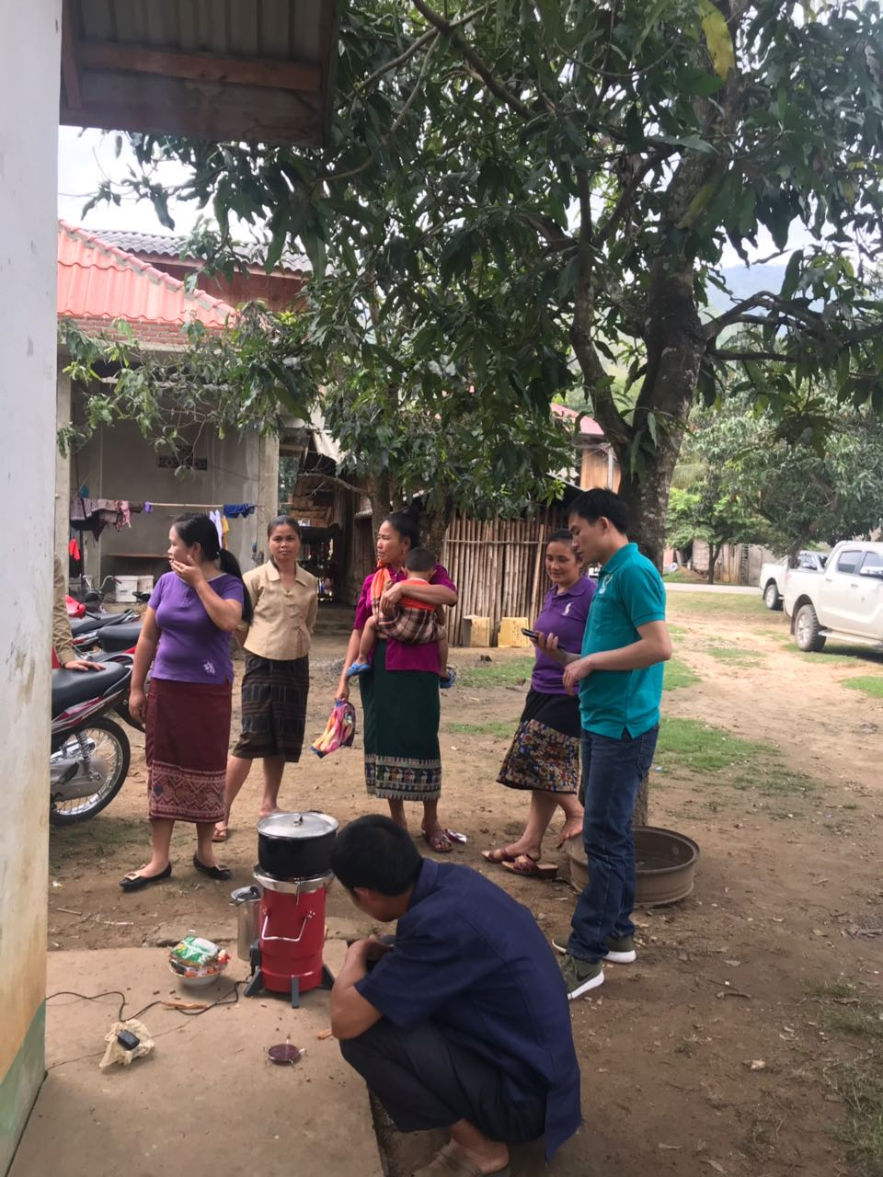
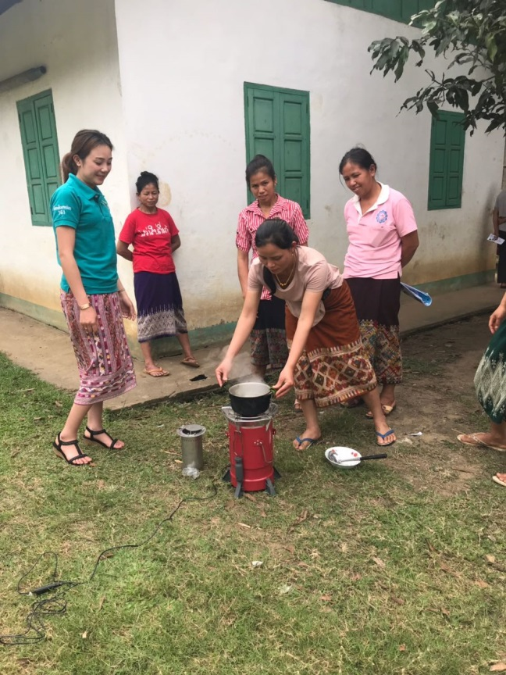
Small demonstration /on the job training for small group in PhiengYam village.
Some target housholds in Piengyam and Nakham Villages received cook stove and signed an agreement of testing the super clean cook stove during a period of 60 days.
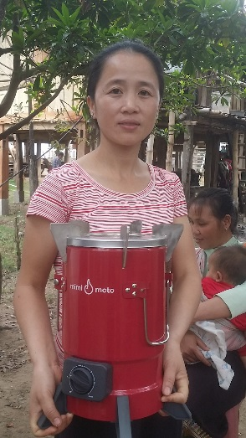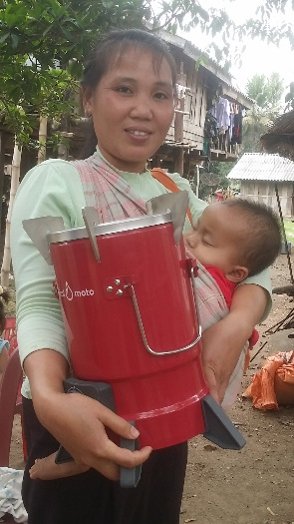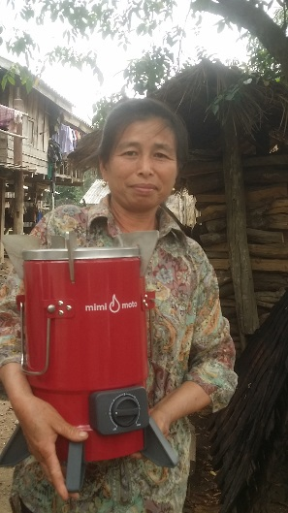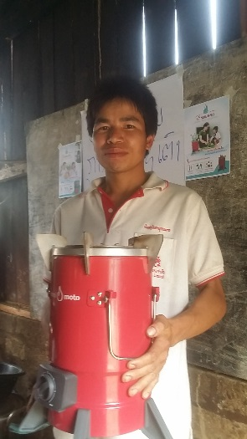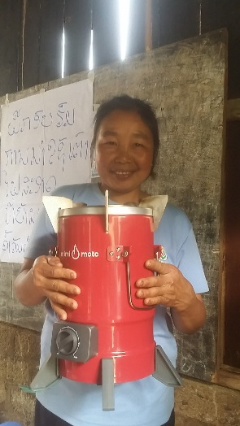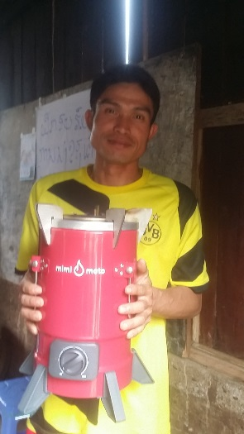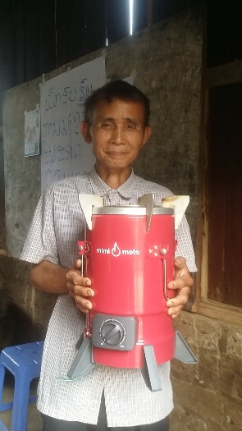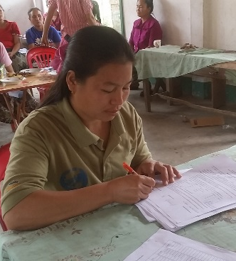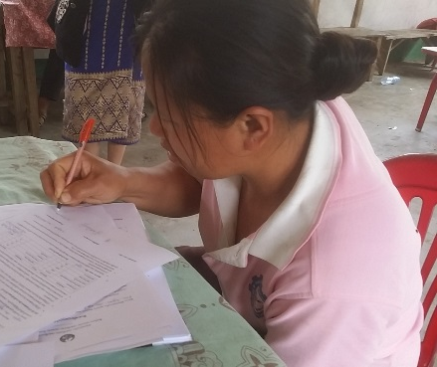

- General conclusion

- Before starting the demonstration in the village, the PRF central team conducted a demonstration for PRF provincial level and district levels. Therefore, before the demonstration at village level, all PRF district and provincial staff already knew how to use the super clean cook stove and could assist the official trainers.
- The training in Luang Namtha was good as the trainers could remember very well how to use the cook stove several months after being trained;
- After different test, it was found that pine trees is the best material for communities to light the super clean cook stove in Houaphanh province (easy to find);
- All target households were very enthusiastic to participate in the super clean cook stove and have requested to use it for more than 2 months. They ask if they can keep the super clean cook stove if other households not interested to test it.
- Every household ask how much is the price of one kilogram of pellet and how they will be able to find pellets in the future?
- During the discussion after the training completion, the community and staff are interested to support the community to produce the pellet and doing private investment;
- The testing shows that super clean cook stove still produces a lot of smoke if the fan is turn on but there are still pellets burning. So it is important to prepare sand to cover the burning pellets directly in the chamber or to throw away pellet out from the burner outdoor;
- The result of the super clean cook stove testing shows that the time for cooking is not as mentioned in the leaflet, result is:
- Small chamber burn less than 1 hour (around 30 minutes)
- Medium chamber burning less than 1 hours (around 40 minutes)
- Big chamber burn less than 3 hours (around 2 hours)

Vientiane capital, 08/04/2018
LN and CD Division

